Physics Practice Test Name: _______________________________
Newton’s Laws

1-8. Complete Newton’s Laws:

1st Law: Objects in motion __________________________________________ in a ________________________

at a ____________________________________________ unless ______________________________________

___________________________________________________________________________________________

2nd Law: _____= _________

3rd Law: For every action ______________________________________________________________________

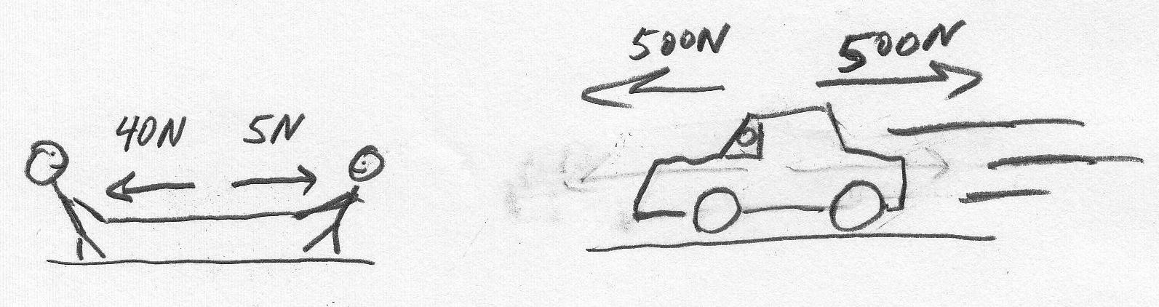
9. Use arrows to show the net forces in the drawings on the right. Label the arrows with the correct force, using the correct units. If there is no net force, you can leave off the arrow, but still give the net force.

The diagram below shows the path followed by a car. It also explains what is happening to the car’s speed as the car is traveling. For each of the segments of the car’s path, tell whether (by circling) the forces acting on the car are balanced or unbalanced.

10. At point A : Balanced Unbalanced
11. Between A & B : Balanced Unbalanced
12. Between B & C : Balanced Unbalanced
13. Between C & D : Balanced Unbalanced
14. Between D & E : Balanced Unbalanced
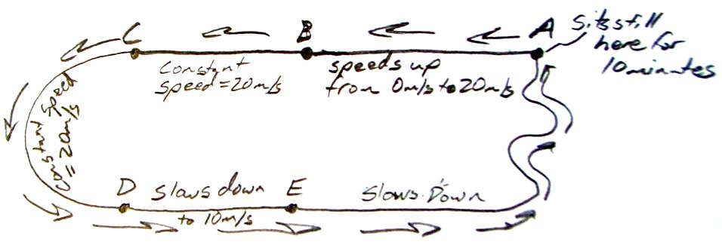
15. A ball is sitting motionless on the ground. The ground is applying an upward force of 20N to the ball. What do you know about the NET FORCE acting on the ball?

A 0.15kg mousetrap-powered car is wound up and held motionless at a starting line. When the car is released, its mousetrap “motor” pushes it for the first 3 seconds. During that time, the car travels 12 meters. After the car’s motor stops pushing, the car continues to “coast” for another 8 seconds.

16. What is the car’s average velocity while the motor is pushing?
17. What is the change in velocity during the car’s acceleration period?
18. What is the car’s acceleration while the motor is pushing?
19. What net force is acting on the car while the motor is pushing?
. What is the change in velocity during the car’s deceleration period?
20. What is the car’s acceleration during the car’s deceleration period?
21. What net force is acting on the car during the car’s deceleration period?
. What force of friction is acting on the car?
22. What force is provided by the car’s motor?
23. The diagram below shows the car during its acceleration and deceleration phases. Use arrows to show all of the forces acting on the car during those phases. If there is more than one force acting on the car, then also include the net force.
- Label the arrows with the names and magnitudes of their forces.
- Use longer arrows for stronger forces.
- Make sure that your arrows are going in the right direction.

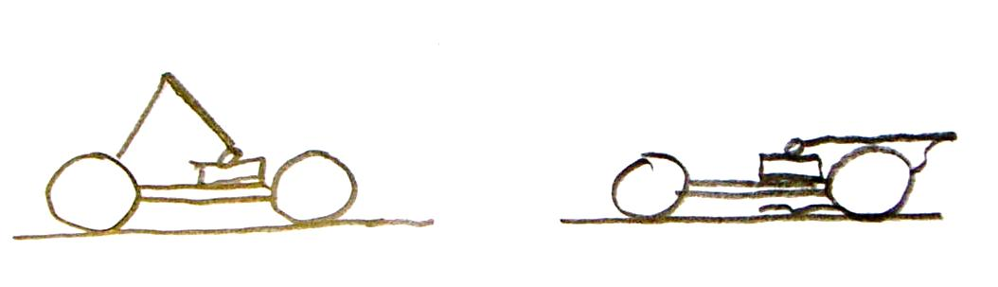

24. Explain how you can prove that someone cannot throw a feather with as much force as he or she can throw a bowling ball. Which of Newton’s Laws are you using when you do this?

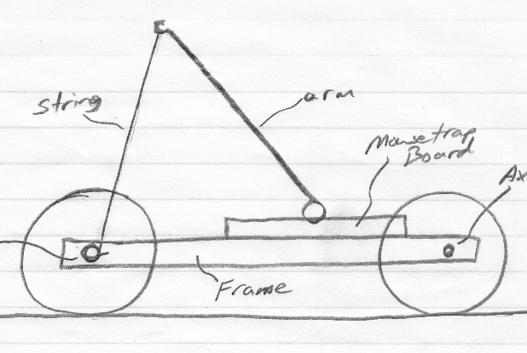

25. The car on the right will move to the left. Use Newton’s 3rd Law to explain why this happens.

26-27. The diagram on the right depicts the flight of a lightweight ball that is dropped from a tall building. The point at which the ball reaches its terminal velocity is shown as a dotted line.
Before reaching terminal velocity

Moment of Reaching Terminal Velocity

After reaching terminal velocity

26. Circle all that are true: Before the ball reaches terminal velocity…
a. Weight > Air Resistance b. Air Resistance > Weight
c. Air resistance = Weight d. Net force is downward
e. Net force is upward

27. Circle all that are true: After the ball reaches terminal velocity…
a. Weight > Air Resistance b. Air Resistance > Weight
c. Air resistance = Weight d. Net force is downward
e. Net force is upward

33-36. A 100kg ice skater and a 200 kg ice skater are standing next to one another. One of them pushes the other, causing them both to slide in opposite directions.
After
Before
33. Who moves faster after they push away?

34. How do you know?

35. Who gets pushed with more force?

36. If the 100kg skater accelerates at a rate of -4m/s² (to the left), how fast will the 200kg skater accelerate?

After
Before
37-39. Two cars collide head on. One has a mass of 2000kg, and the other has a mass of 1000kg. When they collide, they stick together.

37. When they collide, which car’s velocity changes more?

38. Explain why.

Extra practice. Each column contains information and answers for a different version of the problem...
Problems 16-22. A mousetrap-powered car is wound up and held motionless at a starting line. When the car is released, its mousetrap “motor” pushes it for a certain number of seconds. During that time, the car travels a certain distance. After the car’s motor stops pushing, the car continues to “coast” for another number of seconds. At the end of that time, the car rolls to a stop.
Distance Car Traveled  While "motor" is pushing (meters) | 9 | 8 | 5 | 17 | 12 | 10
Time for which "motor" pushes (seconds) | 3 | 2 | 8 | 4 | 25 | 1.2
Time car traveled after mousetrap motor stops pushing (seconds) | 8 | 3 | 15 | 3 | 5 | 9
Car Mass (kg) | 0.15 | 0.4 | 0.15 | 0.5 | 0.1 | 0.35
16. Average velocity while string is unwinding (m/s) | 3.000 | 4.000 | 0.625 | 4.250 | 0.480 | 8.333
17. Maximum velocity -- at end of the acceleration period (m/s) | 6.000 | 8.000 | 1.250 | 8.500 | 0.960 | 16.667
18. Acceleration while the "motor" is pushing (m/s/s) | 2.000 | 4.000 | 0.156 | 2.125 | 0.038 | 13.889
19. Net force while "motor" is pushing (N) | 0.300 | 1.600 | 0.023 | 1.063 | 0.004 | 4.861
20. Acceleration after "motor" stops pushing (m/s/s) | -0.750 | -2.667 | -0.083 | -2.833 | -0.192 | -1.852
21. Net force after "motor" stops (N) | -0.113 | -1.067 | -0.013 | -1.417 | -0.019 | -0.648
22. Force of "motor" (N) | 0.413 | 2.667 | 0.036 | 2.479 | 0.023 | 5.509

Physics
Unit 2: Newton’s Laws
Review Questions & Problems

ANSWER 1-8 AND 10-BONUS ON A SEPARATE SHEET OF PAPER. Answer #9 on this sheet.

1. Suppose the forces acting on a car are balanced. If this is true, there are only two things this car could be doing. What are they?
2. Suppose the forces acting on another car are unbalanced. In this case, there are three different things that the car could be doing. What are they?
3. Person A and Person B are floating in outer space. Person A pushes person B, and they go flying apart. Person A goes faster. Who has more inertia?
4. Define inertia.
5. Newton’s 2nd Law is F=ma. According to this law…
- What should happen to the acceleration of an object if you double the force that you are applying to it?
- What should happen to the acceleration of an object if you apply the same force, but you double the object’s mass?
- If you want accelerate something twice as fast, how much more force should you use?
- If you want an object to accelerate twice as fast when the same force is applied, what should you do to the object’s mass?
6. According to Newton’s 2nd Law, if you apply the same force, which should accelerate faster, a ping pong ball or a baseball?
7. Even if you throw a ping pong ball at a faster speed than a baseball, the baseball will travel farther. Why?
8. An ice skater is standing still on a frozen lake, holding a bowling ball. The ice skater uses a medium force to throw the ball to his left.
a. When the ball moves to the left, what happens to the ice skater?
b. Which force is stronger, the force pushing the ice skater, or the force pushing the bowling ball? Explain how you know.
c. On a different day, the same figure skater throws a ping pong ball instead of a bowling ball. And instead of applying the same medium force, he throws the ping pong ball with all his might. The ping pong ball flies away at a very high velocity, but the skater hardly moves at all. Did the skater apply more force to the bowling ball or to the ping pong ball? Explain.
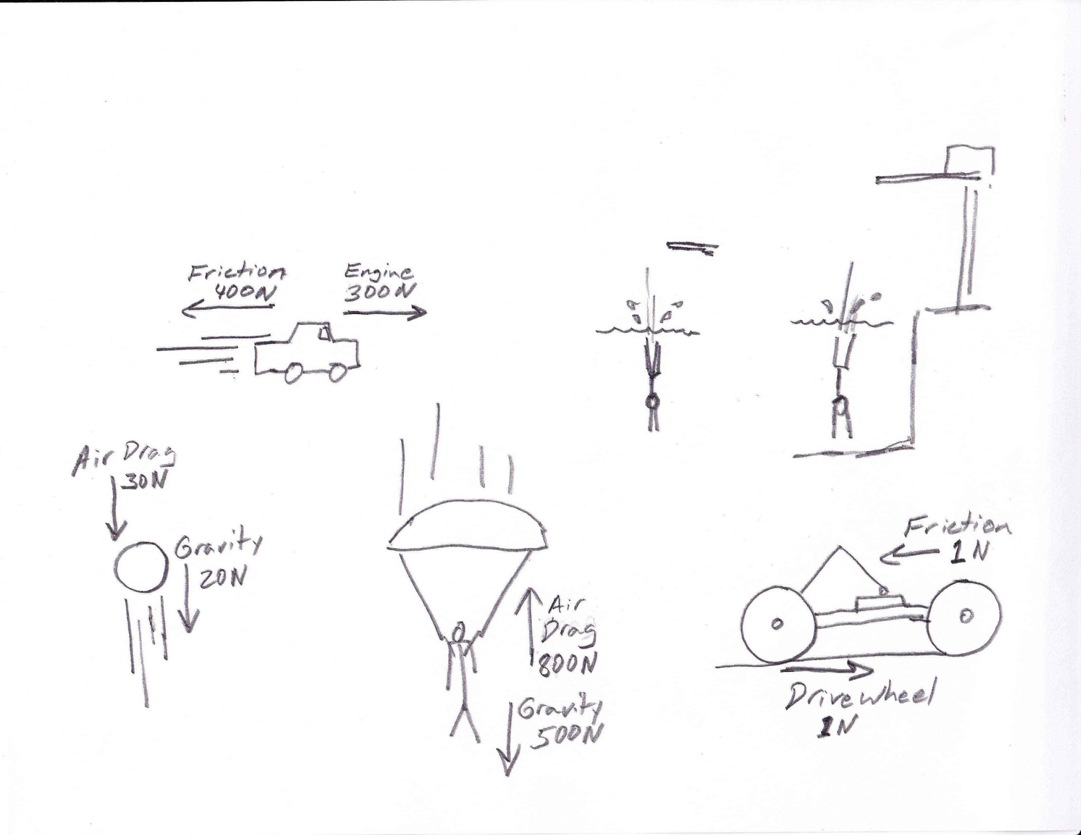
9. In the following diagrams, whenever there is a net force, use an arrow to show that force. Then label the arrow with the magnitude (# of Newtons) of that net force.

10. A 100kg man is falling from the sky. Use F=ma to calculate the weight of the man in Newtons. Remember, weight is the force of gravity, and acceleration due to gravity ≈ 10m/s².
11. A woman is falling at terminal velocity. The force of air resistance pushing her upward is 500N. How much does she weigh? Answer in Newtons, and give an approximation in pounds.
12. A driver applies her brakes to stop her car. After the brakes have been applied, the car travels its final 50m in 5 seconds. The car’s mass is 1000kg. During those last 5 seconds, what is the car’s…
a. average velocity b. Δ v c. Δ t d. acceleration e. Braking Force

13. From #12, what was the car’s velocity before the brakes were applied, in miles per hour? _________

14. A car’s engine is pushing it forward with a force of 400N. The car has a mass of 500kg, and it is moving at a constant velocity. What total force of friction (including air, axles, etc) is acting against the car?

Bonus. If that same car had an acceleration of 0.1m/s², what would the force of friction have to be?

