Physics 200 Name: ___________________________
Midterm Exam Review
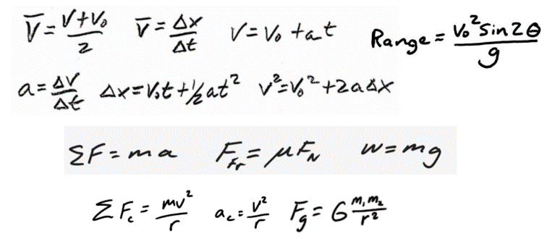
Review Problem 1

There is a new Olympic event -- the 100m 2-Woman Bobsled Jump. The mass of the USA sled itself is 170kg, and the two occupants bring the total mass to 340kg. The coefficients of friction between the steel sled runners and the ice track are µ_{s} = 0.1 and µ_{k} = 0.02. The sled is so streamlined that we can assume air resistance (drag) to be zero.

The track is sloped downhill from the start at an angle of 10° to horizontal, and there is a 10m long acceleration area where the bobsledders are allowed to push. Starting from rest, they attain a final speed of 9m/s over this 10m distance. During this time, they are opposed by a force of friction equal to 40N. At the end of the 10m section, the bobsledders jump in the sled and use gravity to accelerate along the 10° slope until they fly free of the of the track. At this point their speed has reached 30m/s. Once they leave the track, the bobsledders are in free-fall until they make contact with a horizontal bed of fluffy snow that cushions their impact. The landing zone is 100m lower than the end of the track.

This event can be separated into three phases: Phase 1: The bobsledders are pushing; Phase 2: The sled is sliding down the slope; Phase 3: The sled is in free-fall

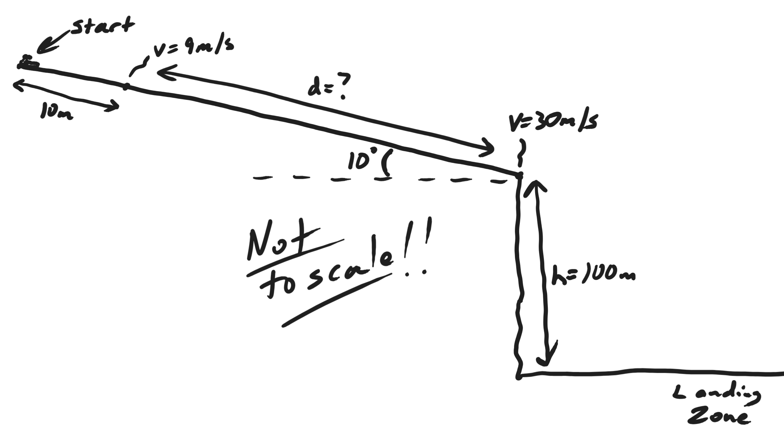

For Phase 1 (pushing):
1. Draw a diagram showing all of the individual forces, and the net force, acting on the system of the bobsledders + sled.
2. Identify one “3rd Law pair” of action and reaction forces for this phase.
3. Draw graphs of distance vs time, speed vs time, and acceleration vs. time. These graphs should represent motion parallel to the slope (not the x or y dimension). The general shapes of your graphs and the beginning and ending values must be correct.
4. Calculate the amount of force that the bobsledders need to apply initially in order to make the bobsled begin to move. Continued ↓

For Phase 2 (sliding):
5. Draw a diagram showing all of the individual forces, and the net force, acting on the system of the bobsledders + sled.
6. Identify one “3rd Law pair” of action and reaction forces for this phase.
7. Draw graphs of distance vs time, speed vs time, and acceleration vs. time. These graphs should represent motion parallel to the slope (not the x or y dimension). The general shapes of your graphs and the beginning and ending values must be correct.

For Phase 3 (free-fall):
8. Draw a diagram showing all of the individual forces, and the net force, acting on the system of the bobsledders + sled.
9. Identify one “3rd Law pair” of action and reaction forces for this phase.
10. Draw X-dimension graphs of x displacement vs time, x velocity vs time, and x acceleration vs. time. The general shapes of your graphs and the beginning and ending values must be correct.
11. Draw Y-dimension graphs of y displacement vs time, y velocity vs time, and y acceleration vs. time. The general shapes of your graphs and the beginning and ending values must be correct.
12. Draw a graph of speed vs. time. The general shape of your graphs and the beginning and ending values must be correct.
13. Calculate the angle at which the bobsled hits the horizontal landing surface.
14. On the provided diagram,
- Sketch the flight path of the bobsled
- Using a head-to-tail configuration, draw velocity vectors v, v_{x}, and v_{y} for the sled at the point where it leaves the slope. Label them with their values.
- Using a head-to-tail configuration, draw velocity vectors v, v_{x}, and v_{y} for the sled at its point of contact with the landing zone. Label them with their values.
- Show the angle of impact that you calculated in number 13.

