Physics 200 (Stapleton) Name: _____________________ School
Notes: Springs + Odds and Ends

Springs Notes:

1. We will be solving problems with two kinds of springs, _____________________ springs and _______________________ springs.

2. The spring constant (or “stiffness constant”) tells us how much force is exerted by a stretched or

compressed spring. It is represented by the letter _____, and its units are __________.

3. The force exerted by a spring with a stiffness constant k that is stretched or compressed a distance of x is…

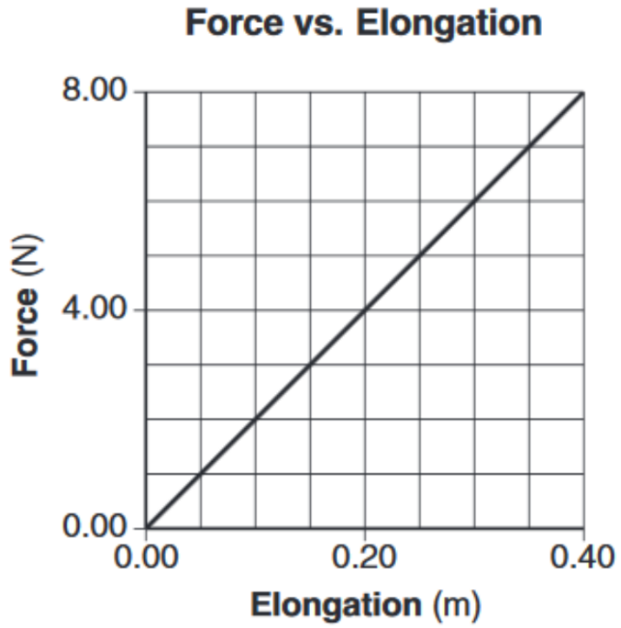

The force that must be applied to the spring to stretch it a distance x equals…

4. What is the spring constant of the spring represented by the graph on the right?

5. How much work must be done to stretch the spring from 0m of elongation to 0.4m of elongation?

6. How much work must be done to stretch or compress a spring with a spring constant of k through a distance x?

7. How much energy is stored in a spring with a spring constant of k that is stretched or compressed a distance x?

Other Forms of Energy (other than mechanical energy):

8. Law of Conservation of Energy with other energy forms (OE): KE_{i} + PE_{i} + OE_{i} = KE_{f} + PE_{f} + OE_{f}

9. List some other (non-mechanical) forms of energy

10. If you drop a tennis ball on a level surface and let it bounce until it comes to rest, what types of non-conservative work and other energy might be involved in this process?

W_{nc} :

OE_{f} :

Electrical Energy Units:

11. The so-called power company sells us energy, not power. The unit that they use for the energy that they sell is the kiloWatt-hour (kWh).

Describe a kiloWatt-hour:

How many joules equals one kiloWatt-hour?

12. Green Mountain Power sells some of their energy at a rate of $0.169/kWh. At this rate, how much does it cost to leave a 10W LED lightbulb turned on for an entire week?

Efficiency: Ratio of output energy to input energy, usually expressed as a percentage.

% Efficiency =

13. Starting from rest, a 10kg ‘possum climbs 5m up a tree and stops at that point, using 1000J of energy in the process. How efficient was this event?

Practice Problems:

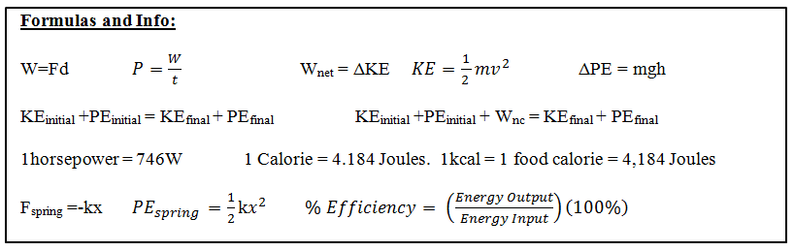

Part 1: Springs

1. Consider an ideal compression spring with k=300N/m. How much force is required to compress the spring a distance of 5cm?

2. How much energy is stored in the spring above when it is compressed 5cm.

3. An ideal extension spring of negligible mass is hanging from a ceiling. One end of the spring is attached to the ceiling, and the other end is pointing downward. A 50g object is added to the bottom of the unstretched spring and the object is then released. The object stretches the spring downward, bobs around for a while, and comes to rest with the spring stretched 20cm beyond its original length.
a. How much energy is stored in the spring after the object comes to rest?
b. What is the spring’s k?
c. Now the 50g object is attached to the end of the spring, raised upward nearer the ceiling, and released. The object falls to a low point and then bounces back up. When the object is at its low point, the spring is stretched 80cm beyond its original length. How far did the object fall before bouncing back upward?

4. A water rocket’s water thrust phase lasts for 0.05 seconds. During this time, the rocket travels upward 0.85m with an average thrust of 400N.
a. How much work is done by the rocket during the water thrust phase?
b. What is the average power output of the rocket during this phase, in Watts? In horsepower?

5. Gravity does work on a falling human. Describe the conditions under which gravity does work on a falling 50kg human at a rate of 1 horsepower.

6. Mt. Everest is 8,848m above sea level, and an average waffle offers about 82,000 calories. Considering only the vertical travel that must take place, how many waffles must a 150 pound human eat in order to climb from sea level to the top of Mt. Everest? Assume that the human’s conversion of waffle energy to mechanical energy is 30%.

7. A 200hp sports car has a mass of 1,600kg. The car accelerates using all 200hp for 6 seconds. Then the driver releases the accelerator and hits the brakes, skidding to a stop. The car’s µ_{s} = 0.8 and it’s µ_{k} = 0.5.
a. What is the car’s speed after 6 seconds?
b. How far does the car skid?

8. Is a car’s stopping distance directly proportional to its velocity or is it directly proportional to its kinetic energy? Why?

9. The frictionless roller coaster in the diagram below has a mass of 500 kg. The coaster is pulled up to point 1 where it is released from rest. Assuming that total energy is conserved, complete the empty elements in the chart below.
Good Stuff

1 km = 1000 m
1 hour = 3600 s
1 mile = 1609 m
W = Fdcosθ
KE = ½ mv²
PE_{g} = mgh
PE_{s} = ½ kx²
P = W/t
F = - kx

Position | Height (m) | Total Energy (J) | Potential Energy (J) | Kinetic Energy (J) | Velocity (m/s)
1 | 35.0 |  |  |  | 0
2 | 0.0
3 | 28.0
4 | 15.0
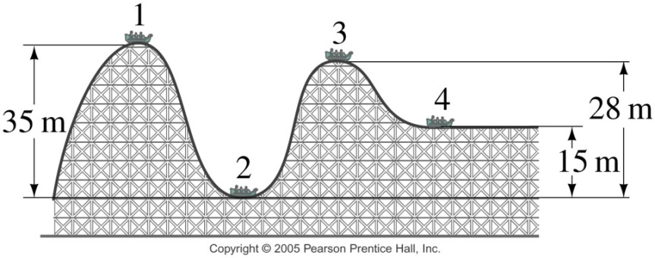

10. A 20kg child slides down a 7m long slide which is inclined to horizontal at a 37° angle.

a. What is the child’s KE at the end of the slide?

b. What is the child’s velocity at the end of the slide?

11. A child creates a homemade bow with the force curve shown on the right. The graph shows how the force applied to the bow string changes as the child pulls it back to the full draw distance of 0.5m.

a. How much work is done in drawing the bow?

b. If the bow is 60% efficient, how much energy will the arrow have when it leaves bow?

c. If the child wants to shoot an arrow with a velocity of 30m/s, what arrow mass should be used?

