Physics 200 (Stapleton) Name: _______________________________
18-19 Practice Quiz: Work and Energy

Formulas and Info:

W=Fd $P=\frac{W}{t}$ W_{net} = ΔKE $KE=\frac{1}{2 }mv^{2}$ PE = mgh

KE_{initial} +PE_{initial} = KE_{final} + PE_{final} KE_{initial} +PE_{initial} + W_{nc} = KE_{final} + PE_{final}

1horsepower = 746W

1. Quincy drags a piece of furniture a distance of 5m from the end of someone’s driveway to the back of her Subaru. If she applies a constant force of 240N, how much work has she done?

2. When Quincy gets home, she uses an electric winch to lift the piece of furniture into her barn loft. The total energy consumed is 3,000 J. If Quincy pays $0.17 per kwh for her electricity, how much does it cost her to lift the item into the barn loft?

3. A 2,000kg truck with an initial KE of 500,000J speeds up to 25m/s over a time interval of 5 seconds.

a. What is the truck’s final kinetic energy?

b. How much work did the truck do as it accelerated?

c. What average power, in Watts, did the truck produce during those 5 seconds?

d. What average power, in horsepower, did the truck produce during those 5 seconds?

4. A 0.3kg apple is hanging at rest on a branch 4m from the ground. The apple suddenly comes loose and falls toward the ground.

a. How much Potential energy does the apple have when it is 1m from the ground?

b. How much Kinetic energy does the apple have at that point?

5. Hans pushes a curling stone. If Hans applies a constant 0.5N force at the angle shown, how much work is done on the curling stone as Hans pushes it 4m to the left?

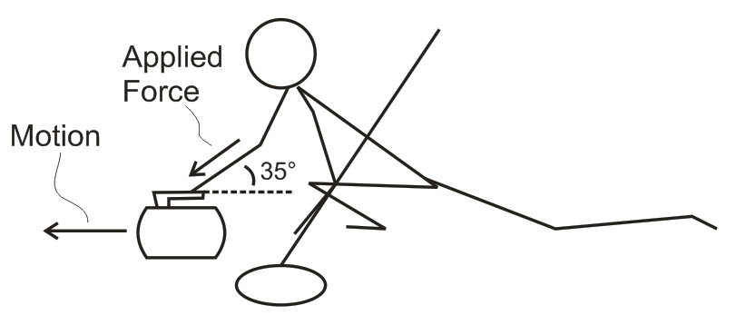

6. A 400kg roller coaster cart is launched by a spring with k=2,000N/m. Before launching the coaster, the spring is compressed a distance of 4m. For most of the coaster’s ride, friction is negligible, but for the 60m between points C and D (which are at equal heights), a constant braking force of 500N is applied. At points B and D the coaster’s speed is 3m/s. Fill in the table below with the correct values. For the table, base your PE values on the zero height shown in the diagram.
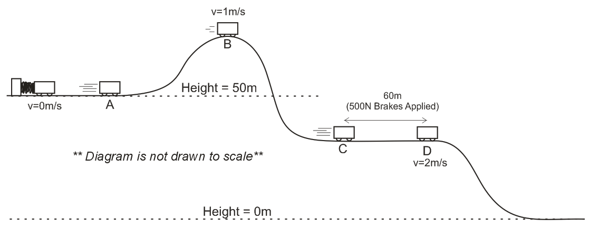

Position | Height | PE | KE | V | Total E
A | 50
B |  |  |  | 3m/s
C
D |  |  |  | 3m/s

