Physics 200 (Stapleton) Name: ______________________

Notes: Waves and Sound, Part 1

Give some examples of waves.

Transverse and Longitudinal Waves

A. A transverse wave (a.k.a. shear wave, sinusoidal wave) is a disturbance ______________________ to the direction of propagation.

B. A longitudinal wave (or compressional wave) is a disturbance ______________________ to the direction of propagation.

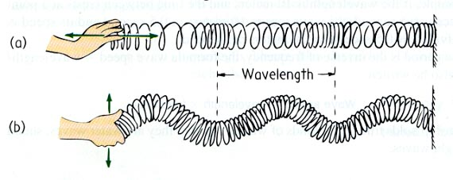Types and parts of waves:

Identify the two different types of waves on the right.

Parts of a longitudinal wave: compression, rarefaction, wavelength



What determines the amplitude of a longitudinal wave?

Formation of a sound wave (longitudinal wave, a.k.a. compression wave)

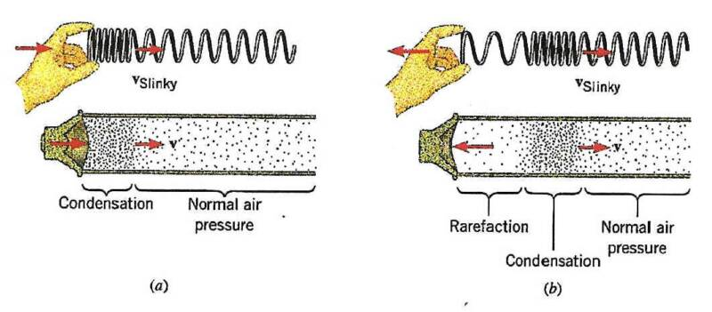

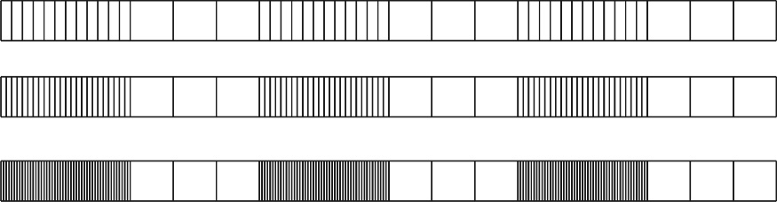

Which of the series of waves on the right shows the greatest amplitude?

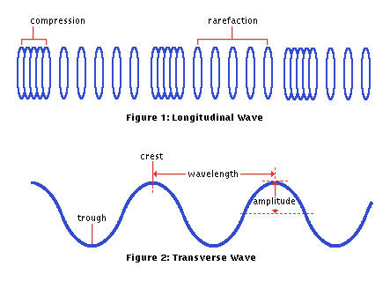

Sound waves are longitudinal, but they can be represented as transverse waves:

Reviewing Interference:

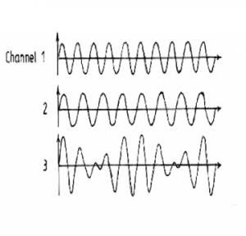Wave Interference can cause “**beats**”. When two waves have slightly different frequencies, their interference alternates between constructive and destructive. The diagram below shows transverse representations of two sound waves (channels 1 and 2) and their resultant sound (channel 3).

* In the diagram, label the channel with the highest frequency (1 or 2).
* Then label regions of constructive and destructive interference. Channel 3 is the “sum” of channels 1 and 2.
* Label the “beats” that will be heard

**Beat frequency =difference in frequencies of two notes that are played together**

Example: What is the beat frequency when 220Hz and 216Hz are played at the same time? _______

**Standing Waves Revisited:**

What are the rules for drawing standing waves?

1.

2. If an end is free to move, it is a(n) _________________. If an end is fixed, it is a(n) __________________.

Draw a vibrating string with the combinations of nodes and antinodes below. Label the free and fixed ends.

* 3 nodes, 2 antinodes
* 4 nodes, 4 antinodes
* 2 nodes, 3 antinodes

**Standing Sound Waves in a Tube**

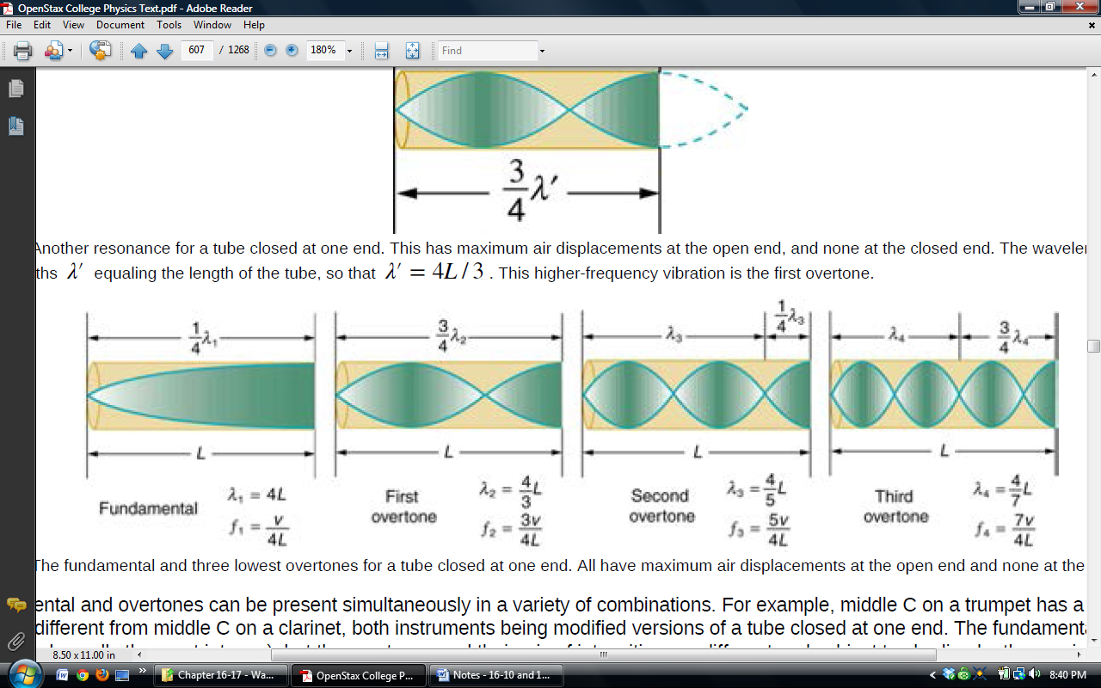Wavelengths and Harmonics in a tube **open at one end** (e.g. an organ pipe)

1. How are waves in an organ pipe different than waves on a string?

2. The diagram above represents the organ pipe waves as transverse waves. In reality, they are longitudinal. What is really happening to air molecules at the antinodes?

3. At the nodes, what are the air molecules doing?

4. For the fundamental, explain why there is a node at the left end and an antinode at the right?

5. Draw the fundamental for a pipe that is closed at both ends. How much of a wavelength does the pipe length represent?

6. For each harmonic above, write an equation for wavelength in terms of tube length.

7. Label any harmonics according to the order of the harmonic (i.e. 1st harmonic, 2nd harmonic, 3rd harmonic…). The lowest frequency harmonic is the **1st harmonic (a.k.a fundamental)**. The **nth harmonic** has a wavelength that is equal to the fundamental wavelength/n.

8. Label the harmonics using the term “overtone,” rather than the term harmonic.

**Resonance Lab**

**Purpose:** To measure the speed of sound using a tuning fork and resonating tube.

**Setup:**



1 ruler 1 meter stick

1 large graduated cylinder 1 thermometer

1 white PVC pipe 1 512 Hz tuning fork $v=fλ$

**Procedure:**

1. Measure the air temperature. Record this in the data table.

2. Calculate the speed of sound. Record this in the data table.

**512 Hz First harmonic (n = 1)**

3. Fill your graduated cylinder almost, but not quite, full of water with the white PVC pipe inside the cylinder. *NOTE: Do not overflow the water.*

4. Strike your 512 Hz tuning fork on one of the green rubber striking blocks. Hold it over the PVC pipe and slowly lift the pipe out of the water until your hear the resonance from the first harmonic.

5. At resonance, measure the length of the PVC pipe that is above water level, L, with the meter stick. Record this measurement in meters in the data table. *Note: Be sure to measure up from the level of the water, not from the top of the graduated cylinder.*

6. Now calculate the wavelength of the sound waves when the first harmonic was produced by the 512 Hz tuning fork. Record this in the data table.

7. Next calculate the experimental speed of sound using the formula v = f where  is the wavelength calculated above in 6 above and f is the frequency of the tuning fork in Hz. Record this in the data table.

8. Finally, calculate the % error in your measurement of the speed of sound compare to the calculated speed of sound. Use the formula % error = 100% . Record this in the data table. Remember that % error can be either + or – !

**512 Hz Third Harmonic (n = 3)**

1. Strike your 512 Hz tuning fork on one of the green rubber striking blocks. Hold it over the PVC pipe and slowly lift the pipe out of the water past the first harmonic until you hear the next resonance. This is the third harmonic. Repeat steps 5-8 above. Record your results in the second column of the data table.

**Another First Harmonic (n = 1)**

2. Get a tuning fork with another frequency that is not 512 Hz. Record its frequency at the top of the third column in the table below. Repeat steps 6-9 above. Record your results in the third column of the data table.

**Data Tables:**

|  |  |
| --- | --- |
| T = room temp | oC |
| vactual (calculated from equation) | m/s |

|  |  |  |  |
| --- | --- | --- | --- |
|  | f = 512 Hz  1st harmonic  n = 1 | f = 512 Hz  3rd harmonic  n = 3 | f = ____ Hz  1st harmonic  n = 1 |
| Lobserved |  |  |  |
| ● |  |  |  |
| Vobserved |  |  |  |
| % error = 100% $×\frac{(\operatorname{observed}{-}actual)}{actual}$ |  |  |  |

**Analysis Questions:**

**Choose one of these answers for each of the questions below.**

A. increase B. decrease C. stay the same

Use the equations we have used in class to help you answer these questions.

_____1.If you decrease the frequency of a tuning fork, what will happen to its wavelength in air at a given temperature (i.e. at a given speed of sound)?

_____2. If you decrease the frequency of a tuning fork, what will happen to the speed of its sound waves at a given temperature?

_____3. If you decrease the frequency of a tuning fork, what will happen to the value of L for its first harmonic for a given diameter tube?

_____4. If you decrease the temperature of the air, what will happen to the speed of the sound waves made by the tuning fork?

_____5. If you decrease the temperature of the air, what will happen to the wavelength of the sound waves made by the tuning fork?

6. How do we know that the first resonant frequency that you hear is the fundamental?

7. As you pull the pipe from the water, you first hear the first harmonic. Next you hear the 3rd harmonic. Why did you not hear a 2nd harmonic? Use a drawing to explain.