Physics 200 Name: _________________________________
Instrument Project Notes: Piano and String Instrument Notes and Major Keys

1. On a piano keyboard, the keys get higher in pitch as you travel to the _____________ (left or right?).

2. Each key on a piano keyboard, whether it is black or white, is separated from the next key by exactly one

_______________ step.

3. On a piano keyboard, the white keys are the notes (A, B, C, D,E, F, and G) and the black keys are called sharps (#) or flats(♭). The black key adjacent and to the right of an A is an A __________. The black key adjacent and to the left of an A is an A____________.

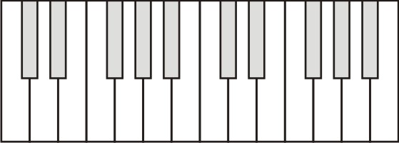
4. Label 13 consecutive piano keys with their note names. For the darkened keys, give either the sharp name or the flat name.

5. If you play all of these notes, from low to high, you are playing what is called a

_____________________________________________

7. Which note letters do not have black key sharps?

8. Which note letters do not have black key flats?

9. If you start on an A, how many half-steps would you have to travel to end on the next E, moving up in pitch? _______

10. Starting from D♭, how many half steps higher is the next F#? ________

11. A major key scale has the following pattern of whole and half steps: __________________________

12. The only major key scale that can be played without using any black keys is the _______ Major scale.

13. Show the keys of a 1-octave C major scale.

14. Show the keys of a 1-octave (8 note) A major scale.

15. Why bother with different kinds of keys? Why not make them all the same color and size?
Playing major keys on String Instruments:

16. The diagram below shows an idealized string instrument with frets. The bold line down the middle represents the string.
a. Label the locations of the nut and the bridge.
b. What is the pattern of whole and half steps for a major scale?

c. Suppose you want to play a 1-octave (8 note) major key scale, starting with the open string, below. For each note in the scale, darken the fret that represents the end of the vibrating portion of the string.
d. In order to play this scale, where do you press on the string with your fingers?

17. Show a different combination of frets that will produce a 1-octave (8 note) major key scale by darkening the appropriate frets.

Practice Questions:
1. How many notes are played in a 1-octave scale?
2. How many half steps separate two notes that are an octave apart?
3. What major key can be played on a piano without using any black keys?
4. Darken the keys of a 1-octave B-major scale.

5. Darken the positions where you would hold down the string to play a 1-octave major scale, starting at the circled fret.

