Physics 200 (Stapleton) Name: _______________________
Newton’s Laws (in 1-D) Practice Test

Conceptual Questions (mostly):
Formulas:

$$∆x=x-x_{0}$$

$$v_{x Ave.}=\frac{∆x}{∆t}$$

$$a=\frac{∆v}{∆t}$$

$$∆x=\frac{1}{2}\left(v_{x0 }+v_{x}\right)t$$

$$v_{x}=v_{x0 }+at$$

$$∆x=v_{x0 }t+ \frac{1}{2}at^{2}$$

$${v_{x}}^{2}= {v_{0x}}^{2}+2a(∆x)$$

$${∑F=F}_{NET}=ma$$

$$w=mg$$

$$F_{f}=µF_{N}$$

$$g=9.8\frac{m}{s^{2}}$$

1. According to Newton, for every action there is an equal and opposite reaction. When an object freefalls toward the Earth, what could be considered to be the action? What could be the reaction?

Action:

Reaction:

2. When a bullet is shot from a gun, the bullet moves very fast in one direction while the gun moves much more slowly in the other direction. According to Newton, actions and reactions are equal and opposite. In what sense is the bullet’s action equal to the gun’s reaction?

3. You’re floating freely in outer space, and you have two seemingly identical boxes – box A and box B. Although the boxes look the same, one has much more mass than the other. Describe a test you could conduct in order to figure out which box has more mass, and explain how the results of the test would be different for the two boxes.

4. A 1,000kg car is traveling to our right with a constant velocity. The car is being propelled by a 3,000N motor force. Draw a diagram showing the car itself and all of the significant forces that are acting on the car. Represent each force as an arrow labeled with the name of the force and the correct magnitude.

5. A small child and a team of Austrian weightlifters are fighting over a sturdy scarf. The child is pulling on one end, and the weightlifters are pulling on the other end. Neither side will let go. As you might expect, the child is being taken for quite a ride. Which end of the scarf has the most tension? Explain why.

6-8. Objects falling through the atmosphere accelerate until they reach a terminal velocity. The table below provides a timeline detailing a base jumper’s descent after jumping off of a very high platform. This table contains important information about the jumper’s two terminal velocities.

Time | Event
0s | Jumper steps off of platform
10s | Jumper reaches a terminal velocity of -55m/s
90s | Jumper pulls chute cord. Parachute deploys.
98s | Jumper reaches a new terminal velocity of -3m/s
120s | Jumper’s feet touch down
121s | Jumper comes to rest

6. Draw a diagram showing the forces acting on an object that is falling at terminal velocity. Label the forces with reasonable magnitudes.

7. On the graph below, create a rough sketch showing how the jumper’s acceleration changed over time. Only the initial acceleration needs to have the proper value. You are not expected to calculate actual accelerations. **The time axis is clearly out of proportion.

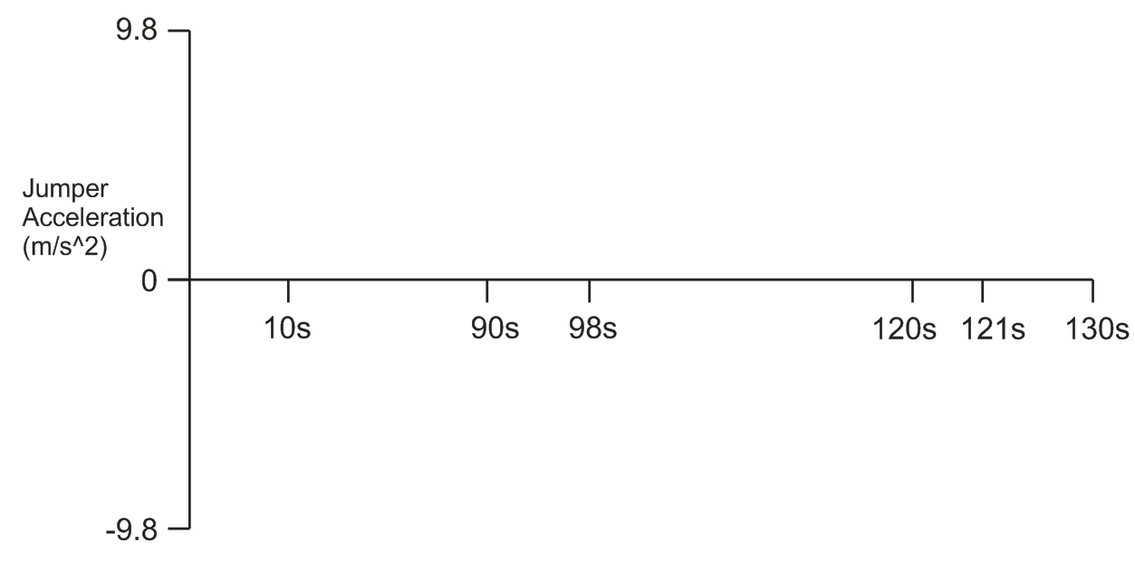

8. On the graph above, indicate every time period when the net force exerted on the jumper was zero.

Problems:

1. What is the weight of an 80kg astronaut on the surface of Uranus, where the acceleration due to gravity is 10.67g?

2. A 4kg box is sitting motionless on a table. What force is the table exerting on the box?

3. A 2.5kg quadcopter is accelerating upward at a rate of 2m/s². What force is being generated by the quadcopter’s propellers?

4. A 70kg porpoise is hanging motionless from a rope with a breaking strenth of 900N. Using the rope, Gunter wants to lift the porpoise 5 meters in as short a time as possible (without breaking the rope). Assuming that Gunter can generate enough power, what is the shortest possible time in which this could be done without breaking the rope?

5. Fred’s actual weight is 800N. Fred is standing on a bathroom scale in a helicopter. Fred wants the scale to read 1,100N. What specific instructions should Fred give the pilot regarding how to fly the helicopter so that the scale will read 1,100N?

6. A child pushes a 0.4kg sled, causing it to slide across a horizontal floor. The accelerating force of 9N, which is applied horizontally by the child, ends abruptly as the sled passes the 0.1m mark. When the accelerating force stops (i.e. when the child releases the sled) the sled continues to slide across the floor, but it slows down and eventually comes to rest. The sled’s coefficient of kinetic friction on this surface is µ_{k} = 0.6.

a. What is the sled’s weight?

b. What force of friction is acting on the sled as it accelerates?

c. What net force is acting on the sled while it is being pushed by the child?

d. What is the acceleration of the sled over this distance?

e. What is the sled’s maximum velocity?

f. What net force acts on the sled as it decelerates?

g. What is the sled’s acceleration as it slows to a stop?

h. How far does the sled travel during its deceleration period?

7. The diagram below shows three masses connected by two segments of massless rope. One segment passes over a frictionless pulley. The coefficient of kinetic friction of the upper masses on the surface is µ_{k} = 0.2,
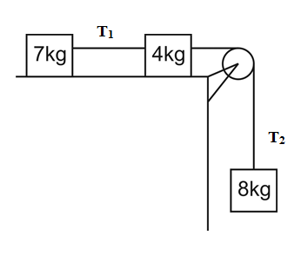
a. Find the acceleration of the objects.

b. What are the tensions in the two segments of rope?

