Physics 200 Name: ___________________________
Notes – 10.3 Dynamics of Rotational Motion: Rotational Inertia

1. A door opens more slowly if you push it closer to its hinges. The door will also open more slowly if it is more massive. From a torque and angular acceleration standpoint, the ______________ the applied force and the ______________ it is applied from the pivot point (the rotational axis), the greater the angular acceleration. The angular acceleration is ______________ proportional to mass. These relationships are analogous to the familiar relationships of force, mass, and acceleration.

2. Starting with Newton’s 2nd Law, derive an expression for torque t in terms of mass m, lever arm r and angular acceleration α (and introduce I – “Rotational Inertia” or “moment of inertia”)

3. Compare Newton’s second law for linear motion and rotational motion.

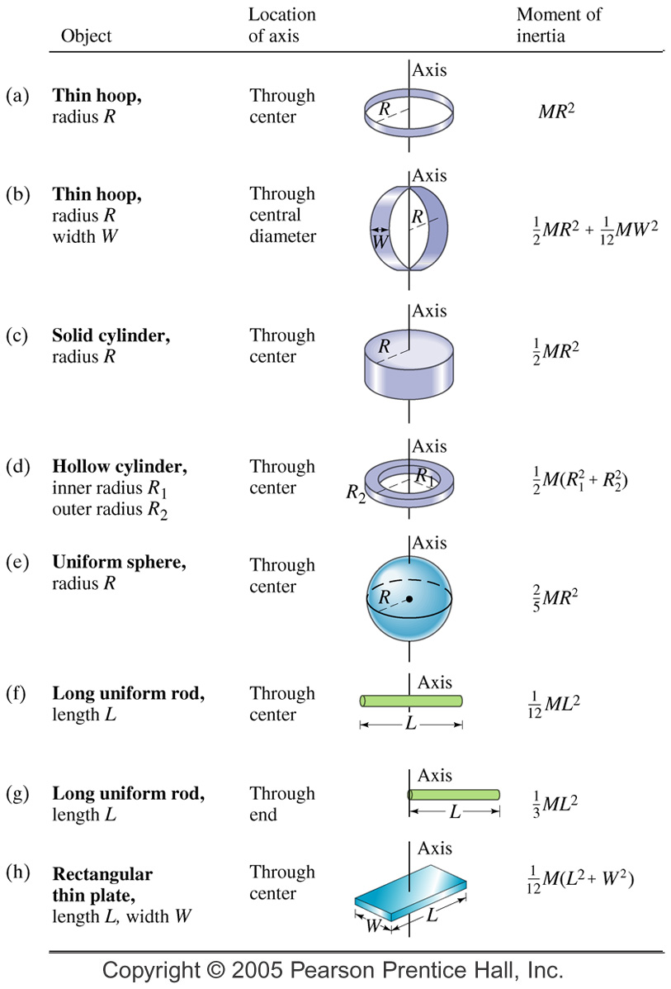

4. The two definitions of torque:

5. Rotational Inertia (I) of Various Objects

A. A single point mass:

B. Multiple point masses:

C. Other shapes – see chart
Practice 10.3: Rotational Dynamics

3. Calculate the rotational inertia of a solid sphere of mass M = 5.0 kg and a radius of R = 0.25 m.

4. Calculate the rotational inertia of a solid cylinder of mass M = 2.0 kg and a radius of R = 0.075 m about its central axis.

5. Suppose you exert a force of 180 N tangential to a 0.280-m-radius 75.0-kg grindstone (a solid disk).
A. What torque is exerted?

B. What is the angular acceleration assuming negligible opposing friction?

C. What is the angular acceleration if there is an opposing frictional force of 20.0 N exerted 1.50 cm from the axis?

Answers:
1. 0.733 s 2. A. 440 m B. 25.1 rad/s, 8.77 m/s 3. 0.13 kg m² 4. 5.6 x 10⁻³ kg m²
5. A. 50.4 N.m B. 17.1 rad/s² C. 17.0 rad/s²

Notes – 10.4 Rotational Kinetic Energy

1. Starting with the linear (or tangential) kinetic energy formula, derive a formula for the rotational kinetic energy of a single mass m, with a velocity v, revolving around an axis at a radius r. The formula should be in terms of I and ω.

2. Calculate the final speed of a solid cylinder that rolls down a 2.00-m-high incline. The cylinder starts from rest, has a mass of 0.750 kg, and has a radius of 4.00 cm.

4. Calculate the final speed of a hoop of the same radius (4cm) that is allowed to roll down an incline of the same height (2m)

5. Compare the speeds of thin hoops and solid cylinders, in general, after rolling down ramps (assuming the objects’ radii and the ramp heights are identical, and that there is no friction).

Practice – 10.4 Rotational Kinetic Energy

1. What is the final velocity of a 1.00 kg hoop starting from rest that rolls without slipping down a hill 5.00 meters high?

2. What is the final velocity of a 1.0 kg solid disk/cylinder starting from rest that rolls without slipping down a hill 5.00 meters high?

3. Calculate the rotational kinetic energy of Earth on its axis. Assume the Earth is a uniform solid sphere of mass M = 5.97 x 10²⁴ kg and a radius R = 6371 km.

4. What is the rotational kinetic energy of Earth in its orbit around the Sun? M = 5.97 x 10²⁴ kg and R = 150 million kilometers.

5. A ball with an initial velocity of 8.00 m/s rolls up a hill without slipping. Treating the ball as a spherical shell, calculate the vertical height it reaches.

Answers:
1. 7.00 m/s 2. 8.08 m/s 3. 2.56 x 10²⁹ J 4. 2.66 x 10³³ J 5. 5.44 m

