Sunny Day Stuff Names (up to 3): ___________________________________________
Physics 200 (Stapleton)

Materials: ruler, calculator, pencil, extra paper, protractor (optional), a thicker and a thinner convex lens, parabolic mirror

1. Draw a picture showing how a convex lens focuses at least two rays to a focal point. Make sure that your drawing obeys the law of refraction at all times.

2. Use a ruler and the sun to find the focal length of your two lenses. Place them in the appropriate bin when you’re done.

Thinner Lens = ________ Thicker Lens = ________

3. Draw a picture showing how a parabolic mirror focuses the sun’s rays to a focal point. Make sure that your drawing obeys the law of reflection at all times.

4. Measure the focal length of the parabolic mirror.

Focal length = ________

5. Suppose you’re building a solar oven, and you want to capture an area of sunlight that is 4x greater than the surface area of your oven’s window. Specifically, all of the rays passing through a 2m wide area must hit a 0.5m wide window, as shown below. Use the law of reflection and the fact that sun rays are essentially parallel to find the minimum height (h, in diagram below) of the reflector panels. For that value of h, give the value of Θ. Show and/or explain your work.
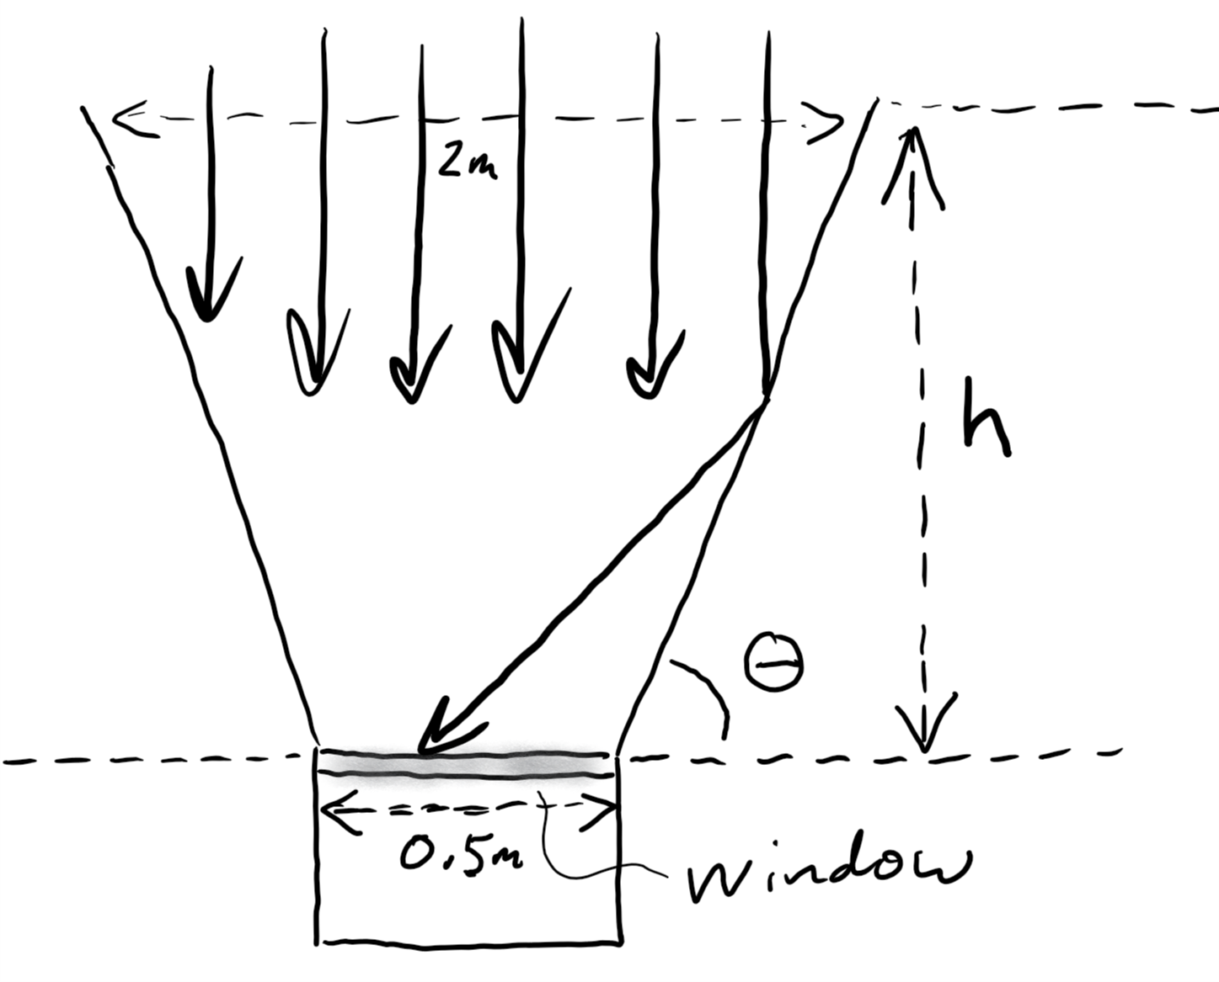

Minimum value of h = _________

Θ for this value of h = _________

