Physics 200 Name: _________________________
Masses Hanging and Dragged at Angles – Newton’s Laws in 2 Dimensions
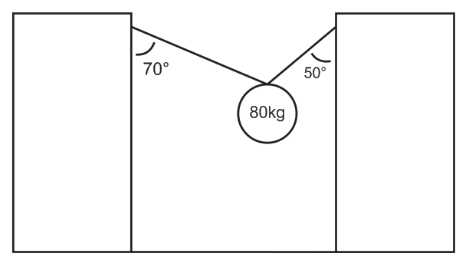
1. The 80kg mass is in static equilibrium. Find the tensions in the two segments of rope.

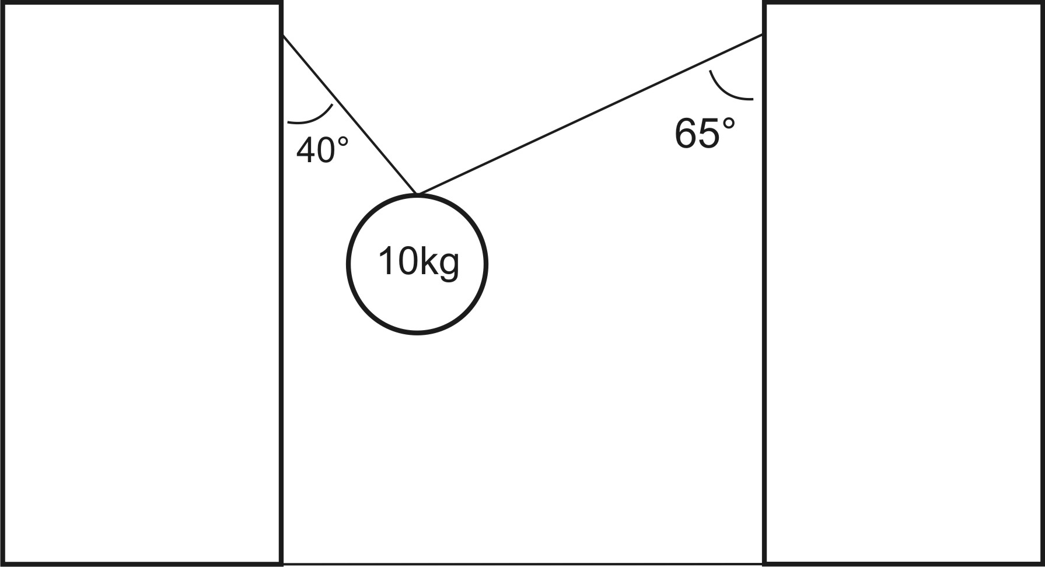
2. The 10kg mass is in static equilibrium. Find the tensions in the two segments of rope.
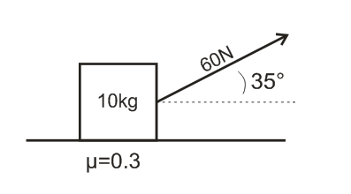
3. A 10kg mass is being accelerated horizontally by the tension in a rope that is attached to the mass as shown. Find the acceleration of the 10 kg mass.

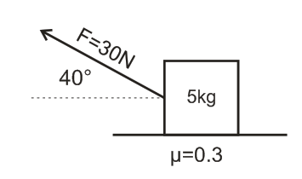
4. A 5kg mass is being accelerated horizontally by the tension in a rope that is attached to the mass as shown. Find the acceleration of the 8kg mass.

