Newton Sled Activity Names: _____________________________________________________
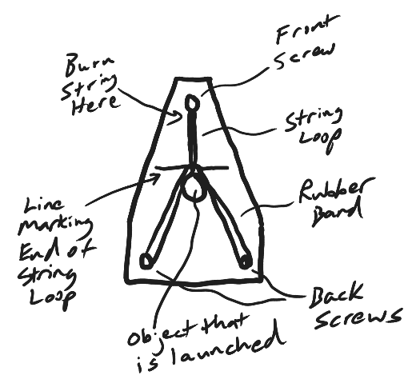
Directions:
Launch all of the items below by burning loops of string to release the stretched rubber bands. Use the same number of rubber bands every time. Make a reference mark so that you can stretch the rubber bands the same distance every time. In general, make sure that every launch happens in the same way. The only manipulated variable should be the object that is launched. Fill out the data table as you go. Then answer the questions. When you complete the launch of the Earth, collect the additional data below.

Object Launched | Sled travel distance (m) | Launched Object travel distance (or subjective description of its speed)
200g mass
500g mass
Ping pong ball
Entire Earth

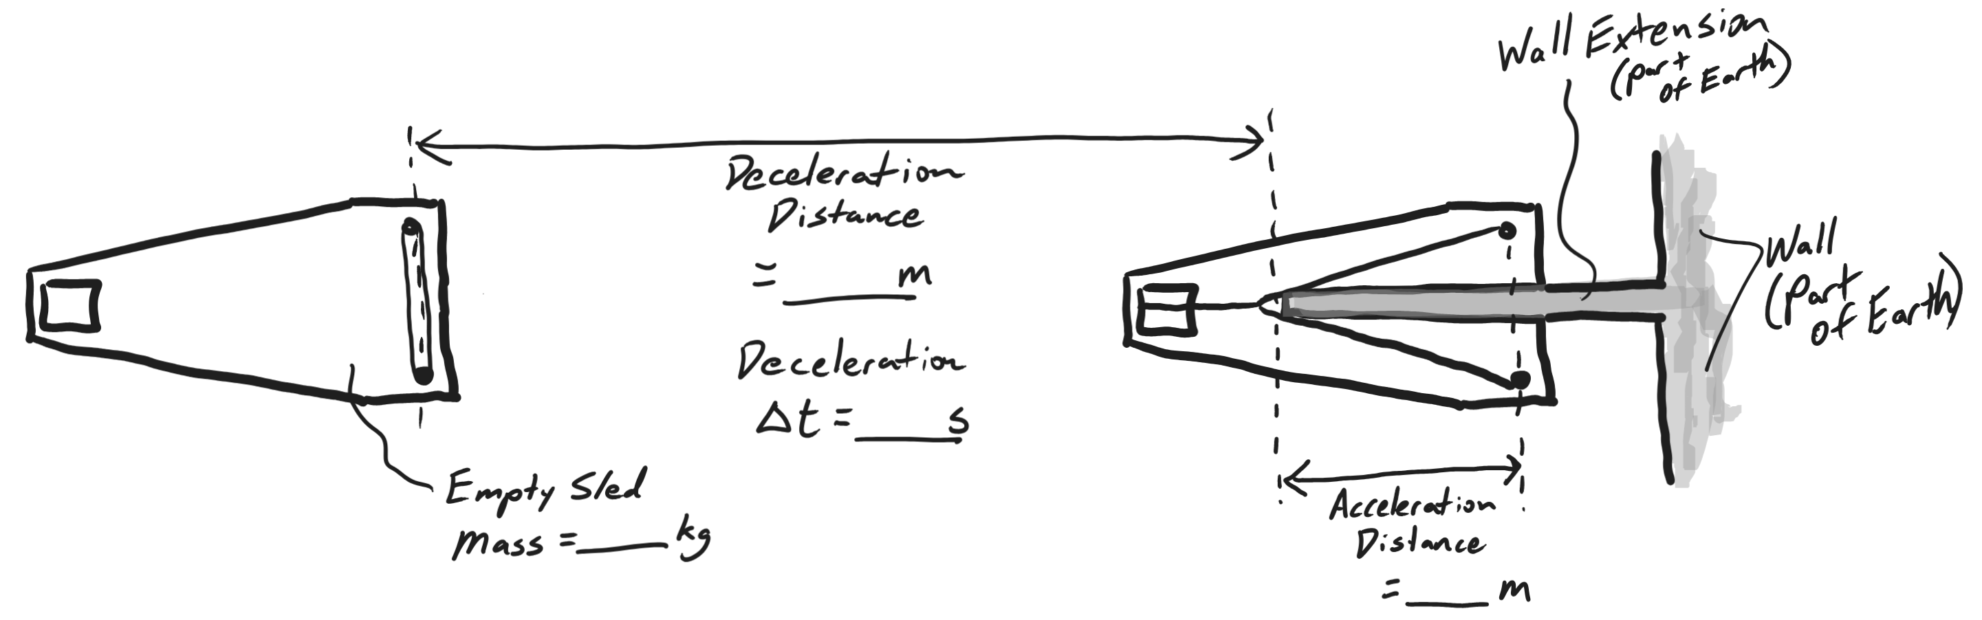
- When the ping pong ball is launched, what gets pushed with a greater force, the sled or the ping-pong ball? Explain your reasoning.

- When the entire Earth is launched, what gets pushed with a greater force, the sled or the Earth? Explain how you can tell.

- Out of all of the items that you launched, which one experienced the most force? ___________________

Which one experienced the least force? __________________

How can you tell?

- Explain how this activity demonstrates F_{net}=ma. Cite specific examples.

- Newton’s 1st Law uses the term “unbalanced.” It says that “objects in motion remain in motion, in a straight line and at a constant speed, and objects at rest stay at rest, unless acted upon by an unbalanced (net) force.”
  - Before, during or after an object’s launch, when are the forces on the object balanced, and when are they unbalanced?
  - For each of these times, explain how you can tell.

- Use the knowledge that the Earth’s mass is 5.972x10²⁴kg, along with data from your Earth launch to…
  - Calculate the acceleration of the sled during the Earth launch deceleration period.

a_{deceleration} = __________

  - Calculate the force of friction exerted on the sled by the floor.

F_{friction} = _________

  - Calculate the accelerations of the sled and the Earth during the Earth launchacceleration period.

a_{acceleration of sled} = _________ a_{acceleration of Earth} = _________

