Physics 200 (Stapleton) Name: _________________________
Newton’s Laws in 1 Dimension
Notes: 1st and 2nd Laws

Net force (F_{net}):
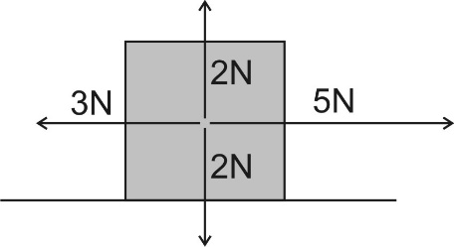

What is the net force that is acting on the box to the right?

Normal Force:

Newton’s 1st Law:

- Usual version: Objects in motion remain in motion in a straight line and at a constant speed, and objects at rest stay at rest, unless they are acted upon by an outside (or unbalanced) force.

- Simpler version:

If there is no net force acting on an object (i.e. any applied forces are balanced), what might that object be doing? What are the options?

What are the options for what an object might be doing if there is a net force acting on an object?

Newton's 1st Law is called the "Law of Inertia." Inertia is:

What kinds of objects have the most inertia?

The basic metric unit of force is the ______________. 1 ______ ≈ 0.224 pounds.
Newton's 2nd Law:

Mass:

The unit we will use for Mass = ________________________, which is abbreviated _________

On Earth, a 1kg mass weighs about 9.8 Newtons or about 2.2 pounds.

Weight:

Primary strategy for solving problems in this unit:

1.

2.

3.

Calculating forces using Newton's 2nd law:

1. A 91N net force is applied to an object. If the object accelerates at a rate of 8m/s², what is the object’s mass?

2. A 1,200kg car is being acted upon by two forces. The car’s motor is providing a 1,000N rightward force, and friction is providing a 300N leftward force. What is the car’s acceleration?

3. A bowling ball is sitting motionless on the ground. The ground is applying a 49N upward force to the bowling ball. What is the bowling ball’s mass?

