Physics 200 (Stapleton) Name: __________________________
Newton’s Laws in 1-D 20-21 Practice Problems

For each of these problems, draw a diagram showing all of the forces acting on the bold object. Label each force with its value and name. If this does not answer the question, continue to solve the stated problem.

1. A 20kg rock is hanging from a rope. If the tension in the rope is 120N, what is the acceleration of the rock?

2. [requires two separate diagrams – one for motionless elevator; one for accelerating elevator]
A child stands on a bathroom scale in a motionless elevator, and the scale reads 200N. What will the scale read if the elevator accelerates upward at 1.3m/s² (assuming that the child continues standing on the scale)?

3. A rocket accelerates directly upward at a constant rate. It starts from rest and ascends the first 20m in 3 seconds. An astronaut is standing in the rocket and accelerating along with it. If the rocket pushes against the astronaut with a force of 855N during this time period, what is the astronaut’s mass?

4. A 70kg scout is standing in a canoe, while the canoe travels leftward at a rate of 4m/s. A paddler brings the canoe (and, therefore, the scout) to a stop over a distance of 15m. What force is applied to the scout during this time period?

5. What horizontal force does Bev need to apply to a 6kg block in order to accelerate the block at a rate of -3m/s², if µ_{k} = 0.35?

6. If Bev must apply a 15N horizontal force to a 6kg block in order to move the block at a constant speed of 6m/s, what is µ_{k}?

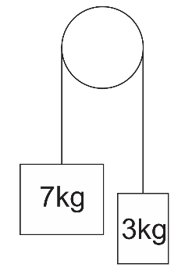
7. Some runners are racing on an extremely slippery floor (µ_{s} = 0.015). Starting from rest, what is the shortest amount of time in which one of the runners can run a distance of 10m?

8. For the diagram on the right, find the tension in the string and the acceleration of each mass.

9. For the diagram below, find the accelerations of the masse and the tension in each string. Note that µ_{k} = 0.2

