Physics 200 (Stapleton) Name: _______________________
Some more practice for Test #3
Formulas:

$$∆x=x-x_{0}$$

$$v_{x Ave.}=\frac{∆x}{∆t}$$

$$a=\frac{∆v}{∆t}$$

$$∆x=\frac{1}{2}\left(v_{x0 }+v_{x}\right)t$$

$$v_{x}=v_{x0 }+at$$

$$∆x=v_{x0 }t+ \frac{1}{2}at^{2}$$

$${v_{x}}^{2}= {v_{0x}}^{2}+2a(∆x)$$

$${∑F=F}_{NET}=ma$$

$$w=mg$$

$$F_{f}=µF_{N}$$

$$g=9.8\frac{m}{s^{2}}$$

1. A 1kg car is traveling to our right on a level surface. There is no engine, and no one is pushing the car, so the car is slowing down. The rate of deceleration is constant. Every second, the car’s velocity is 1m/s slower than the second before. Draw a free-body diagram showing the car itself and all of the significant forces that are acting on the car. Represent each force as an arrow labeled with an appropriate name of the force, the correct magnitude of the force, and the correct units.

2. Before the car above began to slow down, a child was pushing it rightward with a force of 3 N. Create another diagram showing all of the individual forces (and the net force) acting on the car while the child was pushing.

3. Starting from rest, a driver accelerates a car leftward at the car’s maximum possible rate. When the driver reaches 50mph, he sees a deer and hits the brakes, slowing to 30mph. He then continues with maximum acceleration until he reaches the car’s top speed, which he maintains for 20 seconds before hitting a tree and coming to an abrupt stop. Sketch a graph of net force vs time. The “system” that you are analyzing here could be either the car, the driver, or both.
4. The first table, below, is a timeline detailing a parachuter’s descent from an airplane. The second table is an incomplete analysis of mass, forces, and acceleration relating to the parachuter’s fall. Use the timeline and your knowledge of physics to complete the second table. Pay close attention to the times in the second table. Most of them do not coincide with the times in the first table, but you can still use the first table to complete the analysis for those times. Before you go too far, it would be prudent to first identify the times in the second table at which the parachuter has reached terminal velocity.

Time | Event
0s | Parachuter steps out of plane
10s | Parachuter reaches a first terminal velocity of -55m/s
90s | Parachuter pulls chute cord. Chute deploys.
98s | Parachuter reaches a second terminal velocity of -3m/s
500s | Parachuter lands

Time | Parachuter Mass | Parachuter Weight | Force of Drag | Net Force | Acceleration | Velocity
0s | 100kg
5s |  |  | 500N Upward |  |  | -35 m/s
80s
97s |  |  | 1200N Upward |  |  | -5m/s
300s

Problems:

1. What is the mass of an astronaut who weighs 600 pounds on the surface of Jupiter, where g_{jupiter} = 24.8m/s²?

2. A 60kg box is being pushed horizontally across a floor. The box is accelerating at a rate of 2m/s², and the coefficient of sliding friction of the box on this surface is µ_{k} = 0.4.

a. What normal force is the floor applying to the box?

b. What friction force is acting on the box?

c. What force is the student applying to the box?

3. A 60kg skydiver is falling from an airplane, accelerating upward at a rate of 7m/s². What is the force of air resistance that is acting on the skydiver at this time?

4. A Finn jumps off of a cliff while holding on to a rope that is tied to a bunch of helium balloons. As the Finn descends, the tension in the rope 500N. The mass of the Finn is 80kg. Ignoring air resistance, how long will it take the Finn to reach the valley floor, 300m below?

5. Charlene is standing on a bathroom scale in a motionless elevator, and the scale reads 600N. The elevator begins to descend, traveling upward with an acceleration of 3m/s² downward.

a. What is Charlene’s mass?

b. What does the scale read, in Newtons, as it accelerates upward?

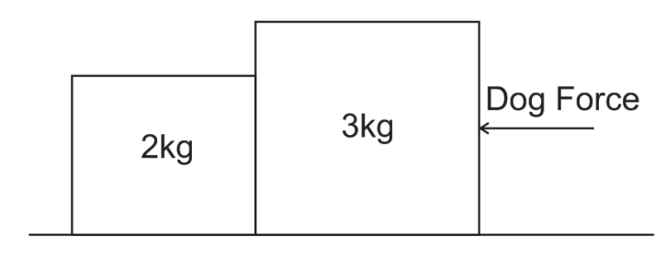
6. Two blocks are sitting on a surface with a µ_{s} = 0.4. A dog nudges the two blocks leftward by pushing the rightmost block with its nose. If the blocks are moving leftward at a constant velocity, what is the contact force between the two blocks?

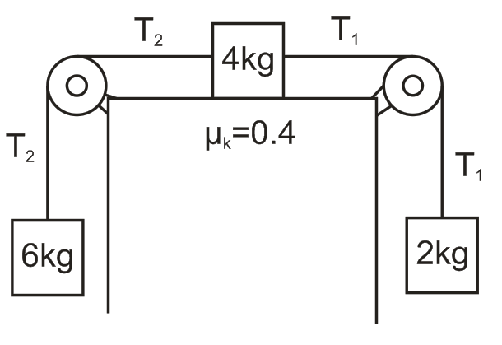

7. The diagram below shows three masses connected by two segments of massless rope. The pulleys are massless and frictionless. The coefficient of kinetic friction of the upper mass on the surface is µ_{k} = 0.4.

a. Find the acceleration of the objects.

b. What is tension T₁?

c. What is tension T₂?

