Physics 200 (Stapleton) Name: ____________________________
Momentum Notes and Ballistic Pendulums

Notes - 8.3 Conservation of Momentum

1. Write the conservation of momentum principle for 2 objects in an isolated (closed) system.

2. An isolated system is defined to be one in which the net external force = _________.

3. Note that from F_{net} = Δp/Δt, when F_{net} = 0 then Δp_{Tot} = __________ (i.e. the total momentum is constant).

Notes - 8.4 & 8.5 Elastic and Inelastic Collisions

1. All collisions conserve momentum. An elastic collision is one that also conserves

_________________________.

2. How is an inelastic collision different from an elastic collision?

3. When a collision is inelastic (not elastic), where does the “lost” kinetic energy go?

4. Give some examples of nearly elastic collisions between macroscopic objects.

Ballistic Pendulums

Formulas: $KE=\frac{1}{2}mv^{2}$ $p=mv$ $PE=mgh$ $m_{i}v_{i}= m_{i}v_{i}$
Impulse = Ft = Δp

Consider the system below, which includes a ballistic pendulum (box) and a projectile (circle). Assuming that the string supports of the pendulum have negligible friction, and assuming that air resistance is also negligible…

…when is momentum conserved? Why?

…when is momentum not conserved? Why?

…when is KE conserved? Why?

…when is KE not conserved? Why?

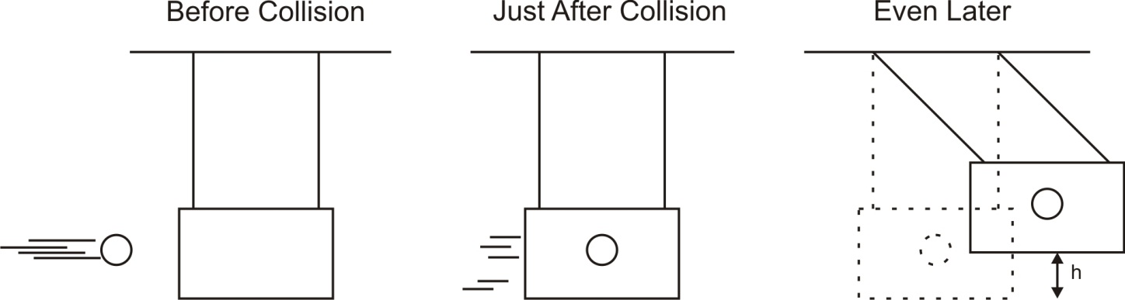

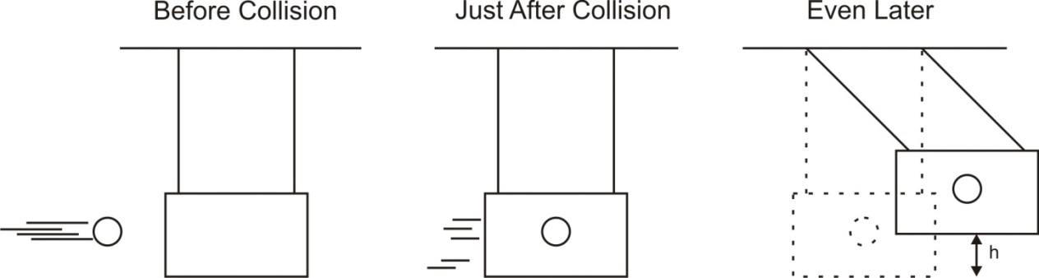

 | Launch 1
Projectile Mass (kg) | 0.01
Pendulum Mass (kg) | 1
Swing Height, “h” (m) | 0.5

Answer the following questions using “launch 1” data. Complete the rest on your own.
1. What is the total potential energy of the ball and pendulum in the “even later” picture?

2. What was the total kinetic energy of the ball and pendulum in the “just after” picture?

3. What was the shared velocity of the ball and pendulum in the “just after” picture?

4. What was the net momentum of the ball and pendulum in the “just after” picture?

5. What was the momentum of the ball before the collision?

6. What was the velocity of the ball before the collision?

7. Prove that this was an inelastic collision.

For launch 2 and your launch, find the projectile’s initial velocity and ΔKE. The questions that follow are included for guidance.
 | Launch 2 | Your Launch
Projectile Mass (kg) | 0.5
Pendulum Mass (kg) | 0.02
Swing Height, “h” (m) | 0.4
Projectile Initial Velocity (m/s)
ΔKE during collision (J)
Impulse (N•s)

Launch 2:
1. What is the total potential energy of the ball and pendulum in the “even later” picture?
2. What was the total kinetic energy of the ball and pendulum in the “just after” picture?
3. What was the shared velocity of the ball and pendulum in the “just after” picture?
4. What was the net momentum of the ball and pendulum in the “just after” picture?
5. What was the momentum of the ball before the collision?
6. What was the velocity of the ball before the collision?
7. What was the projectile’s ΔKE during the collision?
8. What impulse was imparted to the target by the projectile?

Your Launch:
1. What is the total potential energy of the ball and pendulum in the “even later” picture?
2. What was the total kinetic energy of the ball and pendulum in the “just after” picture?
3. What was the shared velocity of the ball and pendulum in the “just after” picture?
4. What was the net momentum of the ball and pendulum in the “just after” picture?
5. What was the momentum of the ball before the collision?
6. What was the velocity of the ball before the collision?
7. What was the projectile’s ΔKE during the collision?
8. What impulse was imparted to the target by the projectile?

