Physics 200
Instrument Construction Directions

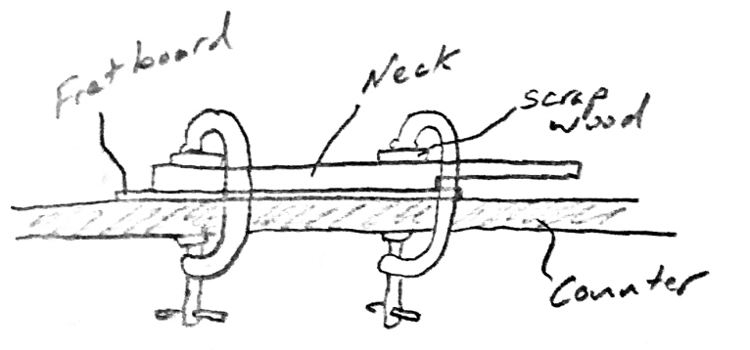
Day 3

- Glue the fret board to the neck
  - With the proper overhang on the body end of the neck, glue the fret board to the neck.
  - Use clamps for at least 15 minutes. Place the fretboard top-down along the edge of a lab table. Place the neck on top of the fret board. Place two pieces of scrap wood on top of the neck, and compress tightly with C-clamps that touch only the table top and scrap wood. The scrap wood prevents the clamps from damaging your instrument neck.
  - Use more clamps if necessary.
- In D104:
  - Cut the sound hole(s).
    - Remove the masking tape.
    - Mark the exact center of your body top (lightly, in pencil)
    - Place the body on the laser cutter bed in landscape orientation, so that the red dot is on the center of your box. Align the body edges with the grid.
    - Confirm the bed height with the dangling metal stick. If necessary, adjust the bed height.
    - Close the lid and press GO.
  - Use the belt sander to sand the body edges and the front of the peg box.
    - Rest your instrument body on the platform in front of the sanding belt. The belt will pull your instrument downward, so resting it on the platform will keep it stable.
    - Sand the edges and corners of your instrument body. Don’t overdo it! Don’t sand the faces of your instrument body with the belt sander!
    - Sand the front (stair step) edge of your peg box. Following the stair step contour, sand until the surface is planar. It is very important that the surface is perfectly planar, rather than concave or convex.
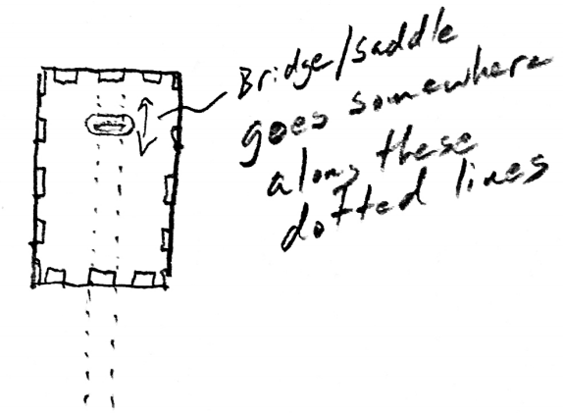
- Determine your bridge/saddle placement.
  - I do this by thumping or tapping the top of my instrument until I have found a location that gives a nice, loud sound. My assumption is that this is the most efficient place to transmit waves from the strings to the body. However, the loudest spot is probably not the strongest spot. Therefore, if you are using steel strings or 6 strings, you may have too much string tension for this location. In that case, you might want to move the bridge closer to the edge of the instrument body.
  - Use a pencil to make a mark to represent the future position of your bridge. This will be the endpoint of your vibrating string.
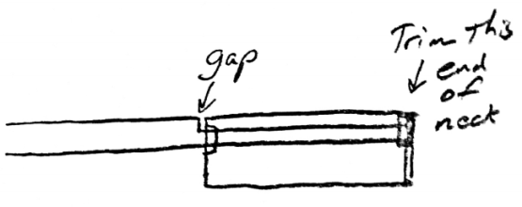
- Trim the body end (not the peg box end) of your instrument neck.
  - Insert the neck all of the way through your instrument, so that the end fits into the internal support. This is a little bit of a hassle.
  - When it is finally seated, you will probably notice a gap between the neck and the body. If this is the case, you will need to cut off a little bit of the neck tip, so that the neck sits flush with the body. Measure the gap. Then remove the neck and cut off a length equal to or slightly greater than that gap.
- Decide on your instrument’s scale length. A standard ukulele (and a 4/4 violin) has a scale length of about 13”. A concert ukulele has a scale length of 15”. A standard mandolin scale length is 13 7/8”. A viola scale length is about 14 ½”.
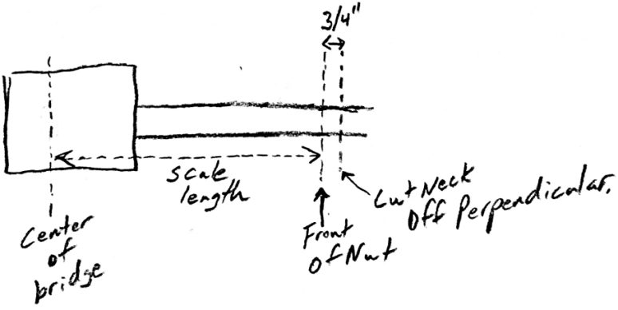
- Measure one scale length from your bridge mark and make a pencil mark on your fret board. This will be the front of the nut. Make another mark ¾” inches behind the nut (opposite the bridge). This is where you will cut off the neck.
- Make the cut perpendicular to neck length.
- Back to D104 for more sanding:
  - Make sure that the end of your neck surface is planar, so that you can securely glue the peg box to it. You may want to use the belt sander to make it perfectly planar. Hold your peg box next to this surface to make sure that both surfaces are planar, and that they match properly. Remember that the peg box should be at an angle to the neck.
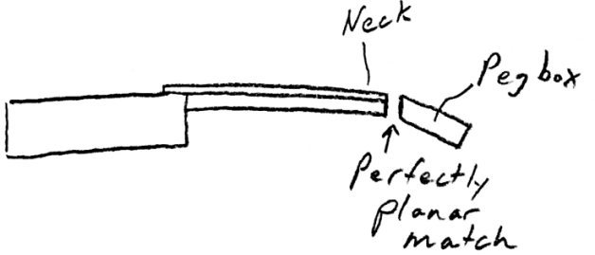
  - Finishing the neck:
    - If the edges of the neck and fret board are not aligned, you can use a plane to shave them off evenly. You can also use the belt sander for this.
    - If you want to sculpt the neck (e.g. make it thinner near the peg box), do that now.
    - This is also the best time to sand the neck. You can use the belt sander today.
- Attach the Peg Box
  - Glue the peg box to the neck. Use tape to hold it firmly in place. For the first few minutes, you should probably stand up the neck so that the peg box doesn’t shift.
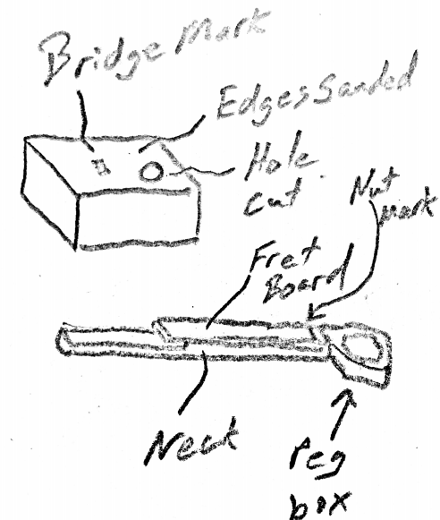
  - The weakest part of your instrument will be the junction between the peg box and the neck. If you want to add strength to that joint, wait until the glue cures. Then glue an additional thin strip of wood across the joint. You can also wait to see if it breaks, and add the strip later if it does.
- At this point, you should have a body with a hole (or holes) cut in it, sanded edges, and a mark for the bridge location. Your neck should still be detached from the body, but it should have a fret board, a mark for the nut, and a glued-on peg box.
- Show your fretboard to Mr. Stapleton, so that he can confirm that it is flat enough to add your frets. If your fretboard is not flat enough, there is still time to plane or sand it.
- Final sanding
  - If anything needs more sanding, now is the time to do it. Do your sanding in D104.
  - Use the finish sander (orbital “palm” sander) for fine sanding. Use the belt sander to remove larger amounts of material.
  - Upon request, you may use the Dremel for small amounts of sanding.
- Create a shallow channel for the nut.
Mark the edges of the channel with pencil
  - Prop up the neck so that its weight does not rest on the peg box. Then carefully cut in on your marks with a coping saw. Stop sawing when the back of the blade is flush with the fret board surface.
  - Use a chisel to “twist out” the material between your cuts.
Insert the nut. Adjust as necessary.
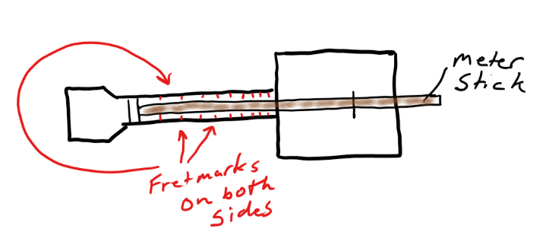
- Mark the fret positions. Measure (in centimeters) the distance between the front edge of the nut to the bridge mark.
  - Calculate your fret placements based on this distance.
  - Confirm that these numbers make sense by making sure that the 12th fret is half-way between the nut and the bridge.
  - Tape a meter stick to your fret board, so that zero cm is at the front of the nut.
  - In pencil, mark each location on both sides of the fret board. Make sure that an imaginary line between opposite fret marks would be perpendicular to the length of the neck.
  - Try to have at least 12 frets, but stop marking frets before you reach the body of the instrument.
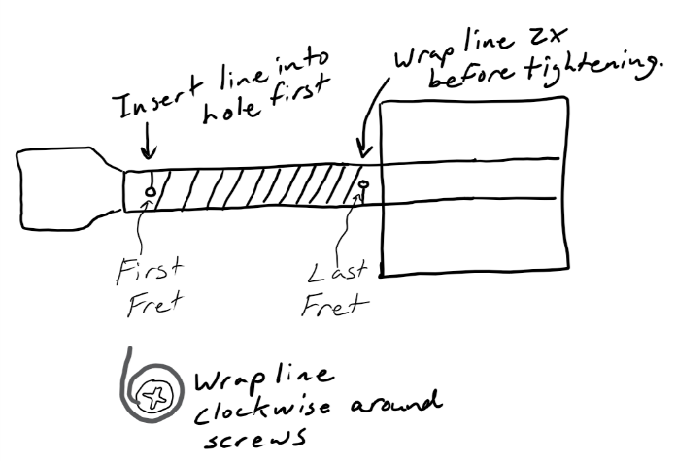
  - Using scissors, or a file, make small notches where each of your pencil marks meets the corner of the fret board.
- Attach the fret “wire”. This is actually 100 pound fishing line that is on the fishing reel. Drill two 1/2” deep holes that are smaller than 1/8” in diameter.
    - The first hole goes on the back of the neck, beneath the first fret.
    - The second hole goes on the back of the neck, beneath the last fret.
  - Using a phillips bit in an electric driver, ream out the entry to each hole. This creates a countersink for a screw.
  - Use a manual screwdriver to screw a ½’ screw into each hole. Push hard, but stop when the screw is fully seated. If you keep going, you will strip the wood.
  - Remove the screw that is under the first fret. Leave the other screw in, but back it out at least half way.
  - Calculate the length of fishing line that you will need for the frets; then add 30%. (You’ll need about 6’ for a 12 fret ukulele).
  - Remove the proper length of fishing line from the reel. Make sure that you don’t have a knot in your segment!
  - Insert one end of the line through one of the 4 special sticks of hardwood. Tie at least two tight knots about an inch from the end, so that the line won’t pull back through the wood.
  - Insert the other end of the line into the hole that you drilled near the nut. Holding that line in the hole, screw a screw into the same hole about 2/3 of the way in. Wrap the fishing line clockwise around the screw once or twice, and screw the screw in the rest of the way, pushing hard.
  - With a partner holding the hardwood end of the line, stretch out the line until there is a lot of tension between you. Keeping the peg box to your left, wrap the fret line around the neck, making sure that it seats in the fret notches that you made.
  - After you have finished the first full revolution, it is important to apply a LOT of tension. The frets must be completely flat on the fretboard. This is 100# line. You won’t break it.
  - As you wind the string, check to make sure that the frets are flat against the fret board. If they’re not, unwind them and then rewind them with more tension.
  - After you finish the last fret, maintain tension and wrap (clockwise) your string twice around the last screw. Maintaining lighter tension, screw in the last screw, pushing hard.
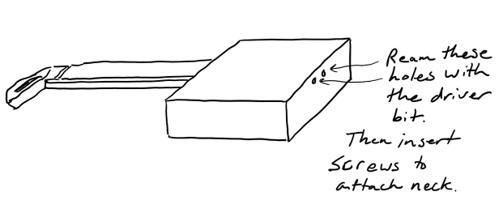
- Attach the neck.
  - Use a driver bit in reverse to ream out the body holes through which you will attach the neck.
  - Insert the neck into the body using glue. Once the neck is fully seated, screw the body to the neck through.
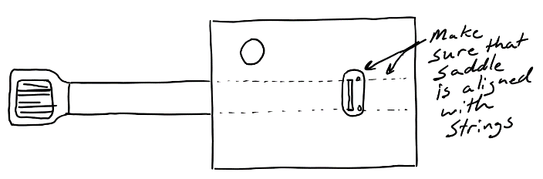
- Add the saddle.
  - Position the saddle so that the bridge slot is correctly located on the mark that you made. The ends of the strings will go through the holes in the saddle. Make sure that the saddle is positioned so that the strings will run straight down the neck. Tape down the saddle or have someone hold it securely in place for you.
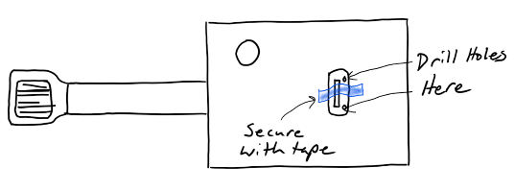
  - Use one of the saddle holes as a template to drill a 1/8” hole through the instrument top.
  - Insert a pop rivet (but don’t tighten it) through the hole that you just drilled, so that one end of the saddle is held in place. Then reorient the saddle and drill the other hole.
  - Glue the saddle pieces to themselves and to the body top, and then use the rivet gun to firmly attach the saddle with pop rivets.
- Add the tuners
  - Get four tuner screws, four plastic tuners, and four pairs of wooden knob parts (one wooden circle with a D-shaped hole, and one with a circular hole). [If you have the black tuners with no notches, you should cut notches in them, either using the scroll saw or a coping saw.]
  - Glue each of the four pairs of wooden knob parts together, matching a D-hole piece with each circular hole piece.
  - Use the scroll saw to cut off the extra (pointy) piece from the peg box (if you haven’t already done so).
  - Use a file to remove any sharp burrs from the head of the tuning screws.
  - Insert the tuning screws into their wooden knob parts. If you want, add some hot glue to keep the screws in place. Back a screw out of the wooden knob just a hair. Then squirt a tiny blob under the screw head and quickly (before the glue cools) insert the screw into its spot in the wooden knob.
  - Pop a plastic tuner into a groove in the peg box, as close to the instrument body as you can get it. If it’s the green kind, point the bumps away from the instrument body.
  - Insert a screw through the back of the peg box and into the plastic tuner. You won’t be able to get it all of the way in.
  - Using an electric driver with a phillips bit, insert the screw into the plastic tuner. To do this, grip the peg box firmly with one hand, holding down the plastic tuner with your thumb. Don’t torque the peg box, or you may break it off of the neck. Run the driver backward and forward until you have made the plastic tuner slide to the back of the peg box and then forward to the front of the peg box again. Leave it at the front of the peg box (nearest the body).
  - Repeat with the other tuners.
- Add the strings (ukulele) [*metal strings will require a special anchor piece. Ask Mr. Stapleton for one.]
  - If you are looking at your instrument with the neck pointing to your left, the string order (from nearest to you to farthest from you) is 40#, 80#, 60#, 40#. Cut four strings that are about 25% longer than your scale length.
  - For each string…
    - Pass one end of the string through its hole in the saddle. Tie some really big knots in the end of it, so that it won’t pull back through the hole.
    - Stretch the other end past the plastic tuner. Tie a large knot in the string so that the knot barely reaches the slot in its corresponding tuner.
    - Floss the string through the slot in the tuner, so that the knot will catch when the tuner is tightened.
    - Tighten the tuner, but not all of the way – for now.
    - Repeat with the other strings
  - Insert the bridge and the nut.
  - Tighten the strings and decide whether or not you need to alter the nut or bridge.
- Adjust the Nut and Bridge:
    - Adjusting the Nut:
      - Each string should be very close, to the first fret, but it should not touch the first fret.
      - The easiest way to make strings lower is to cut deeper grooves in the nut (use a red “junior hacksaw”).
      - Later, if your grooves are so deep that they look silly, you can go to D104 and sand off the top of the nut.
    - Adjusting the bridge:
      - Ideally, the strings should be as close as possible to the entire fret board, but their height should increase as they approach the bridge.
      - In the beginning, are no grooves in the bridge. You will need to make your own. You may want to space them more widely than the nut grooves. This will give you more room to pick individual strings at the strumming end of the string.
- Tune your instrument.
  - Typical Ukulele Tuning (GCEA): with the neck pointing to your left, the nearest string should be a G. The next should go down to the next C. Then up to E and up to A. You may be familiar with the “my dog has fleas” sound. There are a lot of tuning apps. Download a free app and go to a quiet place to tune.
  - In the beginning, you may want to use a cordless drill.
  - Ukulele strings stretch a lot in the first day! You will have to constantly retighten them. After a couple of days they should require much less tuning.
  - You may run out of room on the tuning screws. If that happens, loosen the string and tie a new knot closer to the plastic tuner to shorten the string. Then re-tighten.

