**Physics 200 (Stapleton) Name: _______________________________________**

**2017-2018 Final Exam Review**

**All of the questions and problems in this review come from 2nd semester tests.**

**Rotational Motion**

s = r v = r a = r

❑ = ot + ½t2 2 = o2 + 2(f – i)  = o + t

⧫ = rF = I L = rp = rmv L = I Li = Lf Iii = Iff

KErot = ½I2 KEtrans = 1/2mv2  PEgrav = mgh PEi + KEi = PEf + KEf

**Momentum and Impulse:**

$p=mv$ $F∆t=∆p$ $P_{i}=P_{f}$ $m_{1}v_{1}+m_{2}v_{2}= m_{1}v_{1}^{'}+m_{2}v_{2}^{'}$

**Electric Charge and Electric Field**

qelectron = -1.6x10-19C F=qE k = 8.99x109Nm2/C2

F=ma w = mg v = v0 + at vf2 = v02 + 2ax Fcentripetal = mv2/r

**Electric Current and Circuits**

R = ρL/A    V=IR    P=VI    I=ΔQ/Δt Qelectron = 1.6 x 10-19C

**Waves and Sound**

 v = f Vsound in air ≈331.4 + 0.6TC d = vt fo = fs

**Optics ??**

vmedium =  c = 3.00 x 108 m/s

incidence = reflection n1 sin 1 = n2 sin 2

**Test 1: Rotational Motion**

1. With the same non-zero clockwise torque applied, if an object's rotational inertia is decreased, its angular acceleration

A. increases. B. decreases. C. stays the same.

2. The torque applied to a bolt that is stuck can be increased by all of the following except:

A. increasing the length of the lever arm. B. decreasing the rotational inertia of the bolt

C. changing the direction of the force to be perpendicular to the lever arm. D. increasing the magnitude of the applied force.

3. The units of angular velocity are

A. kg m2 B. rad C. rad/sD. rad/s2 E. N.m

4. The units of rotational inertia are

A. kg m2 B. rad C. rad/s D. rad/s2 E. N.m

6. In an effort to tighten a bolt, a force **F** is applied as shown in the figure below. If the distance from the end of the wrench to the center of the bolt is 40 cm and F = 8 N, what is the magnitude of the torque produced by **F**?

A. 0.00 N.m

B. 0.2 N.m

C. 0.5 N.m

D. 3.2 N.m

E. 5.0 N.m

7. If a wheel turning at a constant rate completes exactly 20 revolutions in 2.0 s, its angular speed is:

A. 0.314 rad/s B. 0.628 rad/s C. 10.0 rad/s D. 62.8 rad/s E. 314 rad/s

9. With the fulcrum in its current position, the beam on the right has a net clockwise torque. To prevent the beam from tipping, in which direction should the fulcrum be moved?

A. to our left B. to our right

10. Which one of the following statements provides the best definition of rotational inertia?

A. Rotational inertia is the momentum of a rotating object.

B. Rotational inertia is equal to the mass of the rotating object.

C. Rotational inertia is the resistance of an object to a change in its angular velocity.

D. Rotational inertia is the resistance of an object to a change in its linear velocity.

12. Suppose several round objects are released from the top of a ramp, so that they roll to the bottom without slipping. Which of the following can be used to predict the object that will reach the bottom first?

a. The objects’ radii b. The objects’ masses c. The objects’ shapes (distribution of mass) d. All of the above

15. A torque applied to a solid object that is free to move will produce

A. a linear acceleration.

B. rotational equilibrium.

C. an angular acceleration.

D. rotational inertia.

Rotational Motion Problems:

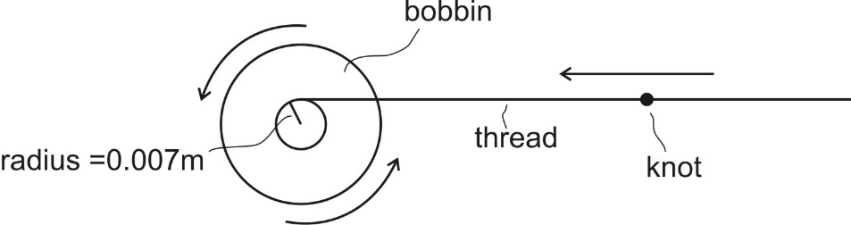1. A sewing machine bobbin rotates, causing thread to wind around it. As the bobbin first begins to move, it accelerates from rest to 10 revolutions per second over a time of 1.4 seconds. Assume that the radius of the bobbin around which the thread is wrapped remains constant at 0.007m.

A. What is the bobbin’s angular acceleration in rad/s2?

B. What is the linear acceleration of a knot in the thread that is being pulled onto the bobbin?

4. Platform diver

A. After jumping off of the diving platform, an olympic diver initially spins at a rate of 0.6 rev/s. Given that his moment of inertia (I) is 4.6 kg⋅m2, calculate his angular momentum at this time.

B. Before the diver hits the water, the diver’s rotational speed increases to 2 rev/s. What is the diver’s moment of inertia (I) at that point?

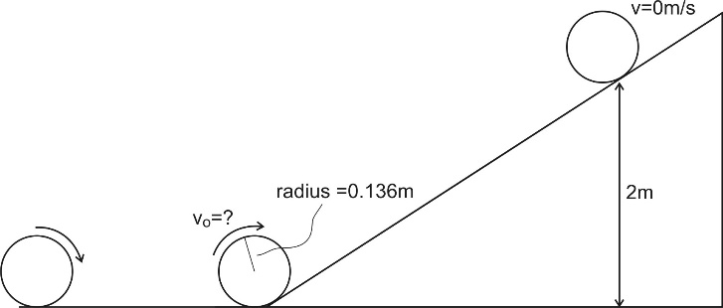5. A 0.175kg disc with a radius of 0.136m (same dimensions as a Discraft Ultrastar Sport Disc) rolls across level ground and then continues to roll up a ramp without slipping. The disc rolls to a point that is 2m higher than the base of the ramp before it stops and then rolls back down. For a disc, I= ½ mr2.

What was the disc’s velocity when it first reached the bottom of the ramp (just before it began to ascend)?

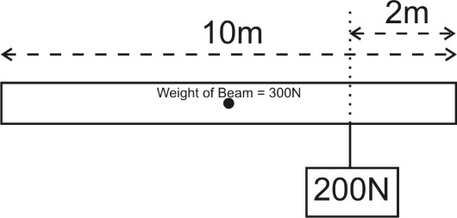

6. A 10m long beam of uniformly distributed mass has a weight of 300N. There is an additional weight of 200N hanging from the beam at a point 2m from the right end of the beam. Describe the location at which a fulcrum placed under the beam would cause the beam to balance horizontally.

**Test 2: Momentum and Impulse**

2. The change in an object’s momentum is equal to

A. its average acceleration B. the force applied to the object

C. its velocity multiplied by the applied force D. the impulse imparted to the object

E.

3. The correct units for momentum are:

a. kgm/s b. Nm/s c. kgm/s2 d. Nm/s2

4-6. Three eggs of equal mass are thrown with the same velocity at three walls of equal mass. Each wall is shaped into a block standing on its edge, and the point of collision is the same for each egg and wall. The first egg splatters against a hard wall and comes to a stop. The second egg hits a soft wall and comes to a stop without splattering. The third egg bounces backward off of a springy wall.

4. Compared to the first egg (hard wall), the second egg (soft wall) experiences…

a. Greater force and the same impulse b. Less force and the same impulse

c. Greater force and greater impulse d. Less force and greater impulse

e. Same force and impulse

5. Which egg experiences the greatest change in momentum?

A. First egg B. Second egg C. Third egg D. None of them

6. Now consider the walls in number 4. Which wall is most likely to be knocked over by the egg impact?

a. Hard wall b. Soft wall c. Springy wall d. None of them

8. A motionless mass M suddenly explodes breaking apart into two separately moving pieces. The first piece has a mass of $\frac{1}{3}M$ and second piece has a mass of $\frac{2}{3}M$. After the explosion, if the velocity of the first piece is -V, what is the velocity of the second piece?

A. V/2 B. V/3 C. V D. 2V E. 3V

9. A 1kg ball is dropped to the ground. It hits the ground with a velocity of -6m/s and bounces back up with a velocity of +4m/s. What impulse was imparted to the ball?

A. -2kgm/s B. 4 kgm/s C. -6kgm/s D. 10kgm/s E. 24kgm/s

10. A 1,200-kilogram car traveling at 30 meters per second hits a huge pile of cardboard boxes and is brought to rest in 6 seconds. What is the magnitude of the average force acting on the car to bring it to rest?

A. 6 × 102 N B. 6 × 103 N C. 6 × 104 N D. 6 × 105 N E. 6 × 106 N

**Momentum and Impulse Problems:**

1. A 1,000kg car is traveling at a speed of 25m/s. When the brakes are applied the car is brought to a stop by a constant 800N force.

a. What is the momentum of the car before the brakes are applied?

b. How many seconds does it take for the brakes to stop the car?

2. A golf ball of mass 0.045 kg is hit off the tee at a speed of 45 m/s. The golf club was in contact with the ball for 3.5×10-3 s.

a. What is the impulse imparted to the golf ball?

b. What is the average force exerted on the ball by the golf club?

3. A piece of putty with a mass of 0.24kg velocity of 15m/s collides with a second piece of putty that is moving with a velocity of -28m/s. After the collision, the two pieces of putty stick together and travel with a shared velocity of -4m/s. What is the mass of the second piece of putty?

**Test 3: Electric Charge and Electric Fields**

1. Which is a true statement?

A. Electric field lines are parallel to the surface of a conductor.

B. Electric field lines are perpendicular to the surface of a conductor.

C. Electric field lines are at an angle of 45 degrees to the surface of a conductor.

D. The angle electric field lines make with the surface of a conductor can vary.

2. When placed in an electric field,

A. both a proton and an electron will be accelerated in the same direction as the electric field.

B. both a proton and an electron will be accelerated in the opposite direction of the electric field.

C. the proton will be accelerated in the same direction as the electric field and the electron will be accelerated in the opposite direction.

D. the electron will be accelerated in the same direction as the electric field and the proton will be accelerated in the opposite direction.

3. Which diagram correctly depicts the direction of the electric field from charge -q?

-q

-q

-q

-q

A. B. C. D.

4. In electrostatic equilibrium, the electric field inside a conductor is equal to

A.  B. F/q C. zero D. 

5. Given two protons separated by a given distance, which of these statements is true.

A. The gravitational force between them is much stronger than the electric force.

B. The electric force between them is much stronger than the gravitational force.

C. The electric force and gravitational force are approximately the same strength.

6. Charge moves much more freely and easily in a

A. conductor B. insulator C. semiconductor

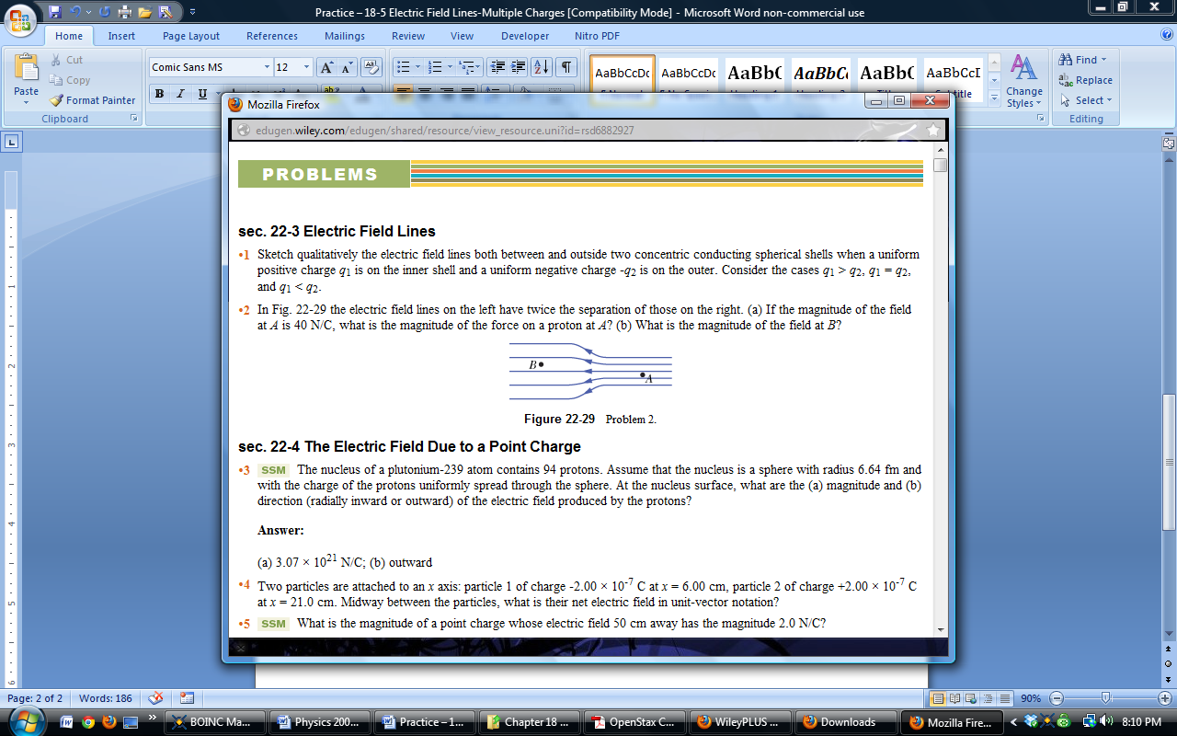D. Charge moves just as freely and easily in all of the above.

7. At which point is the electric field greater?

A. A B. B C. The electric field strength is the same at A and B.

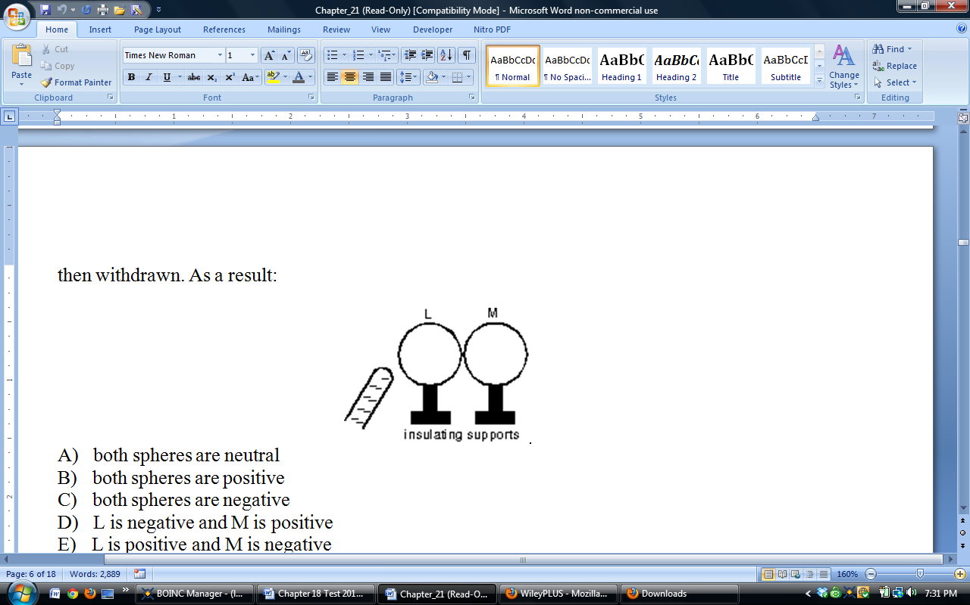8. Two uncharged metal spheres, L and M, are in contact. A negatively charged rod is brought close to L, but not touching it, as shown. The two spheres are slightly separated and the rod is then withdrawn. As a result:

A. both spheres are neutral B. both spheres are positive

C. both spheres are negative D. L is negative and M is positive

E. L is positive and M is negative

11. What is the unit of electric field?

A. N B. N/C C. C D. m/s2 E. kg

12. What is the unit of electric charge?

A. N B. N/C C. C D. m/s2 E. kg

13. What is the unit of electric force?

A. N B. N/C C. C D. m/s2 E. kg

15. If the distance between two charges increases by a factor of 3X, what happens to the size of the electric force F on each charge?

A. 1/16 F B. 1/9 F C. 1/3 F D. 9 F E. 16 F

16. If the charge on two particles is each increased by a factor of 3X, what happens to the size of the electric force F on each charge?

A. 1/16 F B. 1/9 F C. 1/3 F D. 9 F E. 16 F

18. Like charges (such as two positive charges or two negative charges) will

A. attract each other.

B. repel each other.

C. both attract and repel each other.

D. annihilate each other in a burst of energy.

19. In response to bringing a charged particle close to a metal conductor,

A. only the negatively-charged electrons move.

B. only the positively-charged protons move.

C. both the electrons and protons flow in the same direction.

D. the electrons flow in one direction and the protons flow in the other.

Electric Charge and Field Problems:

1. What is the electric force between two 40.0 C charges that are 22.0 cm apart?

3. What is the magnitude and direction of the electric force exerted on a -3.30 μC charge by a 480 N/C electric field that points in the positive x-direction?

4. What magnitude point charge creates a 5.50 x 104 N/C electric field at a distance of 0.400 m?

**Test 4: Electric Current and Circuits**

Match each SI unit with the correct electrical parameter. Choices…

A. Resistance B. Drift Velocity C. Energy D. Current E. Charge

F. Potential Difference G. Resistivity H. Power

1. _____ kilowatt-hour 2. _____ volt 3. _____ ohm 4. _____ watt

5. _____ ampere 6. _____ coulomb

7. In a circuit, the indicated direction of the current is

A. in the opposite directions of protons moving through the wire

B. flowing out of the positive battery terminal.

C. in the same direction as the net electron flow.

D. in the same direction that protons are moving through the wire.

8. If the potential difference across an 8Ω resistor is multiplied by 1/2,

A. only the current is doubled.

B. only the current is halved.

C. only the resistance is doubled.

D. only the resistance is halved.

E. both the current and resistance are doubled.

10. Which of the following appliances consumes the most power when operating?

A. Appliance #1: 120 V 1.0 A

B. Appliance #2: 200W

C. Appliance #3: 120 V 2.0 A

D. Appliance #4: 400W

E. There is no way to tell for sure.

12. The resistance of a conductor depends upon:

A. the length of the conductor.

B. the specific material of the conductor.

C. the cross-sectional area of the conductor.

D. all of the above

13. In a circuit with one battery and three resistors, when does the power provided by the battery equal the sum of the powers dissipated by each of the resistors?

A. When the resistors are in parallel B. When the resistors are in series

C. Always D. Never

15. If a circuit consists of a battery and two resistors connected in series to each other and a third identical resistor is added in series, the current in the circuit will:

A. increase B. decrease C. stay the same

Electric Current and Circuits Problems:

1. You have a 30m long piece of silver wire having a radius of 1.5*10-3m. (Ag = 1.59 x 10-8 .m)

A. What is the resistance of this wire?

B. How much current will flow through the wire if there is a 9 V potential difference between the ends (i.e. if it is hooked up to a 12.0 V battery)?

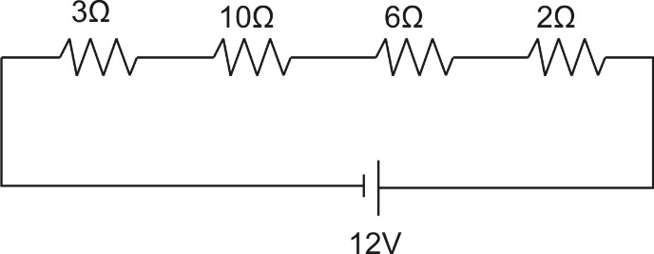

3. A. Calculate the total equivalent resistance of this circuit.

B. Calculate the current flowing through this circuit.

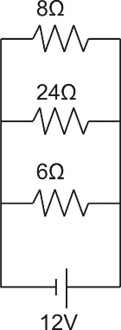4. Bob spends 20 hours annually operating his hairdryer on a 120V circuit. Bob’s hairdryer draws 12.5A of current. If Bob’s electricity costs $0.15 per kilowatt-hour, what is the total cost of the electricity that he uses to run his hairdryer?

5. A. Calculate the total equivalent resistance of this circuit.

B. Calculate the total current flowing through this circuit.

C. Calculate the current flowing through the 24- resistor.

D. Calculate the power dissipated as heat through the 24- resistor.

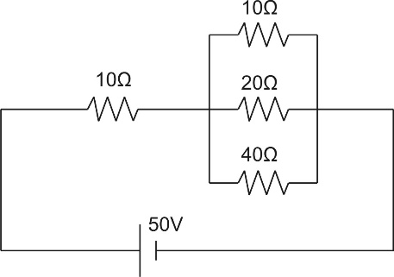

6. A. Calculate the total equivalent resistance of this circuit.

B. Calculate the total current flowing through this circuit.

C. Calculate the potential difference across the leftmost 10- resistor.

D. Calculate the current flowing through the 20.0- resistor.

E. Calculate the total power dissipated as heat in this circuit.

“Test” 5: Reflection and Refraction

Index of Refraction Table

|  |  |  |  |  |
| --- | --- | --- | --- | --- |
| Vacuum | Air | Water | Glass | Diamond |
| 1.000000 | 1.000293 | 1.33 | 1.52 | 2.42 |

1. The speed of light will be the smallest in

A. a vacuum B. water C. diamond D. air E. glass

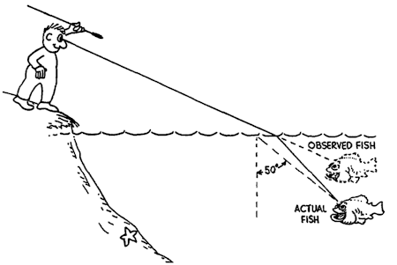

A.

B.

C.

3. Where would the actual fish be in the diagram on the right?

4. In which situation can total internal reflection not occur?

A. water into air B. air into glass

C. glass into water D. glass into air

5. If the speed of light in a transparent material is 1.50 x 108 m/s, what is the index of refraction of this material?

A. 0.33 B. 0.50 C. 2.00

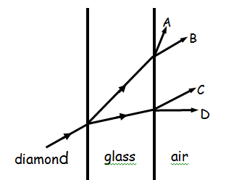 D. 3.00 E. 4.00

10. What path does the light come out? Assume all incident angles are less than the critical angle.

Optics Problems:

1. Find the speed of light in diamond.

2. What is the incident angle for a light beam passing from glass into water if the refracted angle is 35.0o?

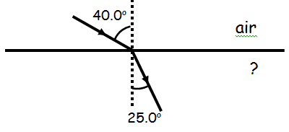

4. Find the index of the unknown material on the right.

B. What material is this?

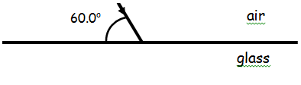

6. Find the angle of refraction.