Circuit Reduction – The Nine Companions

Assume each resistor has a value of 10 Ohms. Find the equivalent resistance of each circuit. Use the space provided to do circuit reductions as necessary.

1.
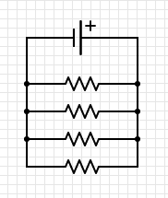
2.
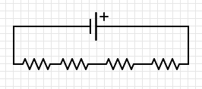

4.
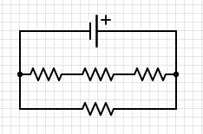
3.
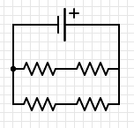

5. 6.
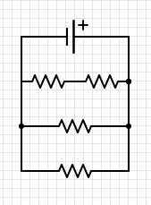
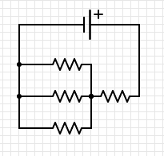

7. 8.
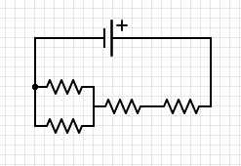
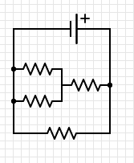

9.
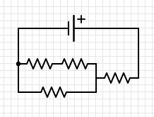

Answers:
1. 2.5 Ω 2. 40 Ω 3. 10 Ω 4. 7.5 Ω
5. 13.3 Ω 6. 4 Ω 7. 6 Ω 8. 25 Ω
9. 16.7Ω

