Physics 200 Name: ___________________________

Notes – 19.1 Electric Potential Energy: Potential Difference

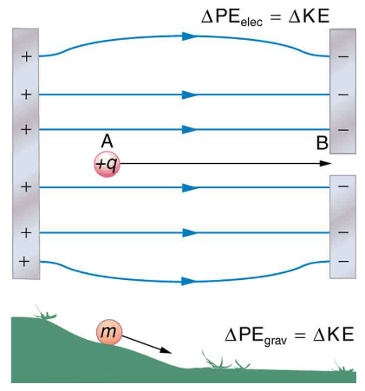
The diagram on the right presents an analogy comparing electric potential energy to gravitational potential energy. Gravitational and Electrostatic forces are both conservative, so the law of conservation of energy applies.

1. Where in the diagram would the positive charge have the greatest potential energy?

2. If the charge (+q) were released to travel from A to B, what would happen to its potential and kinetic energy?

PE: ___________ KE: _____________

3. Electric Potential is electric potential energy per unit of charge. This is not the same as electric potential energy. It is a ratio that applies to a specific point in an electric field, and it allows us to determine the potential energy of any charge at that point.

4. Voltage = Electrical Potential Difference. This is the difference between the electrical potentials at two different points.

5. Units and symbols:
Quantity | Symbol | Formula | Units
Electrical Potential Energy
Electrical Potential

Voltage (Electrical Potential Difference)

6. In practice, you can use these formulas and units:

ΔPE_{e} =

V (voltage) =

7. Example Problem:

Suppose you have a 12.0 V motorcycle battery that can move 5000 C of charge, and a 12.0 V car battery that can move 60,000 C of charge. How much energy does each deliver? (Assume that the numerical value of each charge is accurate to three significant figures.)

8. Electron Volts: It is useful to have an energy unit related to submicroscopic effects. An energy unit called the electron volt (eV), which is the energy given to a fundamental charge accelerated through a potential difference of ____________.

1eV = _______________ J

Notes – 20.1 Current

1. Electric current is defined to be the rate at which ___________ flows.

2. Write the equation for electric current.

3. The unit for electric current is _____________.

4. 1 ampere = 1 _______________ /second.

5. Example:
A. What is the current involved when a truck battery sets in motion 720 C of charge in 4.00 s while starting an engine? Show your work.

B. How long does it take 1.00 C of charge to flow through a handheld calculator if a 0.300-mA current is flowing? Show your work.

6. Label the terms and components in this circuit.

7. By convention, the direction of current flow is from _____________ to _____________. The direction of conventional current is the direction that _____________ charge would flow.

8. In metal wires, current is carried by _____________. So it is _____________ charges that are moving, and they are moving oppositely to conventional current.

9. The fact that conventional current is taken to be in the direction that positive charge would flow can be traced back to American politician and scientist ______________________. He named the type of charge associated with electrons negative, long before they were known to carry current in so many situations. Franklin, in fact, was totally unaware of the small-scale structure of electricity.

10. It is important to realize that there is an __________________in conductors that is responsible for producing the current, unlike static electricity situations, where a conductor in equilibrium cannot have an electric field in it. Conductors carrying a current have an electric field and are not in static equilibrium. An electric field is needed to supply energy to move the charges.

11. If the 0.300-mA current through a wire is carried by electrons, how many electrons per second pass through it? Show your work.

12. Electrical signals are known to move very rapidly. Most electrical signals carried by currents travel at speeds on the order of ______ m/s, a significant fraction of the speed of light. However, the actual electrons move much more slowly on average, typically drifting at speeds on the order of _______ m/s. Another example of sending messages quickly through a slowly-moving medium is provided by __________

________________________________________________________________
13. Show the direction of the drift velocity v_{d}, electric field E and the current I.

Practice – 19.1 Electric Potential Energy: Potential Difference

q_{electron} = -1.6x10⁻¹⁹C KE = ½ mv²

1. A. What is the speed of an electron starting from rest accelerated through a potential difference of 100 V? m_{e} = 9.11 x 10⁻³¹ kg

B. What is the speed of a proton starting from rest accelerated through a potential difference of 100 V? m_{p} = 1.67 x 10⁻²⁷ kg

2. An evacuated tube uses an accelerating voltage of 40.0 kV to accelerate electrons to hit a copper plate and produce x rays. What is the speed of these electrons?

3. A bare helium nucleus has two positive charges (protons) and a mass of 6.64 x 10^{–27} kg.
A. Calculate its kinetic energy in joules at 2.00% of the speed of light. c = 3.00 x 10⁸ m/s.

B. What is this in electron volts?

C. What voltage would be needed to obtain this energy?

Answers:
1. A. 5.93 x 10⁶ m/s B. 1.38 x 10⁵ m/s 2. 1.19 x 10⁸ m/s
3. A. 1.20 x 10⁻¹³ J B. 7.47 x 10⁵ eV C. 3.74 x 10⁵ V
Practice – 20.1 Current

1. Car batteries are rated in ampere-hours (A ⋅ h). To what physical quantity do ampere-hours correspond (voltage? Charge? Energy? . . .)?

5. What is the current in milliamperes produced by the solar cells of a pocket calculator through which 4.00 C of charge passes in 4.00 h?

6. What is the current when a typical static charge of 0.250 μC moves from your finger to a metal doorknob in 1.00 μs?

7. A large lightning bolt had a 20,000-A current and moved 30.0 C of charge. What was its duration?

8. A defibrillator passes 12.0 A of current through the torso of a person for 0.0100 s. How much charge moves?

9. A clock battery wears out after moving 10,000 C of charge through the clock at a rate of 0.500 mA.
A. How long did the clock run?

B. How many electrons per second flowed?

Solutions:
1. charge 5. 0.278 mA 6. 0.250 A 7. 1.50 x 10⁻³ s 8. 0.120 C
9. A. 2.00 x 10⁷ s B. 3.13 x 10¹⁵ e⁻/s

