Physics 200 (Stapleton) Name: _______________________________
Last Year’s Test (22-23): 2-D Kinematics, Version 1

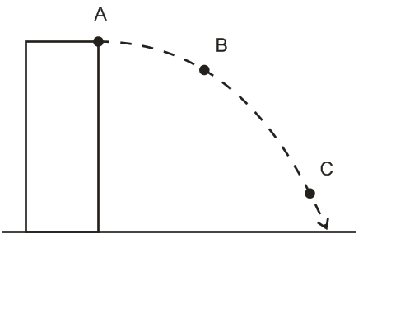
Part 1: Short Answer and Multiple Choice: 1 point each
The diagram on the right shows a projectile that is launched horizontally from the top of a tall building in the absence of air resistance.

1. Use labeled arrows to represent the object’s x velocity (v_{x}) at each lettered point (unless v_{x} happens to be zero).

2. Use labeled arrows to represent the object’s resultant velocity (“v”) at each lettered point (unless v happens to be zero).

3. Use labeled arrows to represent the object’s y velocity (v_{y}) at each lettered point (unless v_{y} happens to be zero).

4. 1m/s =_________ mph

Multiple Choice: Circle the correct answer.
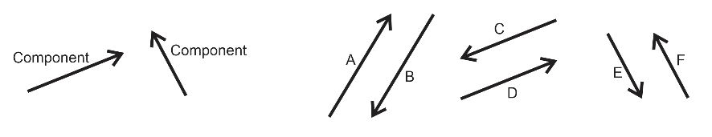
5. Which of the lettered vectors is the resultant that is produced when the two component vectors are added together?
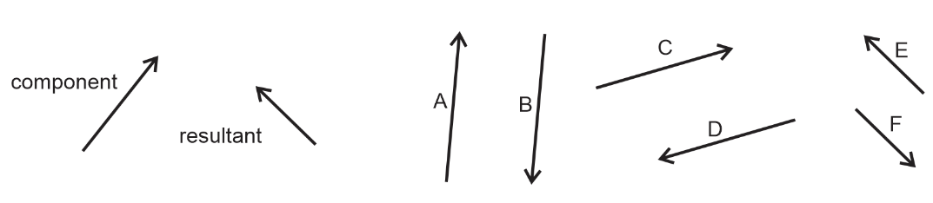
6. Which of the lettered vectors can be added to the component vector to give the resultant vector?

7. A projectile that is shot with a given initial y-velocity reaches a maximum height of 50.0 m. If, on a second shot, the initial y-velocity is doubled, what maximum height will the projectile reach?
A) 75 m B) 100 m C) 150 m D) 200 m E) 450 m

8. If θ is the angle made by vector A and the positive x-axis, then the y-component of the vector A is…
A) A cos θ B) μA cos θ C) A sin θ D) mg – A sin θ E) tan⁻¹θ

9. A vector in the xy plane has an x-component of +5.7 and a y-component of +9.4. The angle it makes with the positive x axis is:
A) 26º B) 34º C) 45º D) 59º E) 66º

10-11. A rock is thrown from the edge of a cliff with an initial velocity v₀ at an angle θ with the horizontal as shown above. Point P is the highest point in the rock’s trajectory and point Q is level with the starting point. Assume air resistance is negligible.

10. Which of the following correctly describes the horizontal and vertical speeds and the acceleration of the point at Point P?

Horizontal Speed Vertical Speed Acceleration
A) 0 v₀ cos θ -g
B) v₀ cos θ 0 0
C) v₀ cos θ v₀ sin θ -g
D) 0 0 -g
E) v₀ cos θ 0 -g

11. Which of the following correctly describes the horizontal and vertical speeds and the acceleration of the point at Point Q?

Horizontal Speed Vertical Speed Acceleration
A) 0 v₀ cos θ -g
B) v₀ cos θ 0 0
C) v₀ cos θ v₀ sin θ -g
D) 0 0 -g
E) v₀ cos θ 0 -g

Part 2: River Problems – In the case of wrong answers, partial credit may be given for correct formulas – in their original form -- and correct units. Enclose your answers and your starting formulas in boxes. For problems with multiple parts, if you do not know the answer to one part, you may make up an answer to use in a subsequent part.
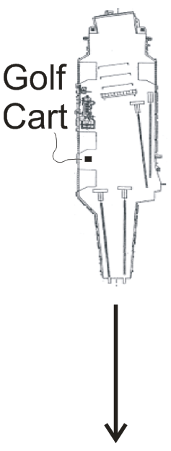
1. (8 Points) An aircraft carrier is traveling at a rate of 10m/s southward. An airman driving a golf cart uses a compass to head eastward across the moving carrier, perpendicular to the carrier’s length. The golf cart’s speedometer reads 6m/s.

a. What is the actual speed of the golf cart, relative to the Earth?

b. What is the golf cart’s direction of travel? Describe the direction in degrees relative to North, South, East, or West.

2. A helicopter is flying in a wind. The helicopter’s heading is due West, and its current air speed (speed in still air) is 50m/s. The helicopter’s actual velocity (relative to the Earth) is 80m/s in a direction 55° West of South. Find the speed and direction of the wind. [Please Note: The following questions refer to x and y components. In reality, these x components are really East-West components, and the y components are really North-South components. But when I work these problems in class, I refer to them as x and y components. It’s easier that way.]

a. (1 pt) What are the x and y components of the helicopter’s heading & air speed (H)?

H_{x} = __________ H_{y} = ___________

b. (1pt) What are the x and y components of the helicopter’s actual velocity (V)?

V_{x} = __________ V_{y} = ___________

c. (3 pts) What are the x and y components of the wind velocity (W)?

W_{x} = __________ W_{y} = ___________

d. (3 pts) Precisely describe the speed and direction of the wind velocity (W).

Wind Speed = ___________

Wind Direction = _______________
2-D Kinematics Test Name: _______________________________
Part 3: Projectile Motion Problems
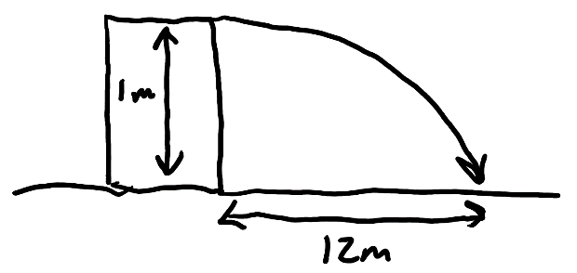
3. (6 pts) You shoot a projectile horizontally from a table top. The projectile flies 12m horizontally before it hits the floor. The point of impact on the floor is 1m lower in elevation than the projectile’s release point.

a. How long is the projectile in the air?

b. What is the projectile’s initial speed as it leaves the launcher?

4. (6 points) An athlete executing a long jump leaves the ground at a 28.0º angle above horizontal and with an initial speed of 8m/s. His landing point is at the same elevation as his take-off point. Determine the following.

a. What is his total time aloft?

c. What horizontal distance does he travel?

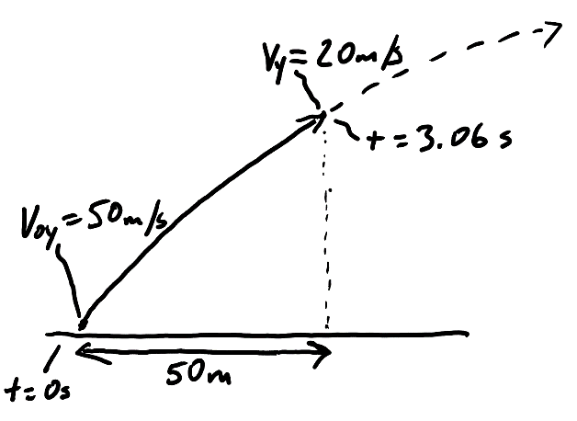
5. (6 pts) A projectile is launched from the ground with an initial y velocity of 50m/s. After 3.06 seconds, the projectile’s y velocity has decreased to 20m/s. During this 3.06 second time period, the projectile has traveled a horizontal distance of 50m.

a. What is the projectile’s height at the moment when its y velocity is 20m/s?

b. What is the projectile’s initial speed?

c. At what angle (relative to horizontal) was the projectile launched?

