Name: ___________________________

Notes – 18.7 Conductors and Electric Fields in Static Equilibrium

1. Conductors contain free charges (i.e. electrons) that move ____________. When excess charge is placed on a conductor or the conductor is put into a static electric field, charges in the conductor quickly respond to reach a steady state called electrostatic ___________________.

2. The free charges move until the field is ________________ to the conductor’s surface.
3. A conductor placed in an electric field will be _______________. A very important point is that the charges will rearrange themselves such that no ________________ exists inside the conductor. If there were a field inside the conductor, free charges in the conductor would continue moving in response to that field until it was neutralized.

4. Properties of a Conductor in Electrostatic Equilibrium
1. The electric field is inside a conductor is _________.
2. Just outside a conductor, the electric field lines are ________________ to its surface, ending or beginning on charges on the surface.
3. Any excess charge resides entirely on the ______________ of a conductor.
5. Two metal plates with equal, but opposite, excess charges. The field between them is ____________ in strength and direction except near the edges.

6. Applications of Conductors
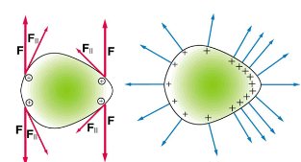
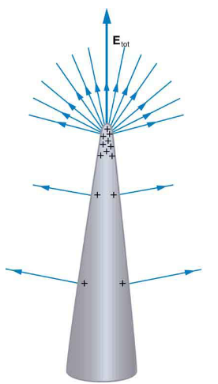
A. On a very sharply curved surface, the charges are so concentrated at the point that the resulting electric field can be great enough to remove them from the surface. As the top left diagram shows, this is because, at sharp points, the repulsive forces (F) of neighboring charges are not as parallel to the surfaces on which the charges reside. Lightning rods work best when they are most pointed. The large charges created in storm clouds induce an opposite charge on a building that can result in a lightning bolt hitting the building. The induced charge is bled away continually from the concentrated charge at the top of a lightning rod, preventing the more dramatic lightning strike.
B. On the other hand, smooth surfaces are used on high-voltage transmission lines and Van de Graaff generators, for example, to avoid leakage of charge into the air.

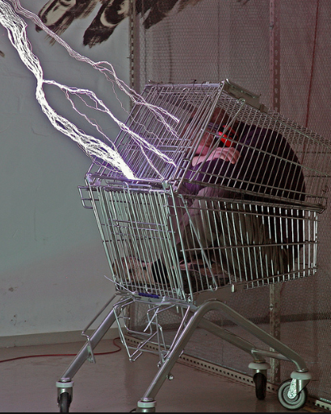
C. Another device that makes use of some of these principles is a Faraday cage. This is a metal shield that encloses a volume. All electrical charges will reside on the outside surface of this shield, and there will be no electrical field inside. A Faraday cage is used to prohibit stray electrical fields in the environment from interfering with sensitive measurements.
D. During electrical storms if you are driving a car, it is best to stay inside the car as its metal body acts as a Faraday cage with zero electrical field inside. If in the vicinity of a lightning strike, its effect is felt on the outside of the car and the inside is unaffected, provided you remain totally inside. This is also true if an active (“hot”) electrical wire was broken (in a storm or an accident) and fell on your car.

Equations and Helpful Information:

Prefixes: n=10⁻⁹ µ = 10⁻⁶ m = 10⁻³
q_{electron} = -1.6x10⁻¹⁹C $F_{e}=\frac{k\left|q_{1}q_{2}\right|}{r^{2}}$$F_{e}=\frac{kq_{1}q_{2}}{r^{2}}$ $E=\frac{kQ}{r^{2}}$ $E= \frac{F}{q}$ k = 8.99x10⁹Nm²/C²
$\sum{F=ma}$ $\sum{F=sum of individual forces}$ w = mg
v_{f} = v₀ + at v_{f}² = v₀² + 2aΔx a_{centripetal} = mv²/r

Practice – 18.7 Conductors and Electric Fields in Static Equilibrium

1. Calculate the linear velocity and the angular velocity ω of an electron assuming it orbits a proton (even though technically it does not) in the hydrogen atom, given the radius of the orbit is 0.530 x 10^{–10} m. You may assume that the proton is stationary and the centripetal force is supplied by Coulomb attraction. m_{e} = 9.11 x 10⁻³¹ kg

2. An electron has an initial velocity of 5.00 x 10⁶ m/s in a uniform 2.00 x 10⁵ N/C strength electric field. The field accelerates the electron in the direction opposite to its initial velocity.
A. What is the direction of the electric field?

B. How far does the electron travel before coming to rest?

C. How long does it take the electron to come to rest?

Solutions:
1. 2.18 x 10⁶ m/s, 4.12 x 10¹⁶ rad/s
2. A. In the direction of the electron’s initial velocity
B. 3.56 x 10⁻⁴ m
C. 1.42 x 10⁻¹⁰ s

Practice – 18.8 Electrostatic Applications

1. Sketch the electric field between the two conducting plates shown below using the principles of electric fields and charges in and around conductors. Assume the top plate is positive and an equal amount of negative charge is on the bottom plate. Also indicate the distribution of charge on the plates.

2. What is the direction and magnitude of an electric field that supports the weight of a free electron (m_{e} = 9.11 x 10⁻³¹ kg) near the surface of Earth? Discuss what the small value for this field implies regarding the relative strength of the gravitational and electrostatic forces.

3. Earth has a net charge that produces an electric field of approximately 150 N/C downward at its surface.
A. What is the magnitude and sign of the excess charge, noting the electric field of a conducting sphere is equivalent to a point charge at its center? R_{Earth} = 6371 km

B. What acceleration will the field produce on a free electron near Earth’s surface?

C. What mass object with a single extra electron will have its weight supported by this field?

4. The practical limit to an electric field in air is about 3.00 x 10⁶ N/C. Above this strength, sparking takes place because air begins to ionize and charges flow, reducing the field.
A. Calculate the distance a free proton must travel in this field to reach 3.00% of the speed of light, starting from rest. m_{p} = 1.67 x 10²⁷ kg, c = 3.00 x 10⁸ m/s

B. Is this practical in air, or must it occur in a vacuum?

Solutions:
2. 5.58 x 10⁻¹¹ N/C toward the Earth’s surface
3. A. -6.77 x 10⁵ C B. 2.63 x 10¹³ m/s² upwards C. 2.45 x 10⁻¹⁸ kg
4. A. 0.141 m

