Physics 200 Name: __________________________
Unit 6: Rotational Motion / Rubber Band Cars

Project Overview:
- Assemble practice cars.
- JUMP INTO the rotational motion alternate Universe and meet rotational versions of many of the concepts we’ve already seen.
- Analyze cars, learn rotational motion concepts, build knowledge to design better cars.
  - Measure wheel and axle moments of inertia
  - Estimate energy input and measure energy output
  - Predict top speed
- Take a group test over the concepts covered.
- Design and build new cars.
- Analyze and fine tune cars. Take measurements, but letting them actually accelerate is forbidden.
- Predict maximum velocity and submit prediction to the race coordinator (Mr. Stapleton).
- Compete. Contest scoring will be based on top speed and accuracy of speed prediction.

Some Rotational Versions of The Same Old Stuff: We have masses moving in lines and in circles. Now we are going to work with masses that simply rotate. Most of what we will do will be the same, but everything will be a rotational version of what we have done before. Here are some linear quantities and their rotational analogs. The table below shows some, but not all, of these analogs.

“Linear” Quantity | Linear Units | Analogous Angular (rotational) Quantity | Angular (rotational) Units | Simple Conversions
Displacement (Δx or s, for arc length) | m | Angular Displacement (ΔΘ) | radians (a dimensionless unit!) | s = Θr  Δx = Θr
Velocity (v) | m/s | Angular Velocity (ω) | rad/s | v = ωr
Acceleration (a) | m/s² | Angular Acceleration (α) | rad/s² | a = αr
Force (F) | N | Torque (τ) | N∙m | Fr = τ
Mass (m) | kg | Moment of Inertia (I) | Kgm²
Momentum  (p=mv) | kgm/s | Angular Momentum  (L = Iω) | Kgm²/s | p = L/r
Translational Kinetic Energy (KE_{T} = ½ mv²) | J | Rotational Kinetic Energy (KE_{R} = ½ Iω²) | J
Work (w = Fd) | J | Angular Work  (w= τ ΔΘ) | J

More useful relationships…

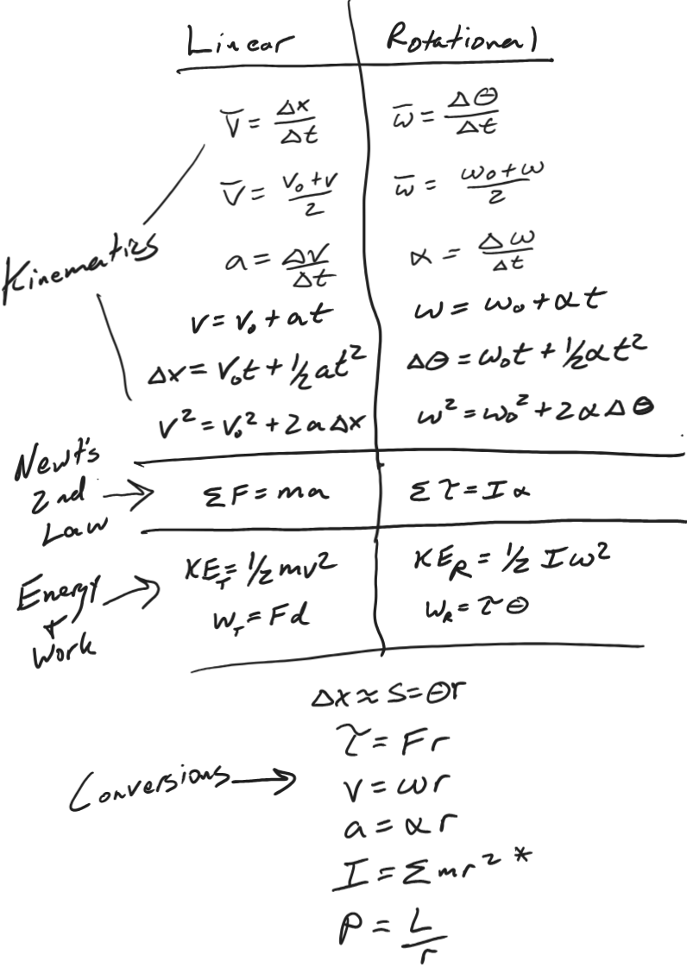
Physics 200 Name: ___________________________
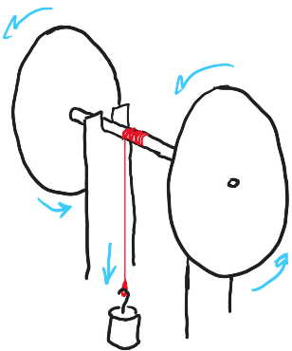
Finding Wheel and Axle MOI – Class Notes Version

Wheel radius (m) | 0.06
Mass of falling weight (kg) | 0.15
Distance descended by weight (m) | 0.9
Descent time (s) | 3.2
Distance risen by weight before stopping (m) | 0.6
Number of wheel and axle rotations during descent | 26
The rear wheel and axle assembly of a rubber band car was supported horizontally by a frame (see diagram). A string was tied to the axle, and a weight was tied to the other end of the string. The string was carefully wound around the axle (with no overlaps) so that the weight was hanging just below the axle. The weight and wheel and axle were held at rest and then released, allowing the weight to fall and causing the wheels and axle to turn. This continued as the weight accelerated downward. When the weight reached its low point, the momentum of the wheel and axle caused the string to wind back up on the axle. This caused the weight to rise again, but it did not rise all the way to its starting point. Data for this event are provided in the table.

- Calculate the angular displacement (in radians) of the wheels and axle during the time that the weight was falling.

- Calculate the axle radius.

- What was the angular acceleration of the wheel and axle during the weight’s descent?

Wheel radius (m) | 0.06
Mass of falling weight (kg) | 0.15
Distance descended by weight (m) | 0.9
Descent time (s) | 3.2
Distance risen by weight before stopping (m) | 0.6
Number of wheel and axle rotations during descent | 26
- Calculate the linear acceleration of the falling mass during its descent.

- Calculate the string tension during the weight’s descent.

- Find the maximum angular speed of the wheel and axle (assuming that its acceleration was constant).

Wheel radius (m) | 0.06
Mass of falling weight (kg) | 0.15
Distance descended by weight (m) | 0.9
Descent time (s) | 3.2
Distance risen by weight before stopping (m) | 0.6
Number of wheel and axle rotations during descent | 26
- Find the maximum speed of a point on the edge of one of the wheels.

- Find the total distance traveled by a point on the edge of one of the wheels.

- Find the non-conservative work done on the system between the time when the weight started to descend and the time when the weight stopped ascending.

- What was the total angular displacement of the wheels and axle during the round trip down and back up?

Wheel radius (m) | 0.06
Mass of falling weight (kg) | 0.15
Distance descended by weight (m) | 0.9
Descent time (s) | 3.2
Distance risen by weight before stopping (m) | 0.6
Number of wheel and axle rotations during descent | 26
- What was the average torque due to friction that acted on the wheel and axle during its round trip down and up?

- What was the torque applied by the string during the weight’s descent?

- What was the net torque acting on the axle during the weight’s descent?

- Find the moment of inertia of the wheel and axle.

Finding Wheel and Axle MOI -- Homework Version. Repeat the same calculations, but use the new set of numbers in the provided table. The scenario is explained back on page 3.

- Calculate the angular displacement (in radians) of the wheels and axle during the time that the weight was falling.
Wheel radius (m) | 0.08
Mass of falling weight (kg) | 0.2
Distance descended by weight (m) | 0.8
Descent time (s) | 2.7
Distance risen by weight before stopping (m) | 0.6
Number of wheel and axle rotations during descent | 24

- Calculate the axle radius.

- What was the angular acceleration of the wheel and axle during the weight’s descent?

- Calculate the linear acceleration of the falling mass during its descent.

- Calculate the string tension during the weight’s descent.

- Find the maximum angular speed of the wheel and axle (assuming that its acceleration was constant).

- Find the maximum speed of a point on the edge of one of the wheels.

Wheel radius (m) | 0.08
Mass of falling weight (kg) | 0.2
Distance descended by weight (m) | 0.8
Descent time (s) | 2.7
Distance risen by weight before stopping (m) | 0.6
Number of wheel and axle rotations during descent | 24
- Find the total distance traveled by a point on the edge of one of the wheels.

- Find the non-conservative work done on the system between the time when the weight started to descend and the time when the weight stopped ascending.

- What was the total angular displacement of the wheels and axle during the round trip down and back up?

- What was the average torque due to friction that acted on the wheel and axle during its round trip down and up?

- What was the torque applied by the string during the weight’s descent?

- What was the net torque acting on the axle during the weight’s descent?

- Find the moment of inertia of the wheel and axle.

