Physics 200 (Stapleton) Name: _______________________________
25-26
Unit 5: Work and Energy

Wikipedia says (correctly) “In physics, work is the energy transferred to or from an object via the application of force along a displacement.” Work and energy are essentially interchangeable. Either can be converted to the other, and they both have the same units, Joules (J).

Work can be calculated using the formula W=Fd. In the formula, d is the displacement (or distance) over which the force acts, and F is a force (or component of a force) in the direction of movement

Energy is often defined as “the ability to do work.” Two basic types of energy are kinetic energy (energy something has because it is in motion), and potential energy (stored energy). Both types of energy can be used to do work, and both types of energy can be produced by doing work.

Mechanical Energy: energy determined by an object’s motion or position. Examples that we will work with during this unit are kinetic energy, gravitational potential energy, and spring potential energy.

- KE = “energy of motion.” KE = ½ mv²
- PE_{g} = Stored Gravitational Energy = Gravitational Potential Energy. ΔPE_{g} = mgh
- PE_{s} = Stored Spring Energy = Spring Potential Energy. PE_{s} = ½ kx² [F_{spring} = kx, where k = “spring constant,” in N/m, and x = stretch distance in meters]
System: Whatever part of the Universe that we choose to focus on. It could be a person, the person and the
Earth, the person and everything in a room, the entire Universe…

The Big Picture (what we’re going to be doing – mostly):
We can find the total mechanical energy in a system by applying the various KE and PE formulas and adding up all of the forms of mechanical energy. This total stays the same unless work adds or remove mechanical energy. If we know how much work is done, then we know what happens to the total mechanical energy. Conversely, if we know how the total mechanical energy has changed, we can deduce how much work has been done. We can use the various formulas (e.g. W=Fd, KE = ½ mv², PE=mgh, PE_{s} = ½ kx²) to calculate mechanical energy, but if we already know mechanical energy, we can also use those formulas to calculate useful stuff like F, d, m, v, h, k and x.

We will also use “Power,” which is the rate of these energy conversions. “Efficiency” describes the fraction of useful energy retained through a conversion.

Thermal Energy: energy relating to an object’s temperature, which is determined by the speed of its randomly-moving individual molecules. Heat is the flow (or transfer) of thermal energy from one object to another.

Power is the rate at which energy or work is added, removed, or used. $P=\frac{W}{t}$ or $P=\frac{E}{t}$ . The units for power that we will use are Watts. 1 Watt = 1J/s. 1horsepower = 746W

Efficiency = $\frac{Output Energy}{Input Energy} x 100\%$ What exactly is considered “output” and what is considered “input” depends on the perspective/purpose of whomever is assessing efficiency. A machine that turns 99% of mechanical energy into thermal energy might be considered very inefficient – unless its purpose is to start fires.

Law of Conservation of Energy (for all energy): For any isolated (no matter or energy entering or leaving) system,
KE_{i} + PE_{i} + OE_{i} = KE_{f} + PE_{f} + OE_{f} OE represents “other energy.” Other energy includes any energy that is not mechanical. OE can be chemical, electrostatic, thermal…

Adding to – or Subtracting From – a system’s total Mechanical Energy: Often work is done to add or remove mechanical energy to a system. This work is said to be done by “non-conservative forces,” because the total amount of mechanical energy in the system changes – total mechanical energy is not conserved. Work by non-conservative forces is labeled W_{nc}. A more general equation for mechanical energy takes this work into account…
KE_{initial} +PE_{initial} + W_{nc} = KE_{final} + PE_{final}.

The Work-Energy Theorem can be useful, but it can also be tricky to apply, and you can get by without it. If you want to use it, it is technically W_{net} = ∆KE. The net amount of work done on an object equals the object’s change in KE. [Here’s an example of its trickiness… if you lift a box from the floor and set it on a table, its KE has not changed, so there is no net work done on the box. At first this seems wrong, but it’s actually right; you do positive work on the box (non-conservative work, because you’re adding PE to the box) and gravity does the same amount of negative work on the box (but this is conservative work, so it does not change the total amount of mechanical energy). The total (net) work is zero.]

Example – Conservation of Energy with No Non-Conservative Work: A skateboarder is skating up the wall of a half-pipe in a frictionless environment.

Use vertical bars to show how the relative values of the skateboarder’s KE and PE, and E_{total} vary at positions 0, 1, and 2.
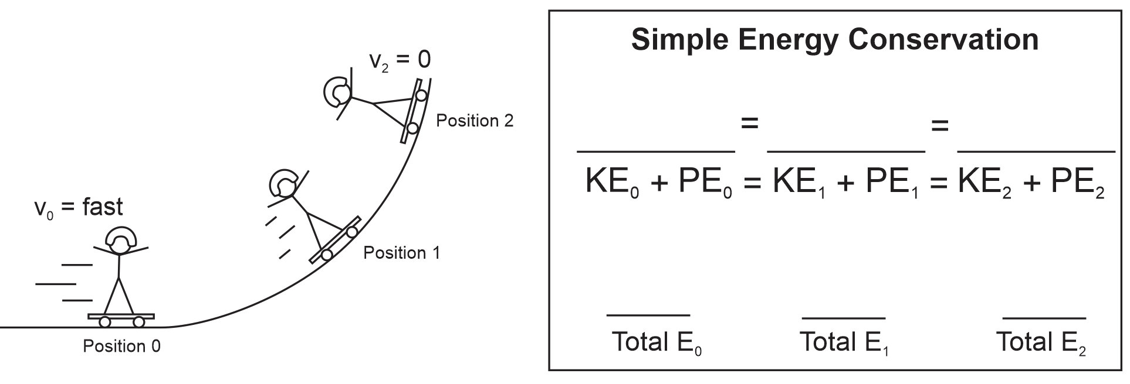

Is work (a force applied over a distance) done on the skateboarder? __________

What does the work? _______________

There is “conservative work” and “non-conservative” work. Conservative work does not change the total mechanical energy of a system, because it is recoverable (e.g., if you compress a spring, you store energy in it, and you can recover that energy by allowing it to push you back). Conservative work allows energy to go in and out of “storage.” Non-conservative work does change the total mechanical energy. The energy for non-conservative work cannot be recovered. It cannot be simply moved “in and out of storage.”

The work done on this skateboarder -- in this frictionless environment with no external forces -- is
____________ ( conservative or non-conservative).
Example -- Negative Work by a Non-conservative Force: A box is sliding down a ramp, slowing down at a constant rate until it stops.
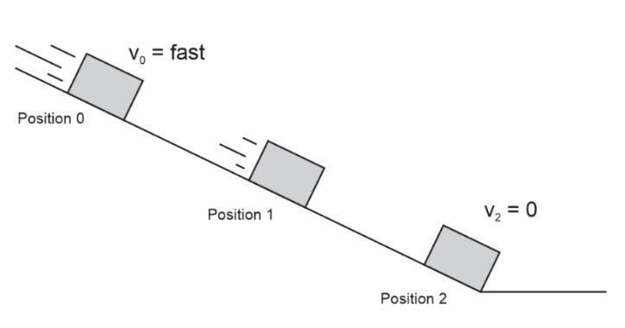
- In the top space, use vertical bars to show the relationship between KE, PE, Mechanical Energy, and non-conservative work.
- Identify the source of the non-conservative work.
- In the bottom spaces, use vertical bars to represent the relative values of the system’s KE, PE, OE, and E_{total} at various stages in its slide.
- Identify the form of OE in this scenario.
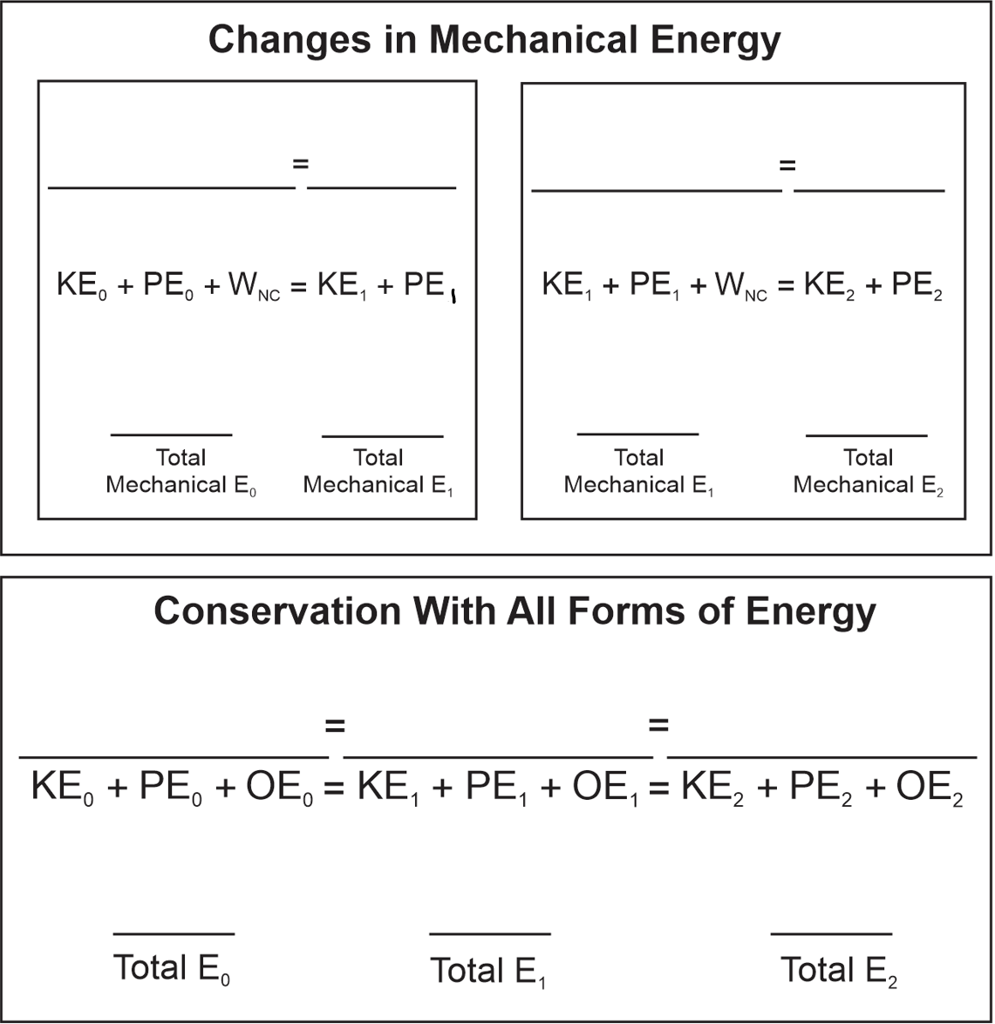
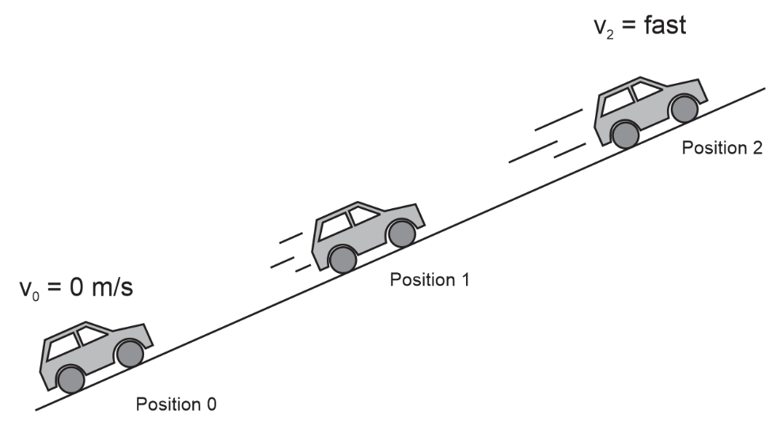
Example -- Positive Work by a Non-conservative Force: Starting from rest, a car continuously accelerates up a hill.
- In the top space, use vertical bars to show the relationship between KE, PE, Mechanical Energy, and non-conservative work.
- Identify the source of the non-conservative work.
- In the bottom spaces, use vertical bars to represent the relative values of the system’s KE, PE, OE, and E_{total} at various stages in its slide.
- Identify the form of OE in this scenario.
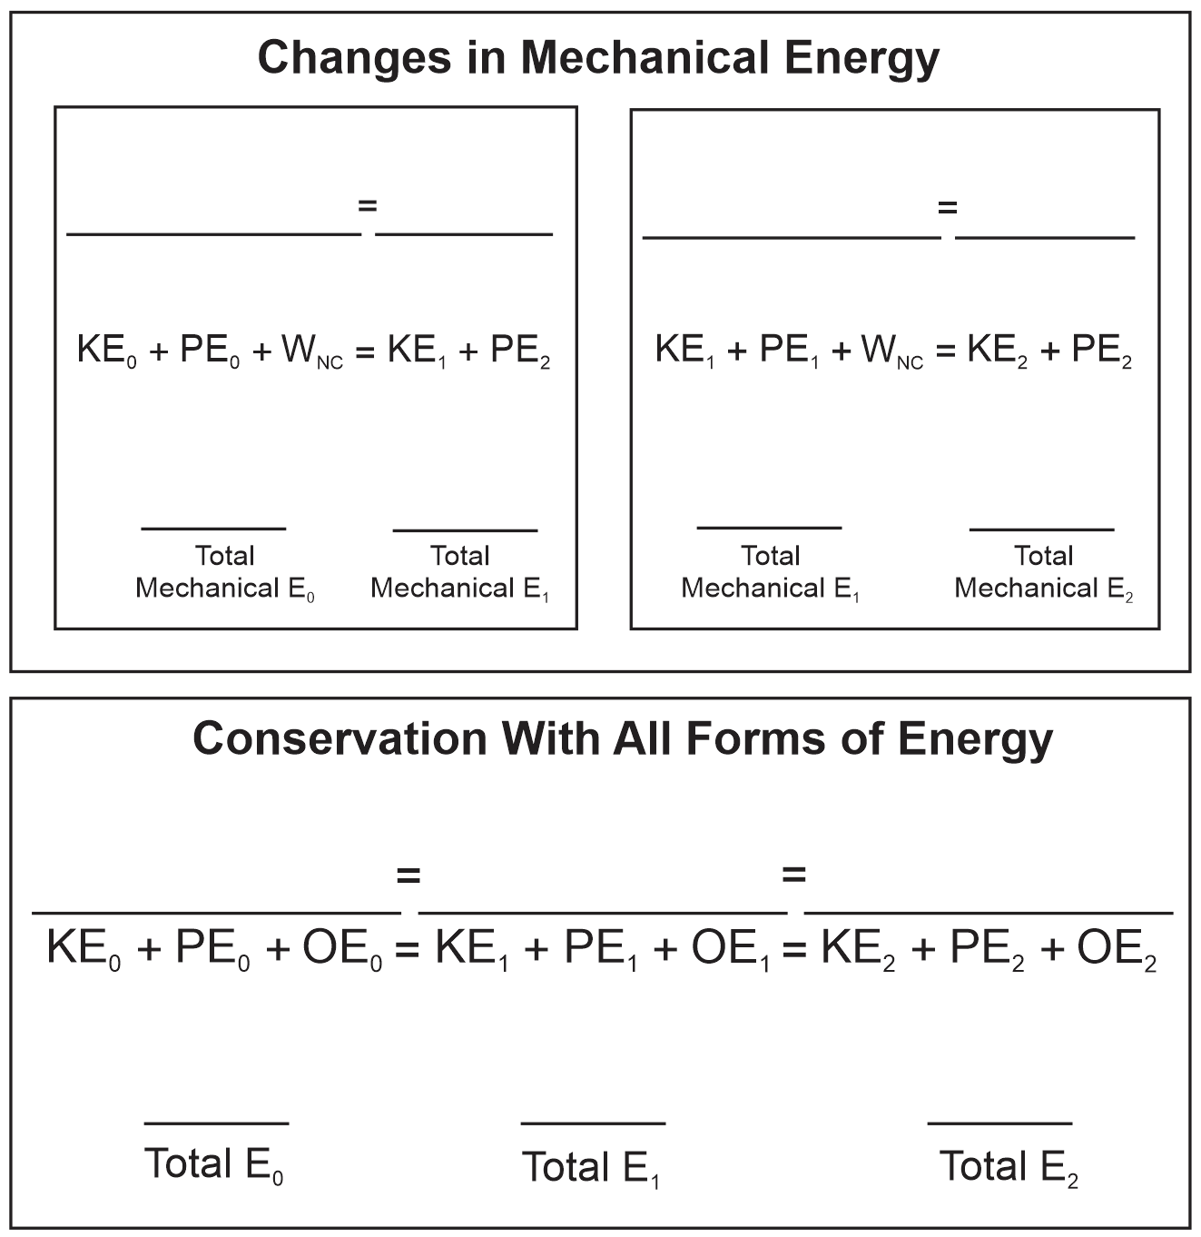
Practice Problems:

1. A child pulls a wagon 4m to the right, applying a constant rightward force of 10N. How much work does the child do?


2. A 60kg military cadet holds a plank for 10 seconds. How much work does she do? [Follow the strict physics definition of work]

3. Another child pulls a wagon using a rope. The tension in the rope is 20N, and the rope makes a 30° angle with horizontal. If the child applies this force constantly as the wagon travels 6m, how much work is done?

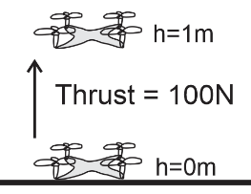
4. [Energy conservation, PE, KE, W_{nc}] A 0.5kg quadcopter takes off vertically from rest with a constant thrust force of 100N. What is the quadcopter’s speed when it reaches a height of 1m?

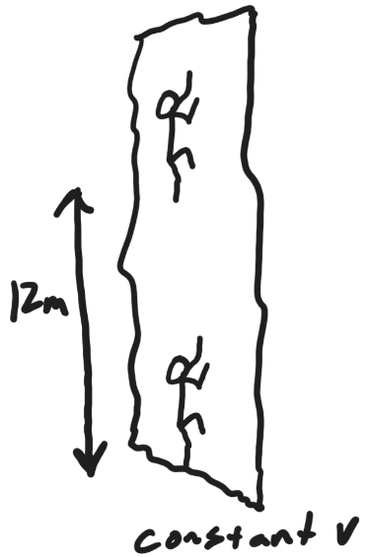
5. [Energy Conservation, Work, Power] A 60kg student climbs 12m up a vertical rock wall in 50 seconds. The student’s speed is constant.

a. Approximately how much work did the student do?

b. What was the student’s average power output, in Watts?

c. How long would the climb have taken if the student’s power output had been 1 horsepower?

d*. The Work-Energy Theorem (a sometimes tricky formula to apply) says that W_{net} = ∆KE. Is this true here?

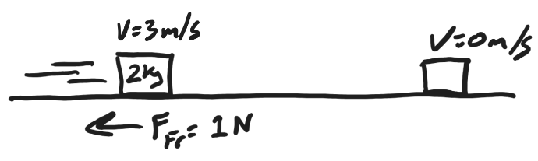
6. [Energy conservation, KE, W_{nc}] A 2kg package is sliding across a level surface at a velocity of 3m/s. The force of friction acting on the package is 1N. How far will the package slide before it stops?

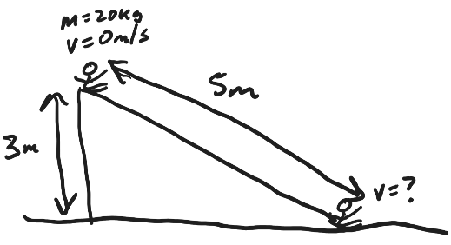
7. [Energy Conservation, PE, KE, W_{nc}] A 20kg child sits at rest at the top of a slide which is 5m long and 3m high. As the child slides down the slide, the child experiences a constant 5N force of friction. What is the child’s speed upon reaching the bottom of the slide?

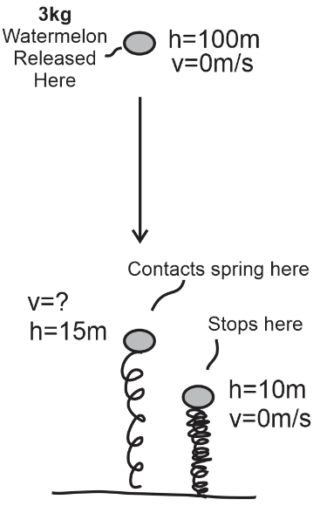
8. [Energy conservation, PE, KE, W_{nc}] A 3kg watermelon is dropped from rest at a height of 100m. It lands on a large spring, contacting the spring at a height of 15m and then compressing the spring a distance of 5m before coming to rest on the compressed spring at a height of 10m.
a. What is its velocity at the moment it first hits the spring?

b. How much energy is stored in the spring once the watermelon comes to rest?

c. What is the spring constant?

d. How much force is the spring exerting on the watermelon when the watermelon comes to rest [It’s about to bounce back.]

9. [Everything] A 200kg roller coaster car is driven up an incline by its 100% efficient electric motor/battery, starting from rest and beginning with a charge of 100,000J of energy. The motor drives the car a linear distance of 70m by applying an average force of 1,120N. At point B, the car’s velocity is returned to 0m/s and the motor shuts off. The car then begins to roll frictionlessly down the hill and across the flat section to point D, where brakes begin to apply a 500N force of friction for the next 40m (until point E.) After point E, the brakes are released, and the car continues to travel downhill without friction. Eventually, the car hits a huge compression spring. By the time the cart reaches point F, it has compressed the spring a distance of 10m and come to rest. The spring’s constant (k) is 1,560 N/m. The car is about to bounce back, but this is where the problem ends. Fill out the table for the car+battery+motor.

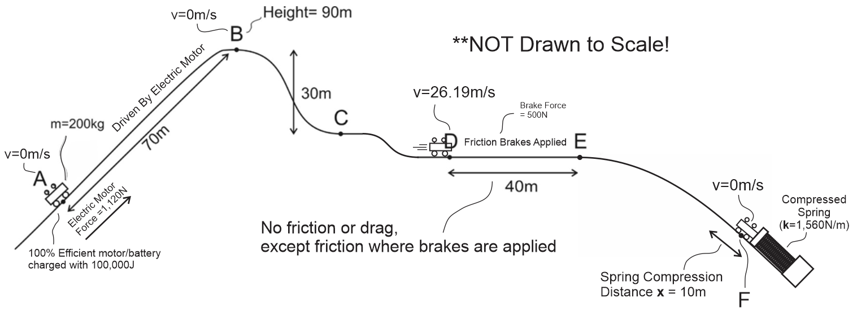

Location | Height (m) | Velocity (m/s) | Gravitational Potential Energy (J) | Spring Potential Energy (J) | Kinetic Energy (J) | Total Mechanical Energy (J) | Electrical Potential Energy (J) | Thermal Energy (J) | Total Energy (J)
A |  | 0 |  |  |  |  | 100,000 | 0
B | 90 | 0
C
D |  | 26.19
E
F |  | 0

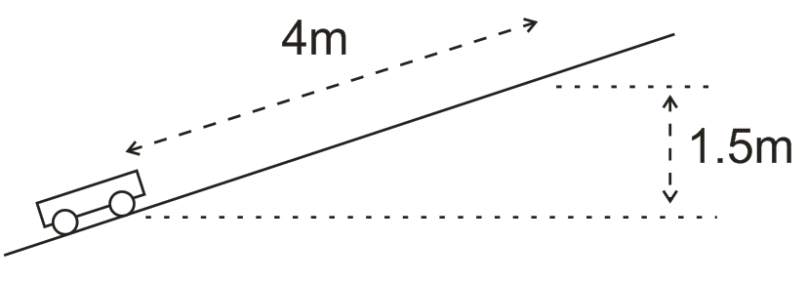
10. [Energy conservation, PE, KE, W_{nc}] A 10kg wagon is initially at rest at a height of 0m. A goat pulls the wagon a distance of 4m along an incline, over a time of 6 seconds. The goat applies a constant force of 70N parallel to the incline. At the end of this 6 second time period, the wagon’s speed is 3m/s, and the wagon is 1.5m higher than when it was at rest.

a. How much work was done on the wagon by the goat?

b. How much power did the goat contribute to the wagon?

c. What is the wagon’s final KE?

d. What was the wagon’s final PE?

e. How much work was done by friction?

f. What was the force of friction?

g. How much work would have been done on the wagon by the goat if the goat had pulled the wagon horizontally while applying a force in a direction 25° above horizontal? Assume that the distance (4m) and the magnitude (70N) of the applied force were the same.
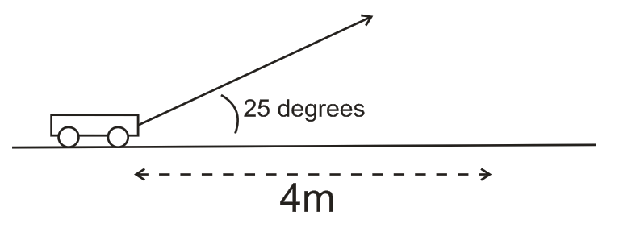
24-25 Energy/Work Test Problems:

1. How much work is done on a box that is pushed 6m to the right by a constant rightward net force of 10N?

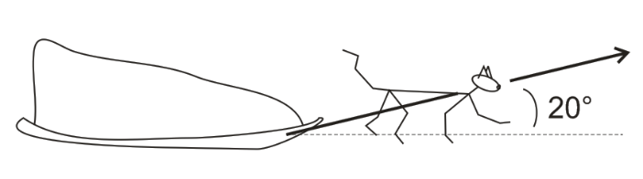
2. A sled cat pulls its load by applying a constant 70N tension force in the direction shown in the diagram (20° above horizontal). If the sled cat pulls its sled 10,000m horizontally (parallel to the dotted line), how much work is does the cat do on the sled?

3. Suppose a 450kg racehorse is initially at rest. For exactly 6 seconds, the horse generates a constant power of 15,000W (about 20.1 horsepower, surprisingly) and uses all of that power to accelerate. The horse travels across level ground.

a. How much work does the racehorse do during this 6 second period?

b. Assuming that none of this work is lost to “other energy,” what is the kinetic energy of the horse after 6 seconds?

c. What is the horse’s speed at the end of the 6 second interval?

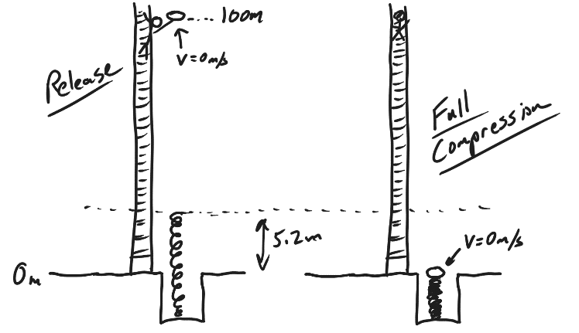
4. Ned thinks he has found a clever method of storing energy in his large spring. He carries a 6kg watermelon to a height of 100m and drops it on the spring. The watermelon falls until it hits the spring and comes to rest, compressing the spring a distance of 5.2m and stopping at ground level. The spring’s k = 350N/m.

a. How much energy is stored in Ned’s spring at the moment when the watermelon’s downward motion ceases?

b. If we assume that all of the non-conservative work done on the watermelon is done by air resistance (drag) acting over the fall distance of 100m, what average drag force is exerted on the watermelon during its fall?

c. The purpose of Ned’s contraption is to store energy in his spring. What is the % efficiency of Ned’s contraption?

5. A 0.15kg graduation cap is tossed directly upward at a graduation ceremony. The cap is released from the thrower’s hand when it is 2m above the ground. At that point it is moving upward with 6J of kinetic energy. [Ignore air resistance.]

a. How much PE does the graduation cap have at the moment when it leaves the hand? (at h=2m)

b. How much PE does the graduation cap have when it reaches its maximum height?

c. How much kinetic energy will the graduation cap have just before it hits the ground?

6. Starting from rest, a 600kg roller coaster car leaves point A and travels frictionlessly down a ramp to point B. At point B, the coaster travels horizontally while its brakes apply a -2,500 N force of friction to slow it down. As friction continues to slow the coaster, the coaster contacts a huge spring (k=10,000N/m), finally coming to stop at point C, after compressing the spring a distance of 3m. When the coaster comes to a stop, the spring pushes it back again.
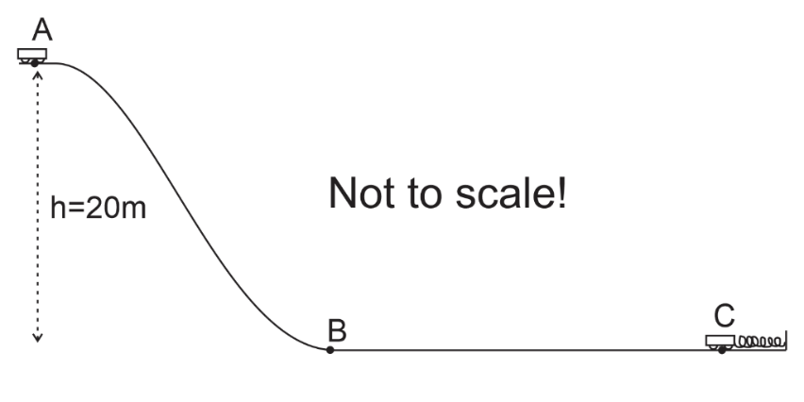

A. Find the coaster’s PE at point A.

B. Find the coaster’s KE at point B.

C. Find the PE stored in the spring, at the moment the coaster comes to rest at point C.

D. Between points B and C the coaster experienced a constant 2,500N force of friction from its brakes. What is the distance from B to C?

