**Unit 1 Handout:** **Motion, Forces, and Water Rockets** Name: ___________________________

Physics 200, 25-26 (Stapleton)

**Kinematics**: The study of motion; specifically, the study of motion without considering its causes.

**Scalar:** A quantity with magnitude (strength, expressed as a positive number), but not a direction of movement.

**Vector:** A quantity with magnitude) and direction (indicating *movement* in that direction).

* In diagrams, arrows are used to indicate the directions of vectors. Magnitude can be indicated by the length of the arrow, or arrows can be labeled with numerical magnitudes.
* For calculations, we use signs to indicate vector direction. Usually, signs follow the same conventions as an x/y grid… upward = positive, downward = negative, rightward = positive, leftward = negative. A -3N force could be either a 3N leftward force or a 3N downward force.

**Δ = Delta** = “change” Formula: Δ = Final – initial. If x changes from 3m to 1m, then Δx = 1m - 3m = -2m.

|  |  |  |  |  |  |
| --- | --- | --- | --- | --- | --- |
|  | **Symbol** | **Meaning** (what it’s *supposed to* mean) | **Vector or Scalar?** | **Common Units** | **How “big” is it?** |
| **Position** | **x** or **y** | An indicator of distance and direction from some chosen point of origin. |  | Meters (m) | 1 long step  0.305m ≈ 1foot |
| **Distance** | **d** | How far something has traveled from its original position, disregarding direction. |  | Meters (m) | 1 long step  0.305m ≈ 1foot |
| **Displacement** | **Δx** or Δ**y**, | Final position minus original position(e.g. x-x0); “Change in position.” Distance in a direction. |  | Meters (m) | 1 long step  0.305m ≈ 1foot |
| **Time** | **t** (or **Δt**) | ? |  | Seconds (s) | 1s = “one mississippi” |
| **Speed** | **v** *(even though v is technically velocity)* | How fast something is moving. A ratio of distance to travel time. |  | Meters per second (m/s) | 1m/s ≈ 2.24mph ≈ 1 long step per second |
| **Velocity** | **v** | A measure of how fast and in which direction. |  | Meters per second (m/s) | 1m/s ≈ 2.24 mph  4.5m/s = 6min/mile pace |
| **Acceleration** | **a** | How fast something’s velocity is changing, and in which direction. |  | Meters per second squared (m/s2 or m/s/s) | Acceleration of gravity on Earth’s surface ≈ 9.8m/s2 |

**Unit conversions by dimensional analysis:**

This is a method of changing units without changing the value of a measurement. It works because we can multiply any number by 1 without changing the number.

Example: 1m/s = 2.24mph, so $\frac{1m/s }{2.24mph}$ = 1 and $\frac{2.24mph }{1m/s}$ = 1. This means we can multiply any measurement by either of these fractions, and we won’t change the measurement – but we can get units to cancel. If we’re trying to convert 35m/s to mph, we can multiply 35m/s x $\frac{2.24mph }{1m/s}$ and get 78.4mph, because the m/s cancel. We can also multiply 35m/s x $\frac{1m/s }{2.24mph}$, but then then nothing cancels and we get a correct answer with crazy units -- 15.625m2/s2mph.

**Velocity and Acceleration**

Symbols: Initial velocity = Final velocity = Average velocity =

If I have a **velocity** of 2 m/s, what does that mean?

One definition of **Velocity**:

**Average Velocity Formula #1**: **Average Velocity Formula #2**:

If I have an **acceleration** of 2m/s2 (2 m/s/s), what does that mean?

One definition of **acceleration**:

Acceleration can happen in two fundamentally different ways:

1)

2)

“Deceleration” usually means ____________________________________, so it can apply to either positive or negative acceleration.

**Average Acceleration Formula:**

Average Speed formula:

***Average* vs *Instantaneous***: when we measure velocity or acceleration, we are measuring average quantities. These are average quantities over some time period. Instantaneousquantities are the velocity or acceleration of an object at a single point in time. For paper/pencil/calculator problems, you will never have to worry about the difference between average and instantaneous acceleration, because accelerations will be constant. Velocities will often change, so it is good to use the average velocity symbol when it applies.

**Sign and Direction Conventions:** Just as in graphing, in physics upward and rightward are considered to

have _____________________ signs, while downward and leftward have _______________________ signs.

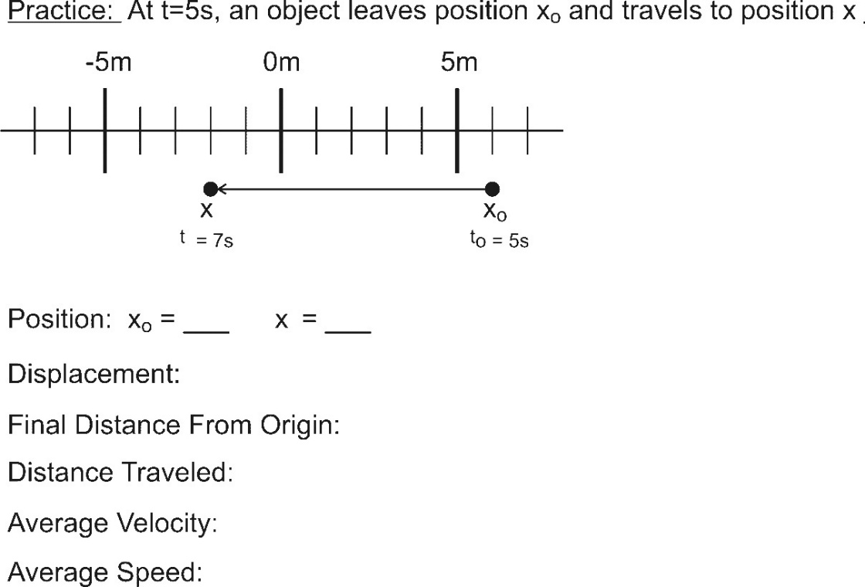Terminology Practice: Starting from rest (motionlessness), an object leaves its initial position and travels to a new position, undergoing constant acceleration along the way. For each quantity, below, provide the symbol and the value.

Initial Position ( ) =

Final Position ( ) =

Displacement ( ) =

Distance traveled ( ) =

Change in Time ( ) =

Initial Velocity ( ) =

Average velocity ( ) =

Final Velocity ( ) =

Average speed ( ) =

Change in Velocity ( ) =

Acceleration ( ) =

Problem-solving with the G.U.E.S.S. method…

* Steps: Identify what is **G**iven. Identify the **U**nknown(s). Identify an **E**quation that helps you find something new with your givens. **S**ubstitute givens into the equation. **S**olve.
* Repeat this process with new equations until you find what you are looking for.
* Other hints:
  + On tricky problems, it can be helpful to list all of the possible variables first. Filling in those blanks is like a crossword puzzle, where each word you find can help you find the next word.
  + On tricky problems, it is also helpful to draw a diagram.

**Kinematics Problems Practice:**  Find whatever it takes to get to the bold item

Example . A quadcopter ascends a distance of 30m while undergoing constant acceleration. If its starting velocity was 5m/s, and this ascent lasts 2 seconds, **what is the acceleration of the quadcopter**?

v0 =

v =

Δv =

=

a =

Δt =

Δy =

Answers: 5,25,20,15,10,2,30

1. A nut is falling at a rate of -5m/s. Gravity accelerates the nut for 6 additional seconds before hitting the ground. **Find the nut’s displacement over these 6 seconds.** To make the math simpler, use -10 m/s2 for the acceleration due to gravity (instead of the actual -9.8m/s2).

v0 =

v =

Δv =

=

a =

Δt =

Δy =

Answers:-5,-65,-60,-35,-10,6,-210

2. A bird flies at a constant speed from the 8 yard line of a football field to the nearest 40 yard line. This flight lasts 8 seconds. **Find the bird’s initial velocity, in yards/s.**

v0 =

v =

Δv =

=

a =

Δt =

Δx =

Answers:4,4,0,4,0,8,32

3. A car accelerates from -30mph to -50mph over a time of 4 seconds. Convert these velocities to m/s, and then find **the car’s displacement in meters.**

v0 =

v =

Δv =

=

a =

Δt =

Δx =

Answers:-13.4,-22.3, -8.9,-17.9,-2.23,4,-71.6

4. A child is traveling with a velocity of -15m/s along a zip line. After slowing down at a constant rate over a distance of 40m, the child comes to a stop. **Find the child’s acceleration**.

v0 =

v =

Δv =

=

a =

Δt =

Δx =

Answers: -15,0,15,-7.5,2.81,5.33,-40

5. A driver sees a turtle in the road and hits the brakes. After slowing down for a time of 3 seconds over a displacement of +20m, the driver has reduced his velocity to 4m/s. **Find the driver’s acceleration.**

v0 =

v =

Δv =

=

a =

Δt =

Δx =

Answers: 9.34, 4,-5.3,6.67,-1.78,3,20

6. You shoot a projectile directly upward. When it leaves your launcher, its velocity is **29.4m/s**. From the moment it leaves the launcher, your projectile is accelerated at a rate of **-9.8m/s2** by gravity (negative means it is downward)*.* When your projectile gets to its highest point, it slows down to zero m/s and then begins to fall. **For this problem, find the projectile’s displacement on its trip from the launcher to its highest point.**

v0 =

v =

Δv =

=

a =

Δt =

Δy =

Answers: 29.4,0,-29.4,14.7,-9.8,3,44.1

7. **Now consider the same shot as in the previous problem, but this time find **all of the following** for the projectile’s round trip from the launcher barrel, up into the sky, and back down to the level of the launcher barrel.

v0 =

v =

Δv =

=

a =

Δt =

Δy =

Answers: 29.4,-29.4,-58.8,0,-9.8,6,0

**Position vs. Time** **Motion Matching Activity Questions:**

On a motion sensor graph of position vs. time…

1. What does a positive (upward) slope tell you about the object’s motion?

2. What does a negative slope indicate?

3. What does the steepness of a slope tell you about the object’s motion?

4. What does a constant (straight line) slope indicate?

5. What might a smoothly curving line indicate?

6. Sketch a negative slope that is becoming less steep. What does this curve indicate about the motion of an object?

7. Sketch a negative slope that is getting steeper. What does this curve indicate about the motion of an object?

8. Sketch a positive slope that is becoming less steep. What does this curve indicate about the motion of an object?

9. Sketch a positive slope that is getting steeper. What does this curve indicate about the motion of an object?

Relationship between speed and velocity/acceleration:

When an object’s speed is increasing its velocity and acceleration _____________________________

______________________________. When an object’s speed is decreasing, its velocity and acceleration

_____________________________________________________________________.

Motion Graphs:

Each row of graphs below comprises a position vs. time graph, a velocity vs. time graph, and an acceleration vs. time graph. Every graph in a row conveys the same motion. For each row, use the one completed graph to fill in the incomplete graphs with reasonable curves. Some rows will have a wider variety of possible answers. **Assume that all acceleration is constant.**

**Graph Comparisons:** use the information provided in one graph to complete the other two graphs. Be aware that some graphs may be unrealistic.



**Forces and Newton’s Laws of Motion:**

Force:

Force units: ____________________________ **1N ≈ 0.225 lbs**

A ____________________________________________________ weighs about 1N.

Net force (Fnet  or ΣF):

Is force a vector or scalar?

What is the net force that is acting on the box in the picture?

Some forces we will be working with:

Weight (w): The force of gravity pulling an object toward a planet

Normal Force (FN): A force exerted by one surface, pushing perpendicularly outward against another surface

Tension (T): The pulling force along the length of a string, chain, cable, etc. *[For simplicity, we will pretend that these objects are massless, so tension is exactly equal in every part of the rope.]*

Friction (FR?): A force resisting the sliding of two surfaces across one another.

Drag (FD): A force resisting the movement of an object through a fluid (e.g. through air, water, or oil)

**Newton’s 1st Law (usual version):** Objects in motion remain in motion in a straight line and at a constant speed, and objects at rest stay at rest, unless they are acted upon by an outside (or unbalanced) force.

* Simpler version:

If there is no net force acting on an object (i.e. the vector sum of all individual forces on the object is zero), what might that object be doing? What are the options?

What are the options for what an object might be doing if there is a net force acting on an object?

Newton's 1st Law is called the "Law of Inertia." Inertia is:

What kinds of objects have the most inertia?

**Newton's 2nd Law:** is an equation that actually takes care of the first law, too…

One definition of **Mass**:

The unit we will use for Mass in force equations is the ________________________, which is abbreviated **kg**.

On Earth, a 1kg mass weighs about 9.8 Newtons or about 2.2 pounds. The water in a 1Liter bottle has a mass of 1kg.

**2nd Law and Free fall:**

* “Free fall” is the state of being acted upon by only the force of gravity (a.k.a. weight).
* Note that, according to this definition, an upward-moving object may be in free fall.
* **g**: the absolute value of free fall acceleration near the Earth’s surface *(also the symbol for gravitational field – the ratio of force per unit of mass at a given location)*
* **Free fall acceleration:** -g or -9.8m/s2

Weight = net force on an object if it were in free fall , so Weight = mafree fall or **w = mg**

*The sensation of weight comes from forces pushing (like a chair) or pulling our bodies. We can have weight even when we feel weightless, as in free fall. We can also feel weight that isn’t there, when a push or pull accelerates us.*

**Primary strategy for solving force problems:**

1. Draw a force diagram showing all of the individual forces acting on the object

2. Write an equation setting Net Force (from Newton’s 2nd Law) equal to Net force (from vector addition of individual forces)

3. Solve for whatever is missing

**Newton’s Third Law of Motion:**

A single force cannot exist alone in the universe without an equal and opposite force. This is sometimes

referred to as action-_______________, but the forces occur ___________________________________________.

Identify the important Newton’s 3rd Law pairs of forces in these situations.

Someone walks to the right:

Car brakes as it travels leftward, slowing down:

Bird flies upward:

A rocket accelerates in the vacuum of space:

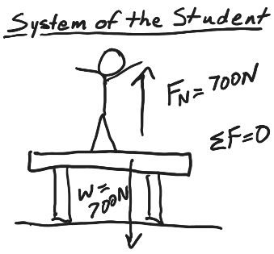**Identifying 3rd Law Impostors:** A person with a weight of 700N stands motionless on a motionlesstable. The table exerts a 700N normal force against the person.

* These two forces are not a 3rd Law pair. How could we prove this?
* Identify the third law partner of each of these forces.

**System:** Any part of the Universe that we choose to examine. The diagram above show the forces acting on the system of the student. Describe all of the forces acting on the system of the table.

**Example Force Problems**

Example 1. A 1,200kg car is being acted upon by two forces. The car’s motor is providing a 1,000N rightward force, and friction is providing a 300N leftward force. What is the car’s acceleration?

Example 2. A bowling ball is sitting motionless on the ground. The ground is exerting an upward normal force (FN) of 49N on the bowling ball. What is the bowling ball’s mass?

Example 3. A 50kg person is climbing down a rope. They are accelerating downward at a rate of 1.5m/s2.

a. What is the person’s weight, in Newtons?

b. What is the tension in the rope?

**Practice Problems**

1. What force is needed to accelerate a child on a sled  at 

2. A net force of 265 N accelerates a bike and rider at  What is the mass of the bike and rider together?

3. What is the weight of a 76-kg astronaut (*a*) on Earth, (*b*) on the Moon  (*c*) on Mars  (*d*) in outer space traveling with constant velocity?

4. What average force (in Newtons) is required to stop an 1100-kg car in 8.0 s if the car is traveling at 95 mph?

Answers:75,115,[745,129,281,0],-5830

5. A 0.140-kg baseball traveling  strikes the catcher’s mitt, which, in bringing the ball to rest, recoils backward 11.0 cm. What was the average force applied by the ball on the glove?

6. How much tension must a rope withstand if it is used to accelerate a 1200-kg car vertically upward at 

7. An elevator (mass 4850 kg) is to be designed so that the maximum acceleration is 0.0680*g*. What force should the motor should exert on the supporting cable on the way up? What about on the way down?

8. A 75-kg petty thief wants to escape from a third-story jail window. Unfortunately, a makeshift rope made of sheets tied together can support a mass of only 58 kg. How might the thief use this “rope” to escape? Give a quantitative answer.

Answers:780, 12720, [50800,44280],-2.32

**Newton Sled Activity Names: _____________________________________________________**

**Directions**:

Launch all of the items below by burning loops of string to release the stretched rubber bands. Use the same number of rubber bands every time. Make a reference mark so that you can stretch the rubber bands the same distance every time. In general, make sure that every launch happens in the same way. **The only manipulated variable should be the object that is launched**. Fill out the data table as you go. Then answer the questions. **When you complete the launch of the Earth, collect the additional data below.**

|  |  |  |
| --- | --- | --- |
| **Object Launched** | **Sled travel distance (m) -- **ACTUALLY MEASURE THIS!\*\*** | **Launched Object travel distance (or subjective description of its speed)** |
| 200g mass |  |  |
| 500g mass |  |  |
| Ping pong ball |  |  |
| Entire Earth |  |  |

1. When the ping pong ball is launched, what gets pushed with a greater force, the sled or the ping-pong ball? Explain your reasoning.
2. When the entire Earth is launched, what gets pushed with a greater force, the sled or the Earth? Explain how you can tell.
3. Out of all of the items that you launched, which one experienced the most force? ___________________

Which one experienced the least force? __________________

How can you tell?

If everything is the same except for the masses, why are the forces different?

1. Fnet=ma helps explain the relationship between objects’ masses and their accelerations, and one major goal of this activity is to see that relationship. Describe an example from this activity and explain how it demonstrates that relationship.
2. Newton’s 1st Law uses the term “unbalanced.” It says that “objects in motion remain in motion, in a straight line and at a constant speed, and objects at rest stay at rest, unless acted upon by an unbalanced (net) force.”
   * 1. Considering the entire time interval spanning before, during, and after an object’s launch, when are the forces on the object balanced, and when are they unbalanced?
     2. For each of these times, explain how you can tell.
3. Use the knowledge that the Earth’s mass is 5.972x1024kg, along with data from your Earth launch to perform the calculations below. They’re so tricky that I have provided you with an organizer on the next page. You should probably have an extra sheet of paper or two for your calculations.

* 1. Calculate the **acceleration of the sled** **during the Earth launch deceleration** period.
  2. Calculate the **force of friction exerted on the sled by the floor**. Assume that the force of friction is constant, and that it is equal during the acceleration and deceleration periods.
  3. Calculate the **accelerations of the sled and the Earth during the Earth launch acceleration** period.
  4. Calculate the **distance moved by the Earth during the Earth launch acceleration period**.

**Ch. 5.1 Notes:** Drag and Terminal Velocity

1. Drag force:

2. Drag force equation:

3. Draw diagrams showing all of the forces acting on a skydiver in 3 different situations: negative acceleration, zero acceleration, and positive acceleration,

4. When a falling skydiver’s net force and acceleration are zero, she or he is said to

be at ______________________.

5. Use the drag formula to derive an equation for the terminal velocity of a skydiver.

6. The table below describes the experience of a skydiver who steps out of a stationary helicopter. Create a reasonable acceleration graph portraying this sequence of events. For each step in the sequence, sketch a diagram showing the individual forces and net force acting on the skydiver. **Note that **a $∝ΣF$** , as long as m is constant.

|  |  |
| --- | --- |
| Sequence | Event |
| 1 | Skydiver steps off of helicopter |
| 2 | Skydiver reaches a **terminal velocity of -40m/s** |
| 3 | Skydiver pulls chute cord. Parachute deploys. |
| 4 | Skydiver reaches a new **terminal velocity of -4m/s** |
| 5 | Skydiver feet touch down |
| 6 | Skydiver comes to rest |

Unit 1 Practice Test Name: ____________________________

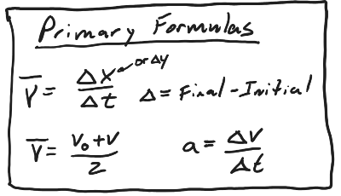Physics 200 (25-26)

**Multiple Choice, Matching, and Short Answer**

1. Circle **all** of the quantities that are vectors

Position Displacement Distance

Force Speed Velocity Acceleration

2. This tells us whether velocity increases or decreases during each second, and by how much.

Position Displacement Velocity Speed Acceleration

3. This tells us how fast something is moving, but it does not tell us the direction of movement.

Position Displacement Velocity Speed Acceleration

4. This tells us how far something has moved, and in which direction.

Position Displacement Velocity Speed Acceleration

#5-9 Answer Choices: A. Weight B. Normal Force C. Friction D. Drag E. Tension

5. ______ The force of a planet’s gravity acting on an object

6. ______ A force that resists the motion of an object moving through a fluid

7. ______ A force that resists the sliding of two surfaces across one another

8. ______ When an attempt is made to stretch an object, this is the pulling force that is exerted in both directions along the entire length of the object.

9. ______ A force that is exerted perpendicularly outward by a surface

Fill in the blanks…

10. 1 foot = __________ meters 11. 1 m/s = __________ mph

12. 1N = _________ pounds 13. 1kg = __________ pounds

14. Which choice describes the person who is closest to actually being weightless?

a. An astronaut orbiting in the Earth in the ISS

b. A child falling at nearly 9.8m/s2 while riding a “free-fall” ride at the fair

c. A circus performer flying through the air, at the very top of their arc

d. A space traveler accelerating at 6g (58.8m/s2 ) beyond the edge of our solar system

e. The driver of a dragster, accelerating from 0-60mph in 0.4 seconds

15. Describe what something could be doing if it has positive acceleration and negative velocity.

16. Describe what something could be doing if it has positive acceleration and zero velocity.

17. Draw sets of position, velocity, and acceleration graphs for the situations described below. To keep things simple, assume that accelerations are constant.

* 1. The rocket is traveling upward and slowing down. [Use the graphs to the right.]
  2. The rocket is falling at a constant velocity. [Use the graphs below.]

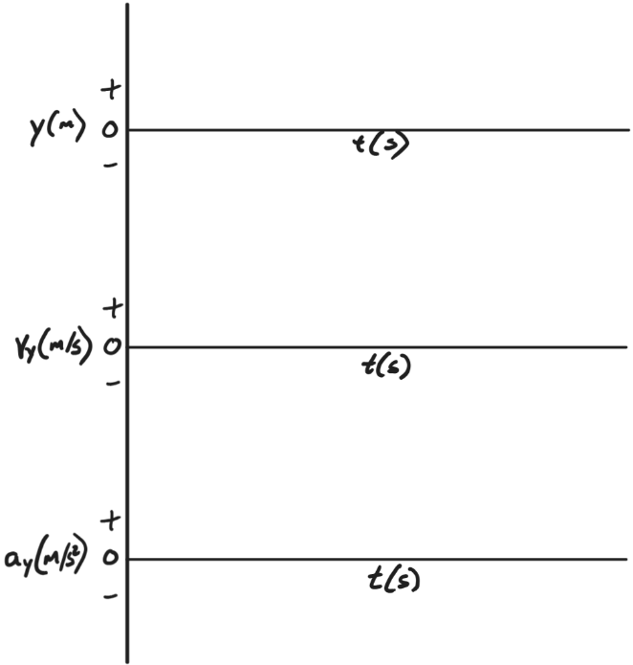



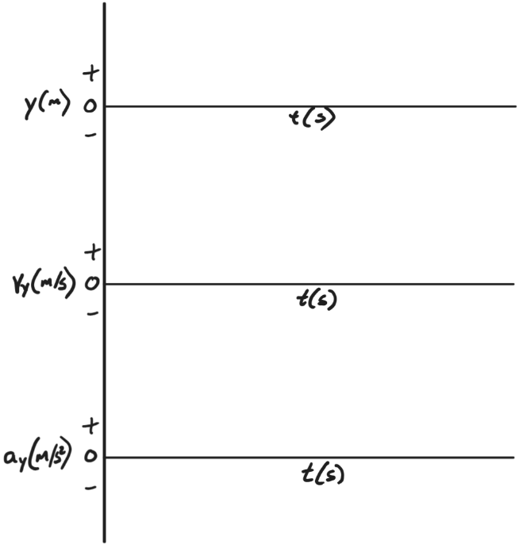

* 1. For this set of graphs, show the moments just before, during, and after it has reached its apogee (highest point). To keep things simple, since the rocket is moving slowly, **you can ignore air resistance.** [Use the graphs to the right.]

18. According to Newton’s 1st law, objects in motion sometimes “remain in motion in a straight line and at a constant speed.”

a. When do water rockets do this?

b. Why do they only do it then?

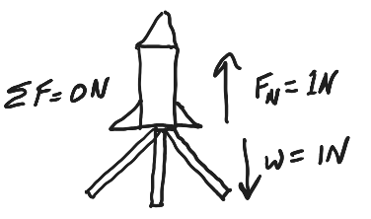19. A rocket sits on its launcher, ready to launch. The rocket’s weight pulls it down toward the launcher. The launcher’s surface pushes up on the rocket with the same force.

a. How could you prove that these forces are not 3rd law pair?

b. Explain how that constitutes proof?

20. Describe one 3rd law pair of forces that is involved when a rocket is falling downward from the sky. Give the direction of each force, and tell what it acts on.

**Problems:**

1. A rocket takes 3 seconds to reach its apogee after launching. If the y displacement is 60m, what is the rocket’s average velocity during these 3 seconds?

2. A ball is launched directly upward, in the absence of air resistance (so its acceleration is -9.8m/s2), with an initial velocity of 30m/s.

a. How long does it take the ball to reach its highest point?

b. How high does the ball go before falling back to Earth?

c. Considering the ball’s entire round trip (up and back), what is the ball’s **overall** **displacement** (not distance)?

d. Considering the ball’s entire round trip (up and back), what is the ball’s **overall** **average velocity** (not speed)?

e. Considering the ball’s entire round trip (up and back), what is the ball’s **overall average speed?**

3. A 20kg **rock** is hanging from a rope. If the tension in the rope is 120N, what is the acceleration of the rock?

Magnitude of acceleration: __________ Direction of Acceleration: ___________

4. Consider the diagram on the right and the following information.

* The rocket’s cross-sectional area is 0.01m2
* The density of the surrounding air is 1.22kg/m3
* The rocket’s drag coefficient is 0.3.
* The rocket’s velocity and weight are shown in the diagram.

a. Find the rocket’s mass.

b. Find the force of drag acting on the rocket.

c. Calculate the rocket’s acceleration.

d. Assuming that this rocket has no parachute, what would its terminal velocity be if it fell from a very high elevation?

5. The same rocket has just made contact with the ground, but it has not stopped moving downward. Find the normal force exerted on the rocket by the ground.

FN = ______

Consider the flight of a water rocket.

* **Before the launch, the total mass of the rocket is 0.8kg.**
* After all of the water comes out during the thrust phase, **the rocket’s total mass remains constant at 0.3kg for the rest of the flight.**
* The rocket has a parachute, which deploys when the rocket is half-way to the ground.
* The rocket reaches terminal velocity before it lands.

Moments during the launch are described in terms of the rocket’s velocity and acceleration at those points. First, mentally identify what the rocket is doing. Before you forget, think about what the rocket’s mass should be and write it down. Then draw a diagram showing the rocket and the individual forces and net force acting on the rocket. Use arrows to show the directions of the forces. Label each force with its correct name and its magnitude.

6. At this moment, the rocket has negative velocity (-4m/s) and zero acceleration. Mass = ______

7. At this moment, the rocket has 0 velocity and positive (+100m/s2) acceleration. Mass = ______

8. At this moment, the rocket has negative velocity (-15m/s) and positive acceleration (+5m/s2).

Mass = ______

9-11. Starting from rest, a rocket-powered sled accelerates rightward. Once the sled reaches top speed, its engine shuts off and the sled slides to a stop. You should assume that **friction acts on the sled for the entire time that it is moving**, and you should assume that **this force of friction is constant**. Ignore air resistance.

9. This problem focuses only on the **acceleration** period (see diagram). The rocket sled and its driver (total mass = 2,000kg ) accelerate horizontally from 0mph to 60mph in 4.4 seconds.

a. Convert 60mph to m/s.

b. Calculate the sled’s average acceleration?

c. How far does the sled travel during this time?

10. This problem focuses only on the **deceleration** period (see diagram). When the rocket sled’s rocket engine is turned off, there is no more thrust. At this point, friction slows the sled down, bringing it to a stop in a time of 7 seconds. What is the force of friction that acts on the sled?

11. If we assume that this force of friction was constant for the entire time that the sled was moving, what was the magnitude of the rocket sled’s thrust during the acceleration period?