Unit 1 Practice Test Version 2 Name: ____________________________

Physics 200 (25-26)

**Formulas** [These will be optional on the test . You get +1% for not using formulas.]:

$\overline{v}=\frac{v_{0}+v}{2}$ $\overline{v}=\frac{∆x}{∆t}$ $a=\frac{∆v}{∆t}$ $speed=\frac{distance}{time}$ $∆ =final-initial$ $ΣF=ma$ $w=mg$

**Multiple Choice, Matching, and Short Answer**

1. Circle **all** of the quantities that are **scalars**.

Force Displacement Acceleration Distance Position Speed Velocity

2. This is another word for “change in position.”

Position Displacement Velocity Speed Acceleration

3. This tells us how fast something is moving, but it does not tell us the direction of movement.

Position Displacement Velocity Speed Acceleration

4. This tells us how the velocity of an object changes over time.

Position Displacement Velocity Speed Acceleration

#5-9 Answer Choices: A. Drag B. Tension C. Weight D. Normal Force E. Friction

5. A B C D E Resistance between two surfaces sliding across one another

6. A B C D E The pulling force in a rope, cable, or chain

7. A B C D E A force exerted perpendicularly outward by a surface

8. A B C D E The force of a planet’s gravity acting on a smaller object.

9. A B C D E Resistance acting on an object moving through a fluid

10. Average Velocity:

11. Displacement:

12. Final Velocity:

13. Position:

Fill in the blanks…

14. 1kg = __________ pounds 15. 1 m/s = __________ mph

16. 1 foot = __________ meters 17. 1N = _________ pounds

17-20. The top row of graphs below plot position vs. time. The middle row shows velocity vs time, and bottom row shows acceleration vs time.

17. Which **velocity graph** represents the same motion as **position graph B**?

F G H I J

18. Which **position graph** represents the same motion as **velocity graph G**?

A B C D E

19. Which **position graph** represents the same motion as **acceleration graph K**?

A B C D E

20. Which **acceleration graph** represents the same motion as **position graph A**?

K L M

21. A car travels rightward at the speed limit. The driver sees a stop sign and stops the car. The car waits for its turn at the intersection and then resumes traveling rightward at the speed limit. Then the car stops at another stop light, and that is where this story ends. Sketch a graph of the car’s acceleration vs. time for this entire “story.”

21. Astronauts orbiting the Earth feel weightless, but they’re not. Explain why this is not true weightlessness.

22. Describe what something could be doing if it has negative acceleration and positive velocity.

23. Describe what something could be doing if it has negative acceleration and zero velocity.

**Problems: \*\*\*\***Include correct units with all answers. For possible partial credit, clearly show useful starting formulas and intermediate answers.****

1. A car travels **8m to the right** (positive direction). Then it drives in reverse, traveling **leftward for 16m**. Assuming that **the entire round trip takes 8 seconds**…

a. What is the car’s average velocity for the entire trip?

b. What is the car’s average speed for the entire trip?

2. Wile E. Coyote drops an anvil in the absence of air resistance. After falling for a short time, the anvil’s **velocity is -49m/s**. The anvil continues to fall for **8 more seconds** until it hits the ground (somehow missing the road runner and landing on Wile E. Coyote). During this 8 second time period…

a. What is the anvil’s change in velocity?

b. What is the anvil’s final velocity?

c. What is the anvil’s average velocity?

d. How far does the anvil fall?

3. The rocket on the right has just touched the ground, but it is still moving downward. There are three forces acting on the rocket, and they are all shown in the diagram. **The rocket’s mass is 0.204kg**. What is the rocket’s **current acceleration?**

4. A bass weighing **24 Newtons** is hanging from a scale. The scale works perfectly, but it reads **30N**, because the person holding the scale isnot holding it steady, and this is causing the bass to accelerate.

a. What is the bass’ mass?

b. What are the magnitude and direction of the bass’ current acceleration?

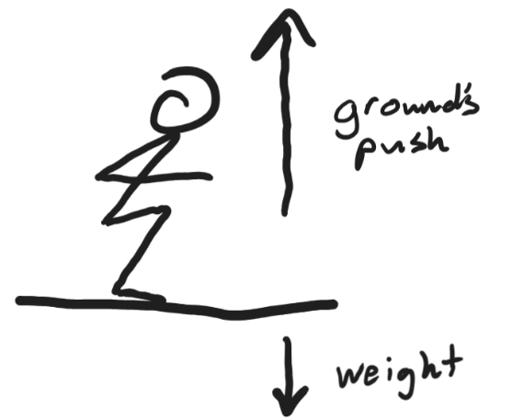5. The diagram on the right shows the only two forces acting on a student as she jumps (we’re ignoring air resistance). **She starts her jump from rest**, and after a **time of 0.12 seconds her velocity is 5m/s, upward. The student’s mass is 50kg**.

a. What is her acceleration?

b. What is the magnitude of the net force acting on the student?

c. What is the magnitude of the ground’s pushing force on the student? [We haven’t talked about Newton’s 3rd Law yet, but this force is equal and opposite to the student’s pushing force against the ground. We jump by pushing the ground downward so that it will push us upward.]