Physics 100 Name: ___________________________
Introduction to Electric Circuits and Current
Notes and PhET DC Circuit Activity

1. There are AC circuits and DC circuits. Right now we are focusing on DC electricity. What do AC and DC mean?

2. What is an electric circuit?

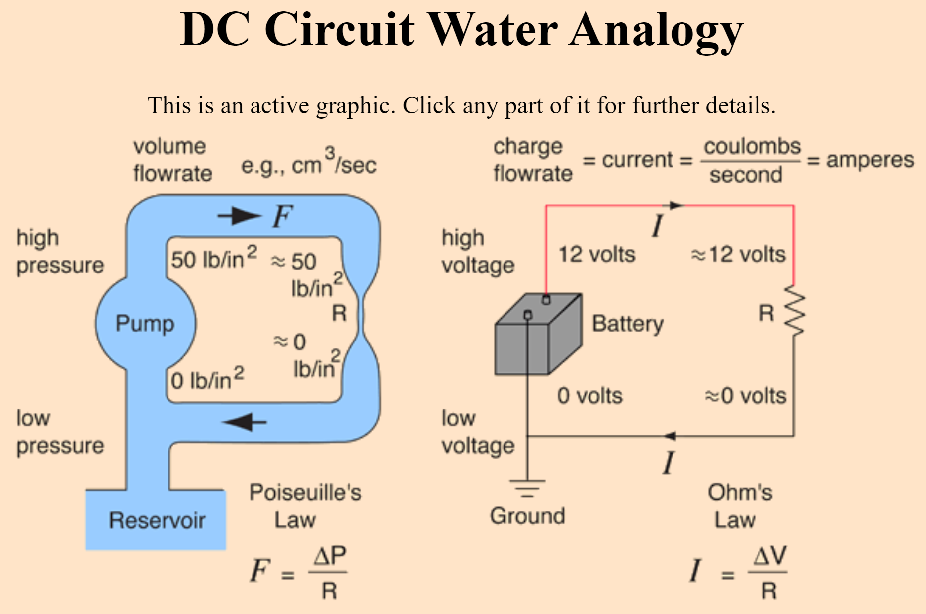

3. In the water circuit, above, what makes the water move?

4. In the electrical circuit, what makes the electricity move?

5. In the electrical circuit, what is the word that we use for the amount of charge that flows around the circuit?

6. In the water circuit, what slows down the water during its trip around the circuit?

7. What slows down the electrical current as it travels around the electrical circuit?

Playing with Circuits: pHet Simulation Circuit Construction Kit: DC

8. Build a simple circuit with one light bulb and one battery. Add another light bulb to the circuit and describe what happens to the current. Did current increase or decrease? Sketch your circuit.

9. Now try to change the circuit so that current changes in the other way (compared to #8). If current increased in #8, see if you can add that second bulb in a way that makes the current decrease. If current decreased in #8, try to find a way to add a second bulb so that the current increases. Sketch your solution.

10. Find two ways to speed up current. Describe them here.

11. We say current flows from positive to negative. This sort of current is called “conventional current.” In reality, electrons move from negative to positive. Change the current mode from electron flow to conventional current and observe what happens. You don’t have to write anything here.

12. Use the voltmeter to measure the voltage of a battery. Do this by touching the probes to opposite ends of the battery. What is the voltage of one battery?

13. Use the ammeter to measure current. What unit is current measured in – what is it’s letter?

14. What causes fires to occur?

15. What other types of objects (other than wire) can you find that can be used to build circuits?

16. What is the purpose of the fuse? Find out and then explain here. If you want a hint, search it up on the internet.

