**Unit 5 Packet: WAVES and SOUND**

Physics 100 Name: _________________________

Mechanical Waves Notes

Wave:

Oscillation:

Types of Waves:

Mechanical Wave:

Examples of Mechanical Waves:

Electromagnetic Wave:

Examples of Electromagnetic waves:

Types and parts of waves:

Name the two different types of waves, below, and explain their primary difference.

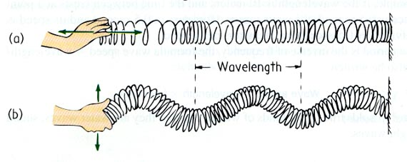

Parts of a transverse wave: crest, trough, wavelength, amplitude

What is the symbol for wavelength?

Name a unit that is used to measure wavelength:

Parts of a longitudinal wave: compression, rarefaction, wavelength



What determines the amplitude of a longitudinal wave?

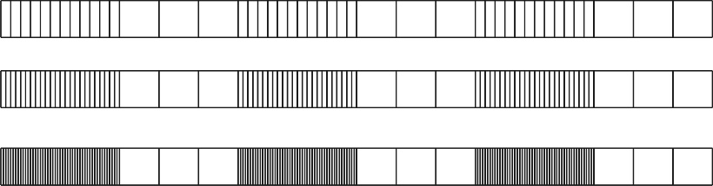

Which of the series of waves on the right shows the greatest amplitude?

Sound waves are longitudinal, but they can be represented as transverse waves:

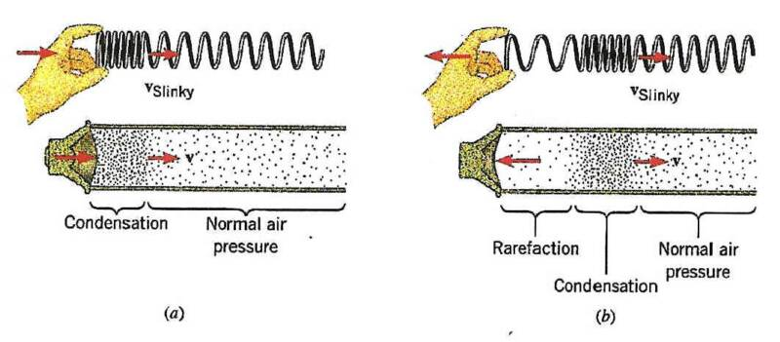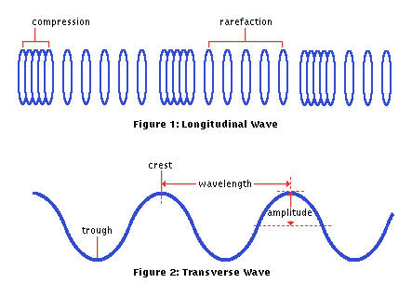

Period and Frequency

Period:

Frequency:

Symbol for frequency:

Units for frequency:

Relationship between period and frequency:

What is the period of the waves below? _________ Calculate the frequency of those waves. λ = _________

Wave Speed

What are the standard (SI) units for wave speed?

Two formulas that can be used to calculate wave speed:

What is the speed of a wave if its wavelength is 5m, and its frequency is 20Hz?

What is the speed of a wave that travels 20m in a time of 5 seconds?

Wave Interference: When two waves overlap one another, their oscillations can add to one another, or they can diminish one another. Label the examples of interference on the right.

Wave Interference can cause “**beats**”. When two waves have slightly different frequencies, their interference alternates between constructive and destructive. The diagram below shows transverse representations of two sound waves (channels 1 and 2) and their resultant sound (channel 3).

* In the diagram, label the channel with the highest frequency (1 or 2).
* Then label regions of constructive and destructive interference. Channel 3 is the “sum” of channels 1 and 2.
* Label the “beats” that will be heard

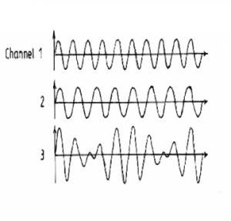

**Sound/Wavesn – More Notes, and Some Problems**

Resonant Frequency:

What does it mean when someone says, “that idea resonates with me?”

The resonant frequency of a child on swing A is 0.5hz. The resonant frequency of the child on swing B is 0.2hz. If you plan to provide the child with the enjoyable experience of being pushed, explain how you should push the child differently on swing B, as opposed to swing A.

**Good Stuff**

Speed of sound in air = 340 m/s

Speed of sound in water = 1500 m/s

**Problems**

1. How long does it take sound to travel the length of the hallway (50 meters)?

2. A dolphin finds food by sending a sound pulse through the water and listening for the echo. How far away is the food if the dolphin hears the echo in 0.10 seconds?

1. How can someone use the sound of thunder to tell how far away a lightning strike was?
2. A fisherman sits on a boat in a lake and is not having very much luck, so he relaxes and watches the waves go by. He notices that 5 waves hit his boat in 15 seconds and it takes each wave 4 seconds to travel the length of his 5 meter long boat. Find
3. The frequency of the waves.
4. The speed of the waves.

c. The wavelength of the waves

8. The adjacent diagram shows a standing wave pattern. (3 pts)

a. Label all the nodes with an N

b. Label all the anti-nodes with an A

c. How many wavelengths long is the segment?

9. Sketch a standing wave in the space provided below that has 3 antinodes and 2 nodes. How many wavelengths are present? (3 pts)

**Chapter 25-26 PRACTICE #1– Waves and Sound**

**Part I: Write the SI unit for each of the following quantities.**

|  |  |  |
| --- | --- | --- |
| **Quantity Abbrev.** | | **SI Units** |
| Wavelength |  |  |
| Wave Speed |  |  |
| Frequency |  |  |

**Part II:**

1. Which wave has the longest wavelength? ________

2. What is that wavelength? ___________

3. Which wave has the shortest wavelength? ________

4. What is that wavelength? ___________

5. Which wave has the largest amplitude? ________

6. What is that amplitude? ___________

7. Which wave has the smallest amplitude? ________

8. What is that amplitude? ___________

9. Which two waves, when added together, will give complete destructive interference?

10. Give an example of a transverse wave.

11. Describe (or list) an example of a longitudinal wave.

**Part III:**

v

f

●

**Key Equations:**

**f = waves/seconds T = seconds/waves**

T =  f =  v = f

12. Which wave has the longest period? ________

13. What is that period? ___________

14. Which wave has the highest frequency?

15. What is that frequency? _________

16. Given v = 20.0 m/s, find T, f, A, and .

T = _______

f = _______

A = _______

● = _______

17. Given v = 500.0 m/s, find T, f, A, and 



T = _______

f = _______

A = _______

● = _______

18. Determine the wavelengths of the series of sound waves below

Top waves: Bottom Waves:

19. Label a rarefaction on one of the waves above.

20. Assuming that they travel at the same speed, which of those waves will have a higher frequency?

21. Which of those waves, above, has a greater amplitude?

22. If two sounds are identical except for their amplitude, what difference will you hear if you listen to them?

23. The transverse waves on the right are being used to represent sound waves.

1. Label the wave with the highest frequency
2. Circle an area where interference will be most constructive.
3. Circle an area where interference will be most destructive
4. Label the area where a “beat” will be heard if the two sounds are played together

24. The people on the right are yelling. Whose sound waves have…

1. The highest frequency?
2. The highest pitch?

25. This diagram shows waves produced by a source moving to the right.

a. Which observer notices the highest frequency?

b. Which observer notices the lowest frequency?

26. The diagram below shows waves made by 3 sources moving with different speeds. Which source is moving the fastest? Circle one.

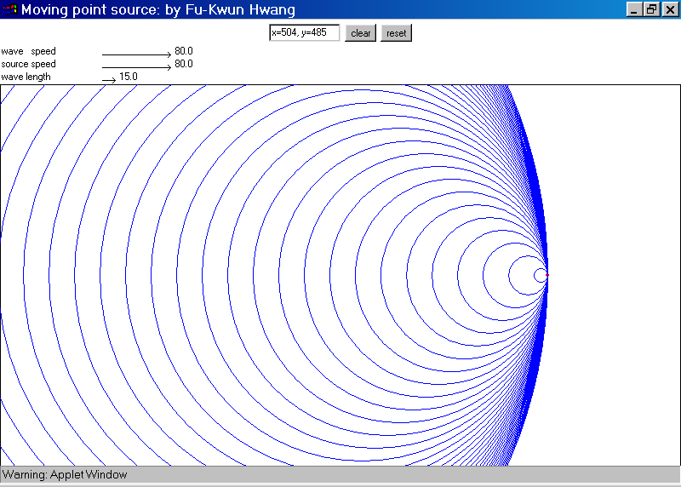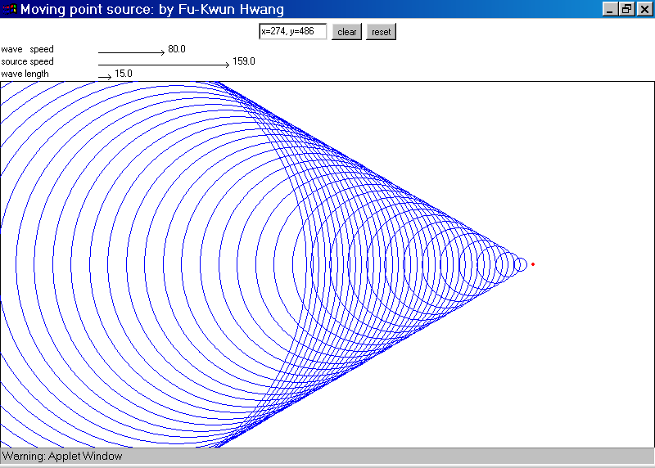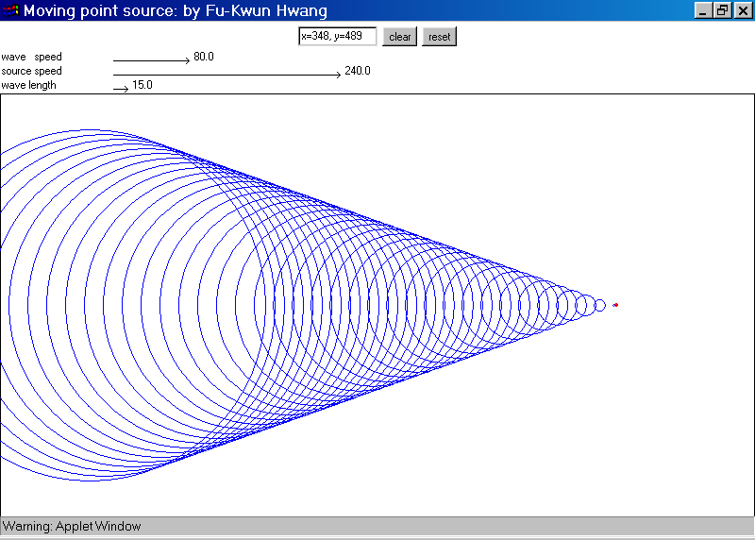

27. On each of the diagrams above, mark a point where a listener could be situated in order to hear a sonic boom

Physics 100 Name: _____________________________________

2014-2015 Test: Waves

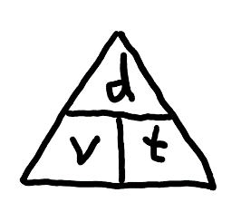

v

f

●

Key Equations:

f = waves/seconds

T = seconds/waves

T =  f = 

* 1. Answer Choices. Use each answer once: A. . mechanical wave B. transverse wave

C. Longitudinal wave D. electromagnetic wave

1. A B C D An oscillation in matter

2. A B C D Oscillations are parallel to the direction of travel

3. A B C D Oscillations are perpendicular to the direction of travel

4. A B C D An oscillation that can travel through a vacuum (empty space)

5. Which of the following is **not** a property of all waves

1. They transfer energy
2. They include oscillations
3. They travel from one point to another
4. They can travel through the vacuum of space.

Match the abbreviations and units below to the correct quantities.

A. Frequency B. Wave Speed C. Period D. Wavelength

6. λ A B C D

7. T A B C D

8. s A B C D

9. hz A B C D

10. m/s A B C D

11. m A B C D

12. v A B C D

12.5. Darken the approximate period and frequency of the wave on the right.

Period = 3s 5s 7s 9s 11s 13s 15s 17s 19s

Frequency = 1hz 1/3hz 1/5hz 1/7hz 1/9hz 1/11hz 1/13hz 1/15hz 1/17hz 1/19hz

13-17. Answer the following questions using the graph below.

13. Which wave has the longest wavelength? A B C D

14. What is that wavelength, in meters?

0.2 0.4 0.6 0.8 1.0 1.2 1.4 1.6 1.8 2.0

15. Which wave has the smallest amplitude? A B C D

16. What is that amplitude, in meters? 0.1 0.2 0.3 0.4 0.5 0.6 0.7

17. Which two waves, when added together, always produce constructive interference? A&B A&C A&D B&C B&D C&D

18. When the two waves on the right interact, they will create beats. How many beats can you see during the time span shown on the graph?

0 1 2 3 4 5 6 7 8 9

19. Which of the sets of waves below represents the **loudest** sound? A B C

20. Which of the sets of waves below has the **least** amplitude? A B C

21. What is the **period** of the waves shown in answer choice B? 2 4 6 8 10 12 14 16 18 20

The diagram to the right shows an object moving and giving off sound waves:



22. Darken the arrow that shows the direction of travel of the object on the right.

23. At which location will an observer hear the **highest** frequency?

A B C D

24. At which location will an observer hear the **lowest** frequency?

A B C D

25. Bats use echolocation to find their prey. Bats can tell that a moth is flying **toward** them if they emit a screech and…

a. the frequency of the echo is lower than the original screech

b. the frequency of the echo is higher than the original screech

c. the echo is quieter than the original screech

d. the echo is louder in the bat’s left ear

26. A singer is singing a very clear note (A – 220hz). The singer’s sound wave consists of a series of rarefactions and compressions. When one of those **compressions** reaches your ear, what happens to the air pressure felt by your ear?

a. it increases b. it decreases c. there is no change d. frequency increases e. frequency decreases

27. The pictures on the right show sound waves produced by moving objects. In which case is the object is moving the **fastest?**

1. B. C.

28. Given v = 30, use the graph on the right to find T, f, A, and .

T = _______

f = _______

A = _______

● = _______

29. Sketch a standing wave in the space provided below that has 5 antinodes and 4 nodes. The dark line represents the wave’s equilibrium position.

30. How many wavelengths long is the diagram that you just drew, above? ___________

31. You saw lightning flash 20 seconds before you heard the thunder. How far away was the lightning strike?

32. A bat finds a moth by sending a sound pulse through the air and listening for the echo. If the bat hears the echo 0.02 seconds after it makes the sound, how far away is the moth?

33. You’re watching waves splash against a boat. You notice that 2 waves pass you every 5 seconds. You also notice that one wave travels the length of the boat in 3 seconds. The boat is 10m long. Find…

1. The frequency of the waves.
2. The speed of the waves.

c. The wavelength of the waves