Physics 100 Name: __________________________
Extra Waves Notes: Interference and Standing Waves

1. When two or more waves arrive at the same point, they add to or subtract from one another to create a new wave. The new wave can be discovered by adding the _________________ of the individual waves. This is a phenomenon called ____________________. When the crest of one wave matches up with the trough of another, this is called ____________________ interference. When the crests and troughs of the two waves match up, the result is called _____________________ interference.

Pure ______________ Interference
Pure ______________ Interference

2. In the diagram below, two waves pass through each other moving in opposite directions, and their disturbances add as they go by. Since the two waves have the same ___________________ and ___________________, then they alternate between constructive and destructive interference. The resultant looks like a wave standing in place. This is called a ____________________________.

3. To our eyes, a standing wave in a string can look like the example below. The points in the string that

do not move are called ______________, and the points that move the most are called _____________________.

String Instrument Harmonics:

A plucked string seems to be simply vibrating back and forth, perpendicularly to the length of the string. In actuality, when a string is plucked, waves travel back and forth along the length of the string, interfering with one

another. This creates several different sets of standing waves, called _________________________.

When we listen to a string instrument, the frequency that we hear is the frequency of the __________________

harmonic, which is the standing wave with the longest possible ________________________, given that the ends of the strings must be nodes.

4. Draw the first harmonic standing wave of a string. Label the nodes (N) and antinodes (A):

5. What is the wavelength of the first harmonic, in terms of the string length, L? λ = ________L
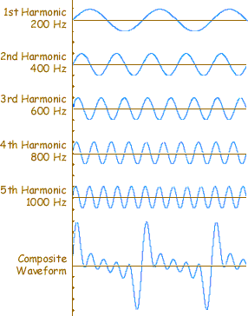
Although our ears can’t pick them out, when a string is plucked, we also hear many other harmonics. The diagram on the right shows how the individual harmonics add up to the “composite waveform” that we hear.

The harmonics are named according to their wavelengths. The 2nd harmonic has half the wavelength of the first harmonic. The 3rd harmonic has 1/3 the wavelength of the first harmonic. The 4th harmonic has 1/4 the wavelength of the first harmonic

6. Draw the 2nd, 3rd, and 4th harmonics (but know that there’s no end to the harmonics), and label their nodes and antinodes. Write their wavelengths in terms of L

