Physics 100 Name: ________________________________
Sound and Waves
Guitar Notes: Understanding Fret Spacing and Scales (both major and minor)

Note  Name | half steps  up from starting note | Frequency (Hz) | Ratio: Current frequency / Previous frequency | Ratio of wavelength to starting note wavelength
A | 0 | 440 | NA | 1
A# (or B♭) | 1 | 466 | 1.059 | 0.944
B | 2 | 494 | 1.059 | 0.891
C | 3 | 523 | 1.059 | 0.841
C# (or D♭) | 4 | 554 | 1.059 | 0.794
D | 5 | 587 | 1.059 | 0.749
D# (or E♭) | 6 | 622 | 1.059 | 0.707
E | 7 | 659 | 1.059 | 0.667
F | 8 | 698 | 1.059 | 0.630
F# (or G♭) | 9 | 740 | 1.059 | 0.595
G | 10 | 784 | 1.059 | 0.561
G# (or A♭) | 11 | 831 | 1.059 | 0.530
A | 12 | 880 | 1.059 | 0.5
A# (or B♭) | 13 | 932 | 1.059 | 0.472
B | 14 | 988 | 1.059 | 0.445
C | 15 | 1047 | 1.059 | 0.420
C# (or D♭) | 16 | 1109 | 1.059 | 0.397
D | 17 | 1175 | 1.059 | 0.375
D# (or E♭) | 18 | 1245 | 1.059 | 0.354
E | 19 | 1319 | 1.059 | 0.334
F | 20 | 1397 | 1.059 | 0.315
F# (or G♭) | 21 | 1480 | 1.059 | 0.297
G | 22 | 1568 | 1.059 | 0.281
G# (or A♭) | 23 | 1661 | 1.059 | 0.265
A | 24 | 1760 | 1.059 | 0.25
1. When musicians play a 1-octave scale, they play ________ notes. When we hear the musical notes at the bottom and top of a 1-octave scale, our ears perceive those notes as being the same notes, even though one sounds higher and one sounds lower.

2. When two notes are separated by an octave, the higher note has a frequency that is

___________________ the frequency of the

lower note.

For example, a musical note with a frequency of 110Hz is an A. If we start singing at that pitch and move gradually upward, we will reach the next A when we get to ______Hz. The next A after that will be heard at _______Hz.

3. The music that most of us listen to uses notes

that divide each octave into ________ equal parts. Each of these equal parts is called a

_________________________

4. A one octave jump in pitch represents a ______________________________ of sound wave frequency.

5. A two octave increase in pitch represents a 2⁽ ⁾ increase in frequency.
6. A three octave increase in pitch represents a 2⁽ ⁾ increase in frequency.
7. A four octave increase in pitch represents a 2⁽ ⁾ increase in frequency.
8. A 1/12 octave increase in pitch (in other words, a half step) represents a 2⁽ ⁾ increase in frequency. In other words, to raise the pitch of a sound by a half step its frequency must be multiplied by 2^{(1/12)} ≈1.0595.

9. 2^{(1/12)} ≈1.0595

10. One whole step = ___________________

The Piano Keyboard

11. On a piano keyboard, the keys get higher in pitch (and frequency) as you travel to the _____________ (left or right?).

12. Each key on a piano keyboard, whether it is black or white, is separated from the next key by exactly one

_______________ step.

13. On a piano keyboard, the white keys are the notes (A, B, C, D,E, F, and G) and the black keys are called sharps (#) or flats(♭). The black key just to the right of a white key is called a __________. The black key with a pitch just to the left of white key is called a ____________.

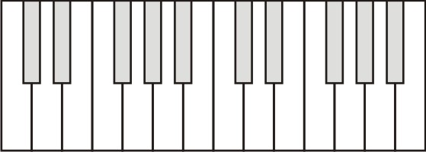
14. Label 13 consecutive piano keys with their note names. For the darkened keys, give either the sharp name or the flat name.

15. If you play all of these notes, from low to high, you are playing what is called a

_____________________________________________

16. A major key scale has the following pattern of whole and half steps:

17. The only major key scale that can be played without using any black keys is the _______ Major scale.

18. Starting with 1, number the keys of a C major scale. Since the first and last note are the same, give them both a 1.

19. Number the keys of an A major scale.

20. A minor key scale has the following pattern of whole and half steps: __________________________

21. The only minor key scale that can be played without using any black keys is the _______ Minor scale.

22. Number keys of a 1-octave A minor scale.

23. Number the keys of a 1-octave C minor scale.

Guitar Notes (frets instead of keys):
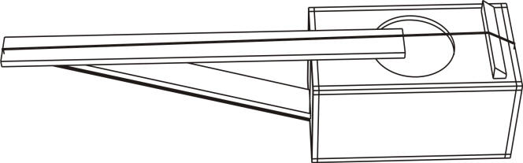

24. Label the nut and the saddle on the string instrument to the right.

25. The diagram below shows an idealized string instrument with frets. The bold line down the middle represents the string.
a. Label the saddle and the nut.

b. What is the pattern of whole and half steps for a major scale?

c. Number the frets that you would use to play a major key scale, starting with the open string.

26. a. What is the pattern of whole and half steps for a minor scale?

27. b. Number the frets that you would use to play a minor key scale, starting with the open string.

The Grand Finale:

28. Pretend the diagram below is your guitar. Write two sets of numbers on the frets…
- Above the string, write numbers for a major scale. Start with a “1” at the nut, and continue rightward. Don’t stop at one octave. Keep going.
- Below the string, do the same thing, but write numbers for a minor scale.

29. Now do the same thing on your actual guitar. Make sure that you have made properly spaced fret marks first.

Review questions:

30. How are the frets spaced on a guitar? Why are they spaced apart by those exact distances?

31. How many notes are in a one octave scale?

32. How many of the notes in a one octave scale are the same note? Which ones are they?

33. Are the notes in a scale evenly spaced along the guitar neck?

