Physics Name: ________________________
Notes: Light and Wave Behaviors

1. What is light?

The “wave-particle duality” of light (and all electromagnetic radiation):

2. How is light like a particle?

3. How is light is like a wave?

The Electromagnetic Spectrum

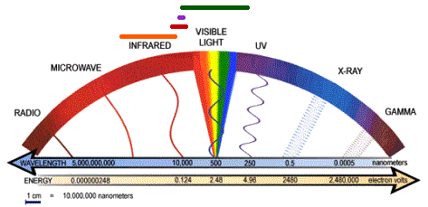

4. The color of light depends on its wavelength. List the colors of light from longest to shortest wavelength:
5. Nicknames for The Two Ends Of The Spectrum:

- The long-wavelength end of the visible spectrum is called the ___________________ end.

- The short-wavelength end of the visible spectrum is called the ___________________ end.

6. Black and white are not really colors. What are they, in terms of wavelengths of light?

Black:

White:

. Describe two ways to show that white light is actually made up of a rainbow of colors?

14. Ordinary (incoherent) light waves:

15. *Coherent light waves (found in ____________________):

Wave Behaviors:

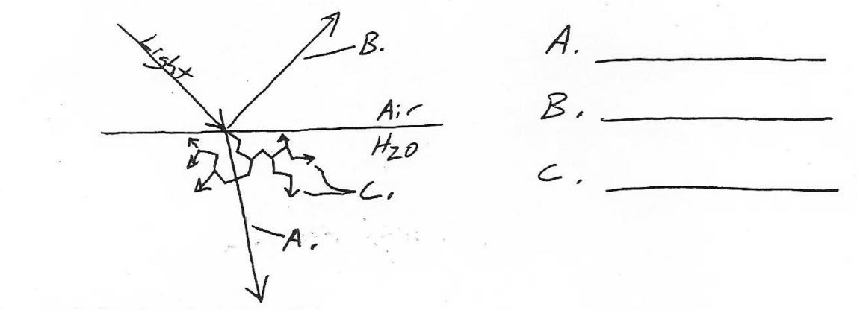

Reflection of waves:
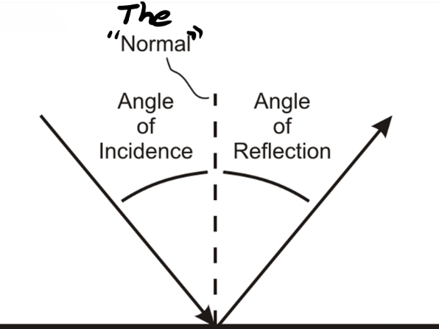
The Law of Reflection: Angle of incidence = angle of reflection

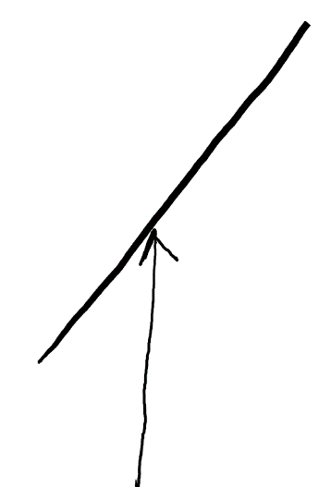
Reflection Practice:

- Show how a light ray is reflected when it hits the mirror.
- Draw and label the “normal.”
- Label the angle of incidence and the angle of reflection.

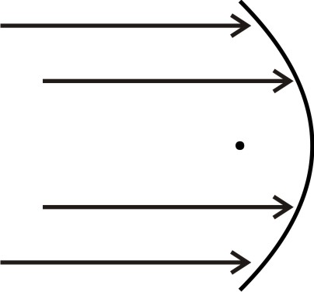
- Show how light reflects off of the parabolic mirror on the right. For one light ray, label the “normal,” the angle of incidence, and the angle of reflection.

Refraction (Bending) of Light

0. The speed of light in a vacuum = C = ________________

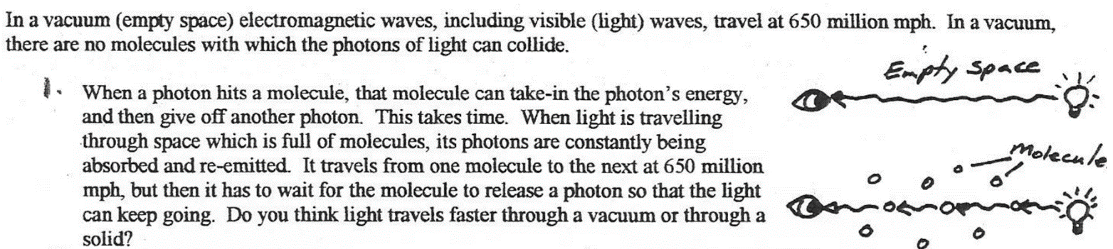

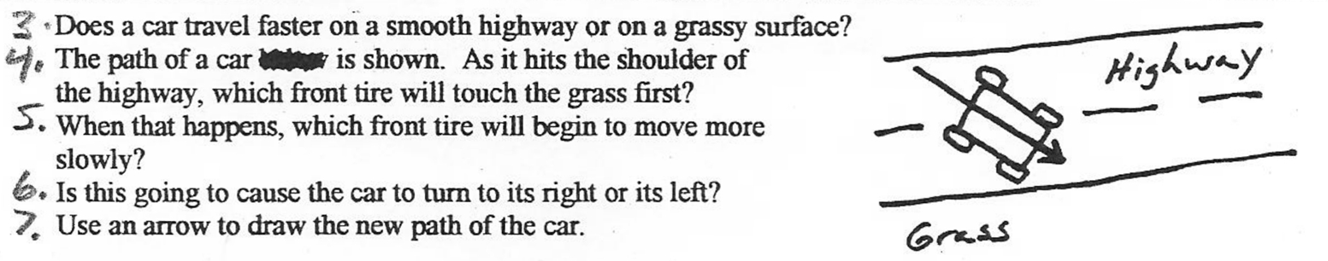

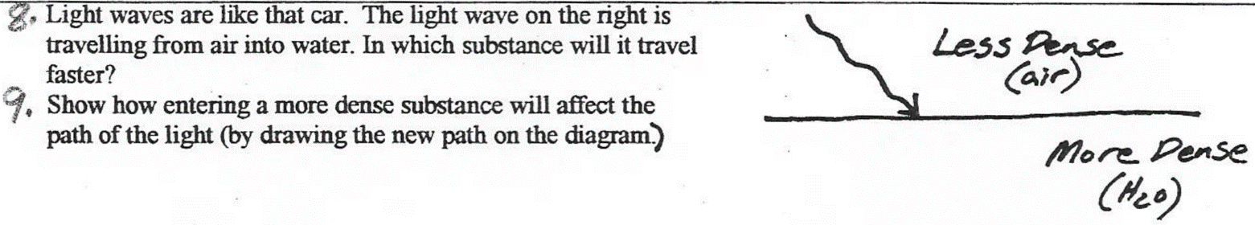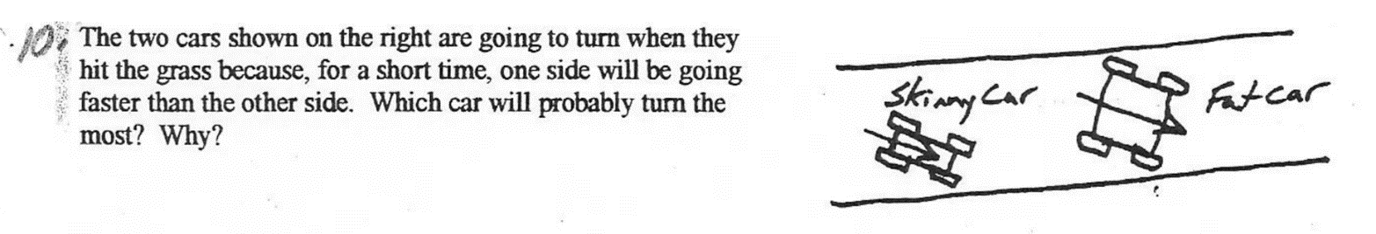

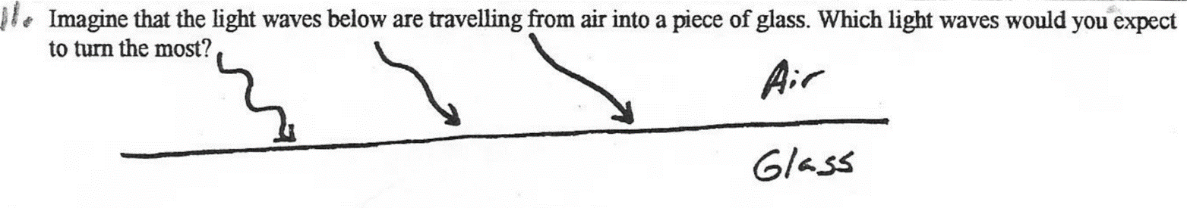

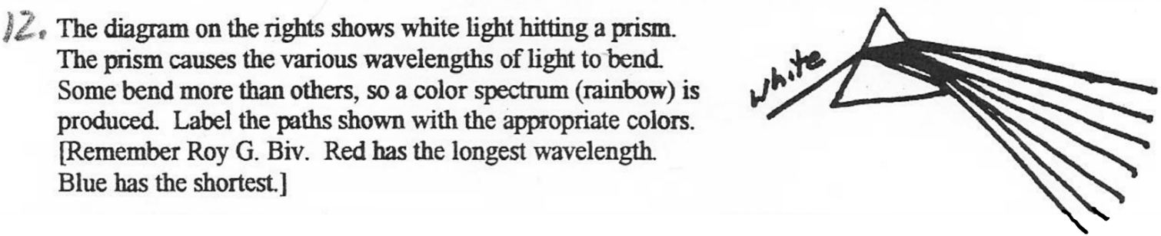

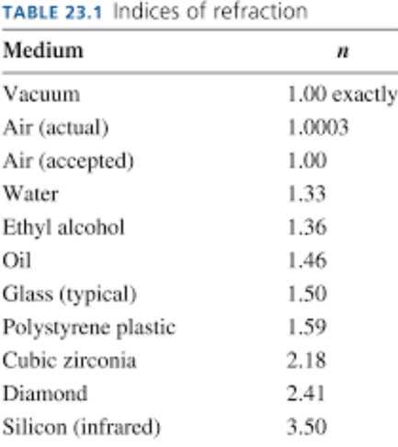
13. When light refracts (bends), it turns __________________ (toward or away from) the medium in which it travels more slowly.

14. Index of Refraction:

15. Higher n = light travels _________ (faster, more slowly).

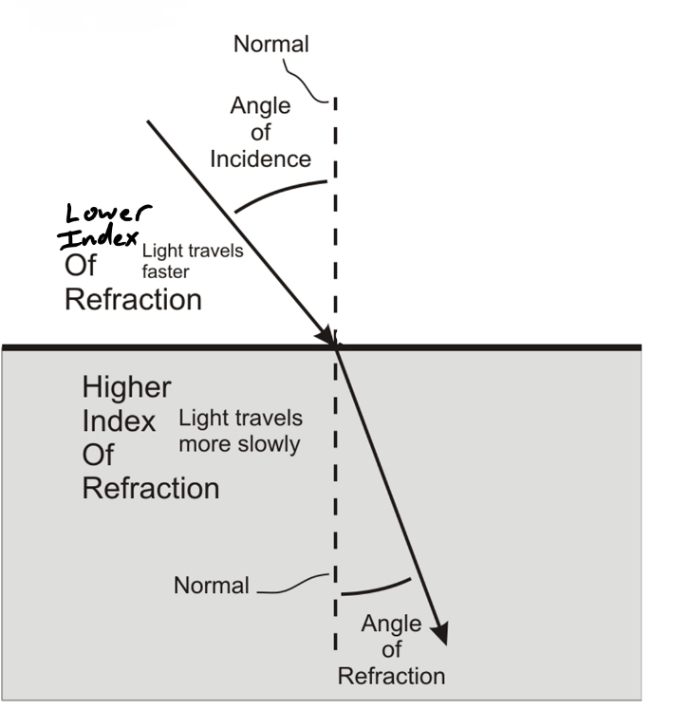
Lower n = light travels _________ (faster, more slowly).

16. The diagram on the right illustrates the Law of Refraction. According to the Law of Refraction…

a. When a light ray travels from a material with a lower n to a material with a higher n, the angle of refraction will be __________ (less than or greater than) the angle of incidence.

b. When a light ray travels from a material with a higher n to a material with a higher n, the angle of refraction will be __________ (less than or greater than) the angle of incidence.

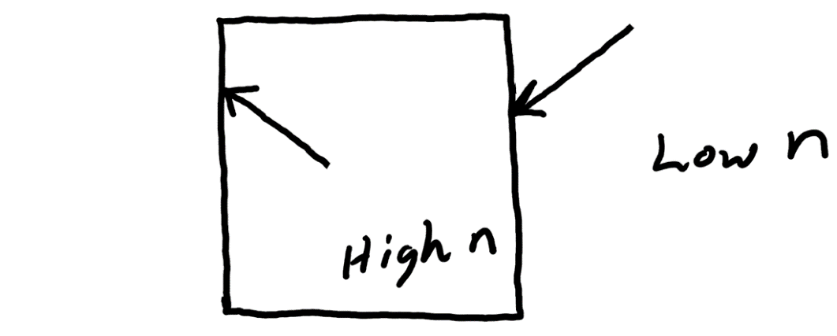
17. The diagram on the right shows a block of clear material with a high index of refraction surrounded by a material with a low index of refraction. For each light ray…
a. Draw the “normal”
b. Label the angle of incidence
c. Draw the angle of refraction. Make sure that the angle’s size is correct (either larger or smaller) compared to the angle of incidence.

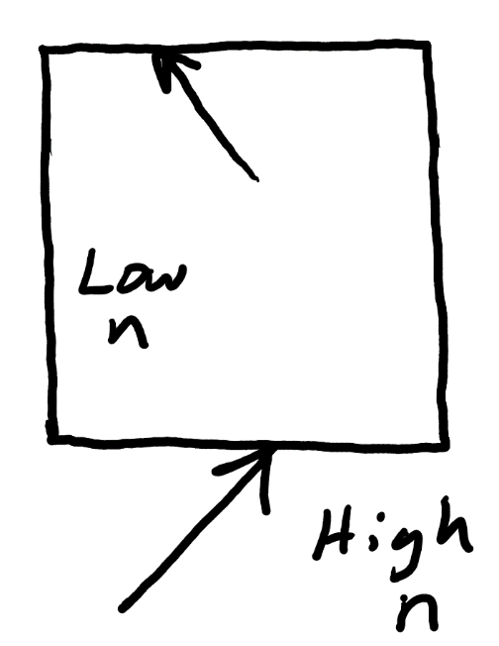

18. Do the same thing on the diagram to the right.

19. The velocity of light in a substance can be found using the equation

