Physics 100
Refraction Practice

For each diagram, draw/label the normal, the angle of incidence, angle of refraction, and the angle of reflection.

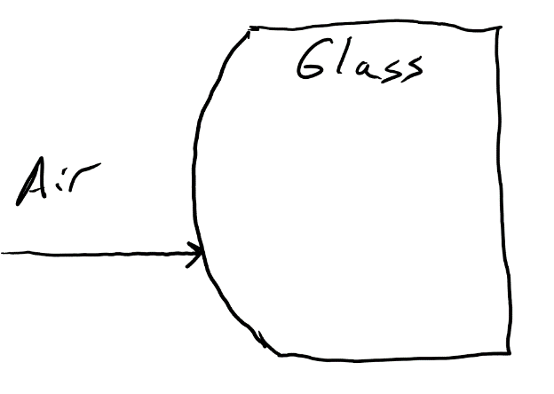
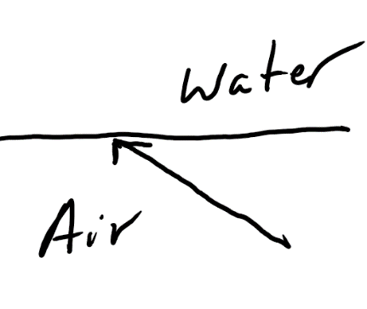

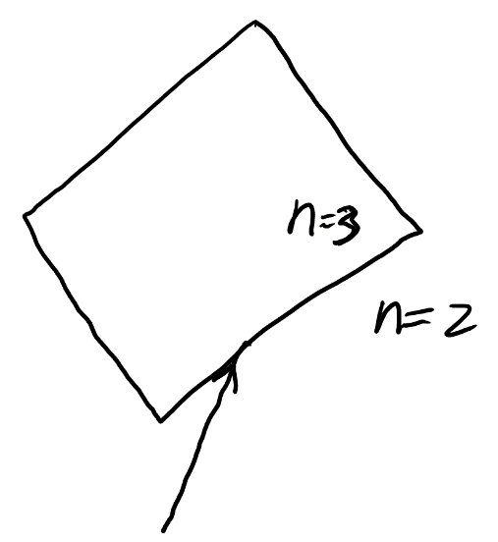
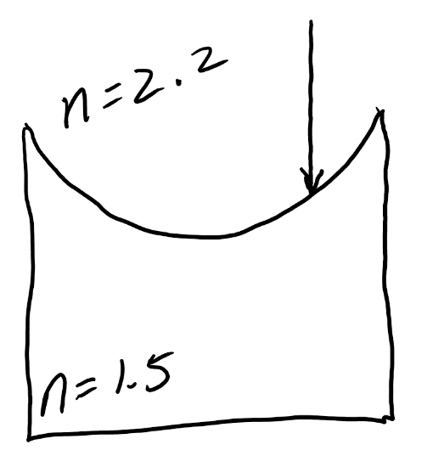

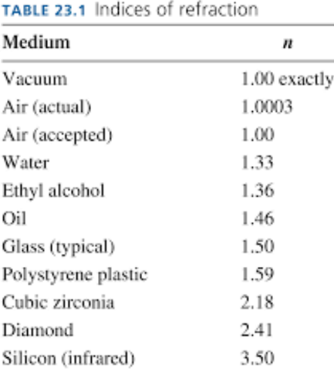

Given that the speed of light in a vacuum is is C = 3x10⁸ m/s….

1. Find the speed of of light in a substance with n = 1.8.

2. Find the speed of of light in a substance with n = 2.3.

3. Find the value of n for a substance in which the speed of light is 1.38x10⁸m/s. Identify this substance.

4. Find the value of n for a substance in which the speed of light is 0.85 x10⁸m/s. Identify this substance using the table on the right.

