Physics 100 Name: ___________________________
More Reflection and Refraction Practice
Lens and Mirror Phenomena (and a fish under water)

1. Draw a convex (bi-convex) lens and illustrate its focal point.

2. Draw a concave (bi-concave) lens.

3. In what situation can a convex lens cause an object to appear larger and right-side up? Draw a picture showing how this happens.

4. In what situation can a convex lens cause an object to appear upside-down? Draw a picture showing how this happens.

5. What do objects look like when viewed through a concave lens? Draw a picture showing how this happens.

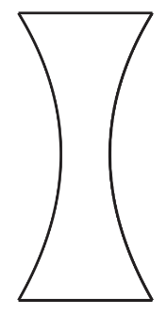

6. In what situation can a concave mirror cause objects to appear larger than usual and right-side up? Draw a picture showing how this happens.

7. In what situation can a concave mirror cause objects to appear upside-down? Draw a picture showing how this happens.

8. What do objects look like when viewed in a concave mirror? Draw a picture showing how this happens.

9. When viewed from a boat, do fish appear larger or smaller than they really are? Draw a picture showing how this happens.

