Physics 200 (Stapleton) Name: _________________________
Notes: Introduction to Newton’s Laws

Newton’s 3 Laws of Motion:
- 1st Law: Law of Inertia. Objects in motion…
- 2nd Law: F=ma
- 3rd Law: Action/reaction

Net force (F_{net}):
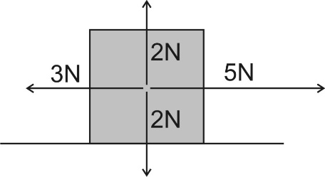

What is the net force that is acting on the box to the right?

Newton’s 1st Law:

- The usual version: Objects in motion remain in motion in a straight line and at a constant speed, and objects at rest stay at rest, unless they are acted upon by an outside (or unbalanced) force.

- Another version: If an object is experiencing a net force, _________________________________________.

If it’s not, _________________________________________________.

Newton's 1st Law is called the "Law of Inertia." Inertia is:

What kinds of objects have the most inertia?

Newton's 2nd Law: F_{net} = ma

Mass:

The unit we will use for mass is the ________________________, which is abbreviated _________

Force:

The unit we will use for force is the ________________________, which is abbreviated _________

Consider a child pushing a toy car. The net force applied to the car equals the mass of the car multiplied by the car’s acceleration. Starting with an ordinary F = ma, show what would happen to the sizes of F, m, and a if…

- The car’s mass is increased, but the applied force is kept the same.

- The car’s mass is decreased, but the applied force is kept the same.

- The car has the same mass, but it accelerates faster.

- The car has the same mass, but less force is applied to the car.

Newton’s 3rd Law:

State Newton’s 3rd Law of Motion:

Describe some examples of action/reaction pairs demonstrating Newton’s 3rd Law.

- Walking Rightward:

- Car driving leftward:

- Helicopter flying upward:

- Gun shooting bullet rightward:

In the case of a gun and a bullet, what is equal and opposite, and what is not? Explain.

