Physics 100 Name: _________________________________
Notes and Practice: Friction and The Normal Force

Define Normal Force:

Define Friction:

What determines the strength of friction between two surfaces?

1)

2)

3)

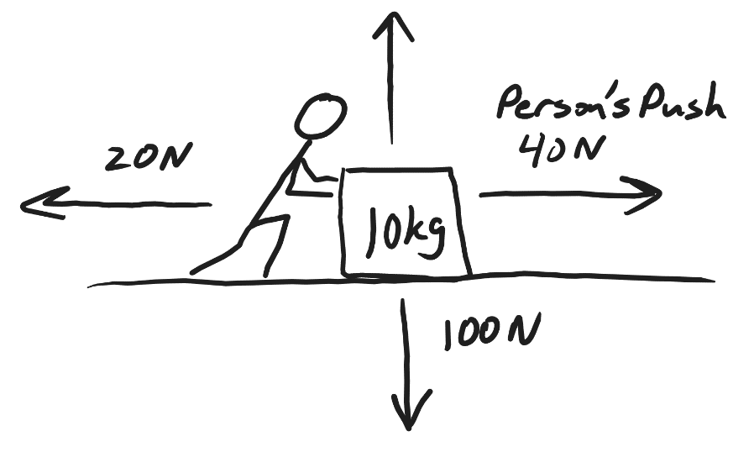
In the diagram on the right, a person is pushing a box. The box is sliding rightward along a level surface. The force of the person’s push is labeled.

A. Label the other forces that are acting on the box: Normal Force, Friction, Weight.

B. Fill in the magnitude of the force that is missing its magnitude.

C. Calculate the net force acting on the box

F_{net} =

D. Use Newton’s 2nd Law to find the box’s acceleration

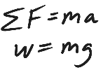
Friction Problems: Draw a diagram showing all of the individual forces and the net force. Then solve the problem.

1. A 3kg box is sliding with a velocity of -2m/s. The force of friction acting on the block. The block’s acceleration is +1m/s². If a person is pushing the block with a force of -4N, what is the force of friction that is acting on the box?

2. A child and her sled have a combined mass of 20kg. Her brother is pushing her along a flat, snowy surface with a force of 40N. If the snow is applying a -10N force of friction, what is the child’s overall acceleration?

3. A hunter is beginning to drag an antelope. The hunter applies a +150N sideways force to the antelope, which has a mass of 60kg. If the antelope is currently accelerating at a rate of 2m/s², what force of friction is acting on the antelope?

4. A car weighing 10,000N is being pushed to the left by three stranded students. If the car has a constant velocity of -1m/s, and the students are applying a total force of -800N, what is the force of friction acting on the car?

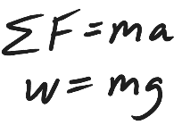
Elevator Problems:
When you’re standing on a scale, what does the scale reading tell you?

5. A student has a mass of 50kg. He is standing on a bathroom scale in an elevator, and the scale reads 300N. What is the student’s acceleration?

6. Another student has a mass of 50kg, and she is standing on a bathroom scale in an elevator. This elevator is accelerating upward at a rate of 2m/s². What is the scale reading?

7*. A third student is also standing on a scale in an elevator, and the scale reads 300N. If the student weighs 600N, what is the acceleration of the student and elevator?

8. A fourth student, whose mass is 60kg, is standing in an elevator on a bathroom scale. The student feels very heavy. In fact, when she looks at the scale, the scale reads twice her normal weight. What is the elevator’s acceleration?

Real-life Problem – Analyzing a Sliding Object

Fill in all of the information below and create a diagram showing all of the forces acting on a sliding object. First slide the object down the hallway and time its slide. Slide it far enough so that you can measure it’s slide time precisely. Then count floor tiles to determine its sliding distance. 1 foot = 0.305m, so you can convert the number of floor tiles (which are each one foot) to meters. Use this formula $\left[a= \frac{2∆x}{t^{2}}\right]$to find the acceleration of the object while it is sliding. Draw a diagram showing all of the individual forces acting on the object as it is slowing to a stop. Add the net force to your diagram, too. Label each force with the correct units, and indicate the correct direction. You’ll need mass in kilograms, so you need to know that 1kg = 1,000g.

Diagram Goes Here…

Slide time (s) _________ Slide distance (floor tiles) __________ Slide distance (meters) __________

Acceleration while sliding (m/s²) = ________ Object mass (g) = _________ Object mass (kg) = _________

F_{net} during slide (N) = ________ Object Weight (N) = __________ F_{Normal} (N) = __________

F_{friction} (N) = ________

Show your math work here...

