Physics 100 Name: _________________________________
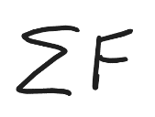
Notes and Practice: Newton’s 2nd Law and Terminal Velocity

1. Newton’s 2nd Law: F_{net} = ma I often write F_{net} like this…

2. If you want, you can use an algebra triangle for F=ma…
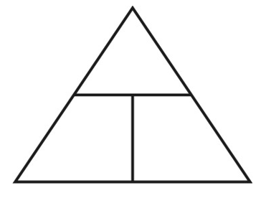

3. Use Newton’s 2nd Law to fill in the missing values in these diagrams

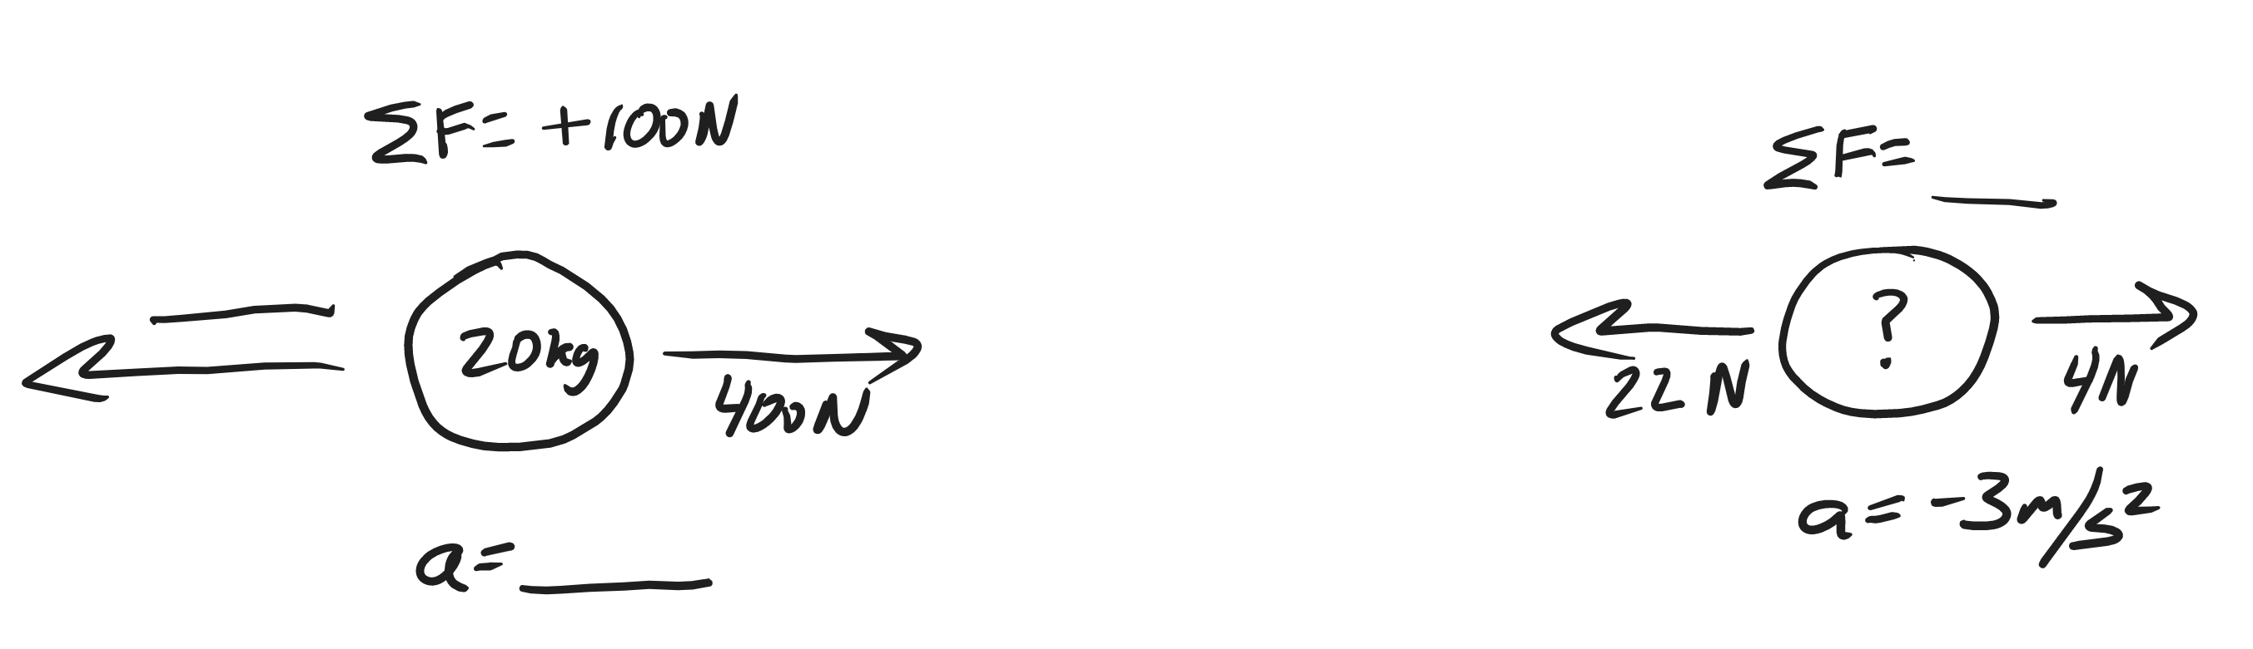

4. Newton’s 2nd Law can also be used to calculate weight. Since weight is the force of gravity, we can use F=ma, with 10m/s² substituted in for acceleration. We usually write the weight formula like this…

5. What is the weight of a 10kg block of ice, on Earth?

6. Use Newton’s 2nd Law, and the formula for weight, to fill in the missing values in these diagrams

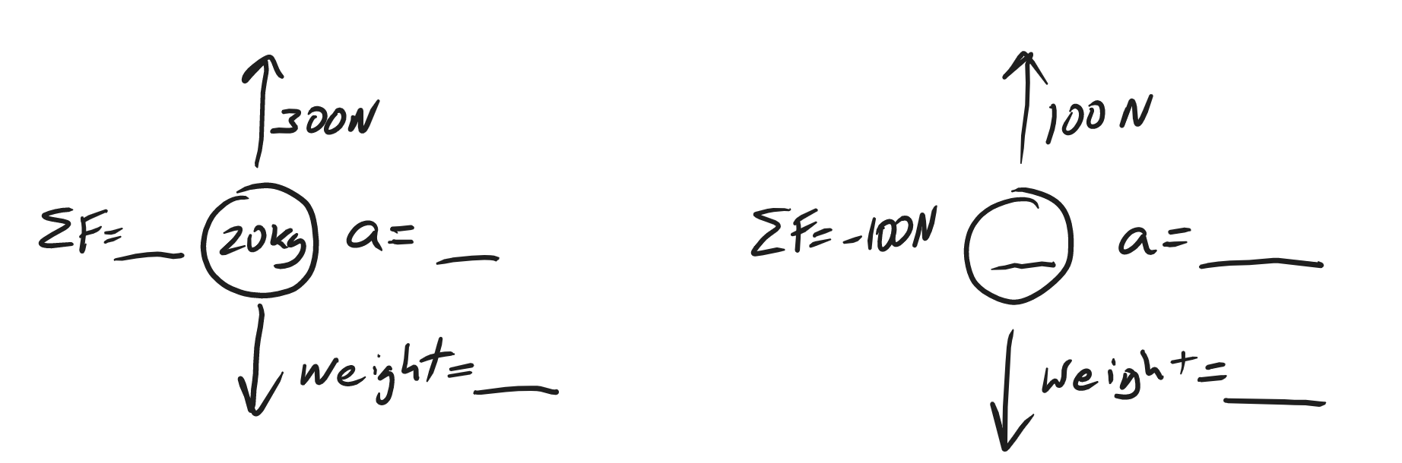

Practice Problems:

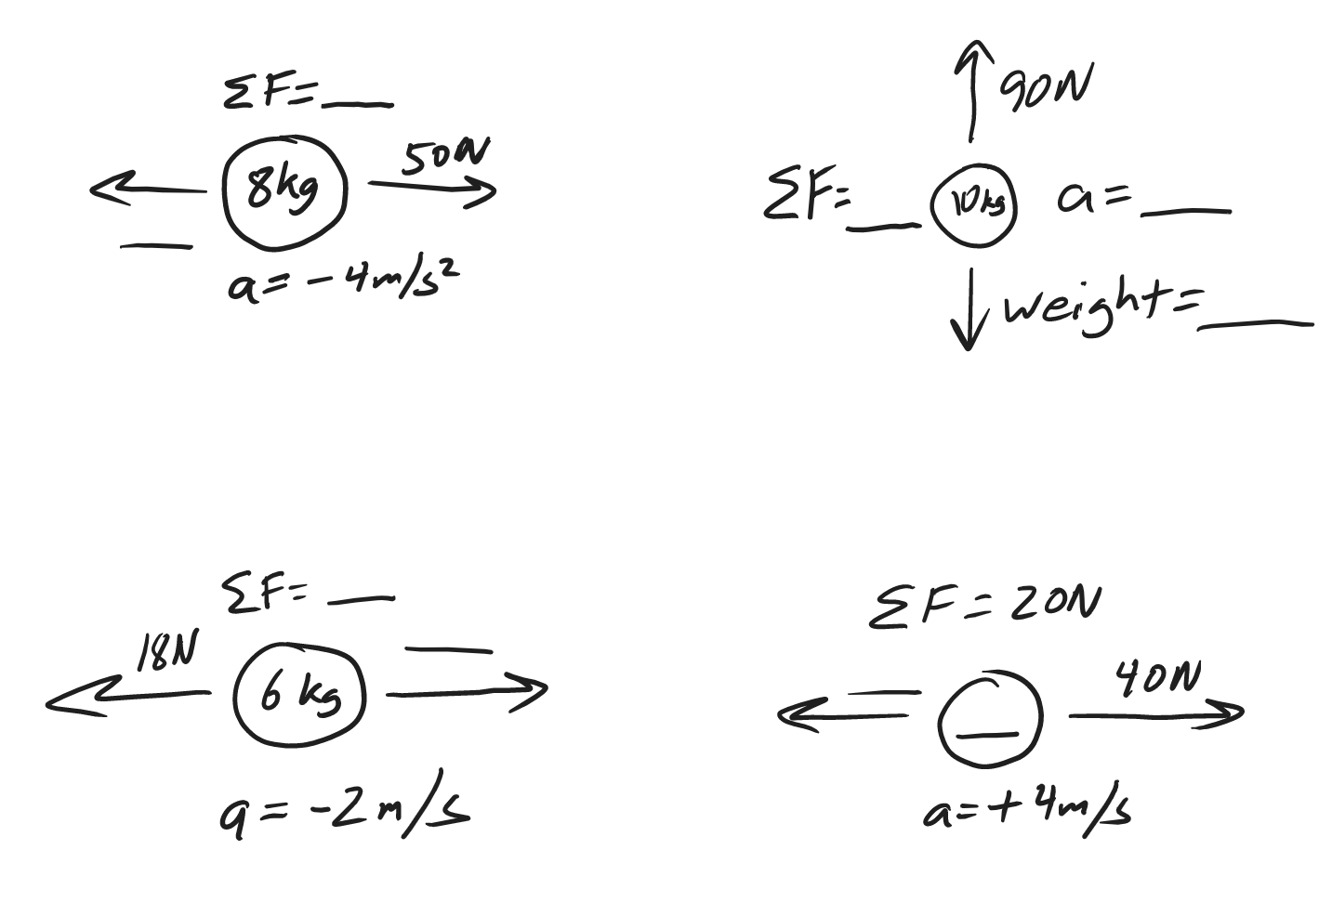
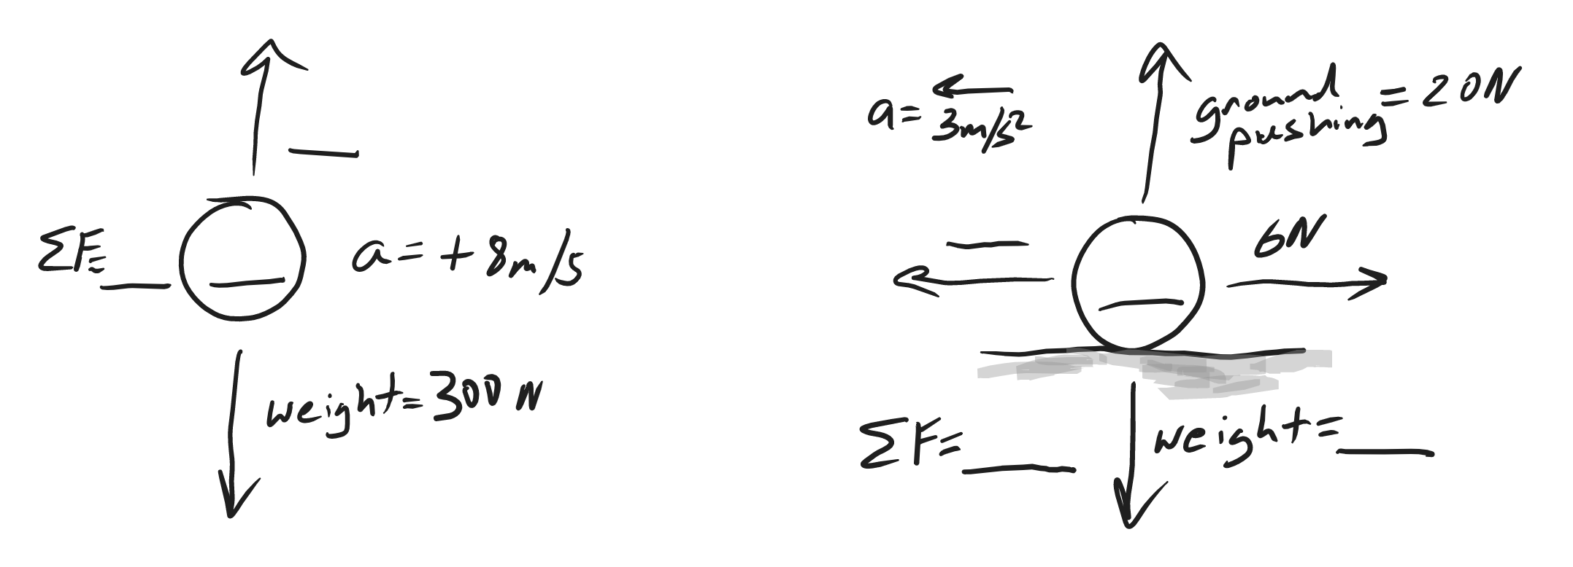

Drag and Terminal Velocity:

7. What is drag?

8. Draw diagrams showing all of the forces acting on a skydiver in 3 different situations: negative acceleration, zero acceleration, and positive acceleration. Which one of these situations is called “terminal velocity?” Why?

The first table below provides information relating to a parachute jump. A parachuter steps out of an air plane, begins to fall, and subsequently reaches terminal velocity. After reaching terminal velocity, the parachute deploys her chute. The chute takes a few moments to open, and soon after that the parachute reaches a new terminal velocity. Minutes later, the parachute lands on the ground.

9. What happens to a falling object’s velocity as it reaches terminal velocity?

10. Why does a falling object reach a terminal velocity?

11. How and why does the act of a parachute opening her parachute affect her terminal velocity?

12. Use the provided data to fill in the table below. Include proper units!

Time | Event
0s | Parachuter steps out of plane
15s | Parachuter reaches a first terminal velocity of 60m/s
50s | Parachuter pulls chute cord. Chute deploys.
60s | Parachuter reaches a second terminal velocity of 7m/s
600s | Parachuter lands

Time | Parachuter Mass | Parachuter Weight | Air Resistance (plus direction) | F_{net}  (plus direction) | Acceleration  (direction) | Speed
0s | 100kg
10s |  |  | 800N Upward |  |  | 45m/s
45s
55s |  |  | 1600N Upward |  |  | 40m/s
150s

Terminal Velocity Practice: The first table, below, is a timeline detailing a parachuter’s descent from an airplane. The second table is an incomplete analysis of mass, forces, and acceleration relating to the parachuter’s fall. Use the timeline and your knowledge of physics to complete the second table. Pay close attention to the times in the second table. Most of them do not coincide with the times in the first table, but you can still use the first table to complete the analysis for those times. Before you go too far, it would be prudent to first identify the times in the second table at which the parachuter has reached terminal velocity.

Time | Event
0s | Parachuter steps out of plane
20s | Parachuter reaches a first terminal velocity of 45m/s
75s | Parachuter pulls chute cord. Chute deploys.
80s | Parachuter reaches a second terminal velocity of 4m/s
700s | Parachuter lands

Don’t forget proper units!

Time | Parachuter Mass | Parachuter Weight | Air Resistance (plus direction) | F_{net}  (plus direction) | Acceleration  (direction) | Speed
0s | 50kg
3s |  |  | 100N Upward |  |  | 20m/s
72s
76s |  |  | 1500N Upward |  |  | 40m/s
500s

