Physics 100 Name: ______________________________
Notes: Momentum and Impulse

Definition of Momentum:

Symbol: Why?

Formula:

Three ways to arrange the momentum formula:

Momentum Units:

Practice Using the Momentum Formula:

1. A 3kg goliath frog has a velocity of 2m/s. What’s its momentum?

2. A 50kg pig has a momentum of 150kgm/s. What’s the pig’s velocity?

3. A farmer is chasing the pig. The farmer’s velocity is 4m/s, and her momentum is 200kgm/s. What is the farmer’s mass?

Is momentum a vector quantity or a scalar quantity? Why?

Net Momentum:

Law of Conservation of Momentum:

Practice Using the Law of Conservation of Momentum:

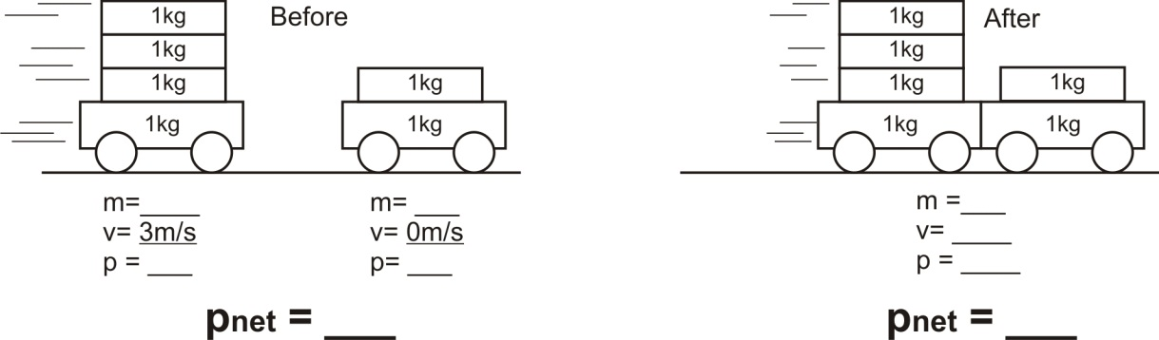
4.

5.
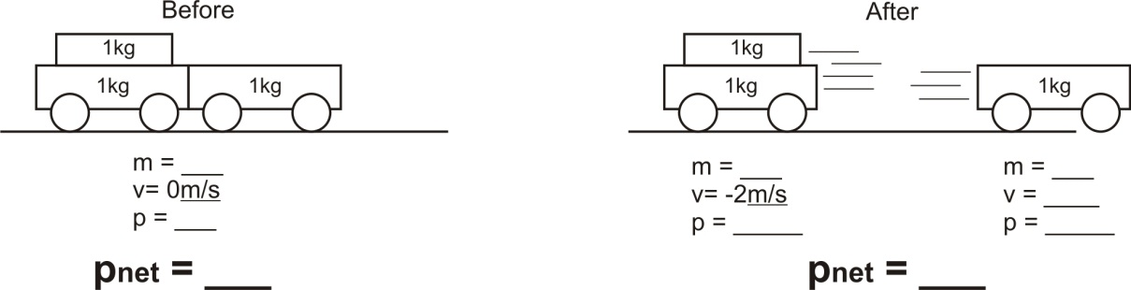

What is “impulse?”

Formula relating impulse to momentum:

Units for impulse:

Three ways to rearrange the impulse/momentum formula:

6. A 2kg block of wood moving at a velocity of 5m/s slows to a stop over a time of 3 seconds. What net force brought the wood to a stop?

7. A 1,000kg car is rolling toward you at a velocity of 2m/s. In order to slow the car to a velocity of 1m/s by pushing against the car for 10 seconds, how hard will you have to push?

Conservation of Momentum Practice Problems (attach extra paper if necessary)

