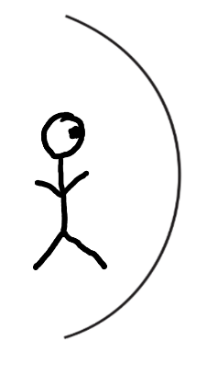
Physics 100 Name: ____________________________
Class #44 Lesson Starter Quiz

The person on the right is looking at itself in a concave mirror. Use solid lines to show…
1) how light travels from the person’s foot, reflects off of the mirror, and then travels to the person’s eye, and
2) how light travels from its eye, to the mirror, and back to its eye.
Then use dotted lines to show…
3) the apparent path of the light behind the mirror
4) the apparent location and image that the person sees behind the mirror

Physics 100 Name: ____________________________
Class #44 Lesson Starter Quiz

The person on the right is looking at itself in a concave mirror. Use solid lines to show…
1) how light travels from the person’s foot, reflects off of the mirror, and then travels to the person’s eye, and
2) how light travels from its eye, to the mirror, and back to its eye.
Then use dotted lines to show…
3) the apparent path of the light behind the mirror
4) the apparent location and image that the person sees behind the mirror

Physics 100 Name: ____________________________
Class #44 Lesson Starter Quiz

The person on the right is looking at itself in a concave mirror. Use solid lines to show…
1) how light travels from the person’s foot, reflects off of the mirror, and then travels to the person’s eye, and
2) how light travels from its eye, to the mirror, and back to its eye.
Then use dotted lines to show…
3) the apparent path of the light behind the mirror
4) the apparent location and image that the person sees behind the mirror

Physics 100 Name: ____________________________
Class #44 Lesson Starter Quiz

The person on the right is looking at itself in a concave mirror. Use solid lines to show…
1) how light travels from the person’s foot, reflects off of the mirror, and then travels to the person’s eye, and
2) how light travels from its eye, to the mirror, and back to its eye.
Then use dotted lines to show…
3) the apparent path of the light behind the mirror
4) the apparent location and image that the person sees behind the mirror

