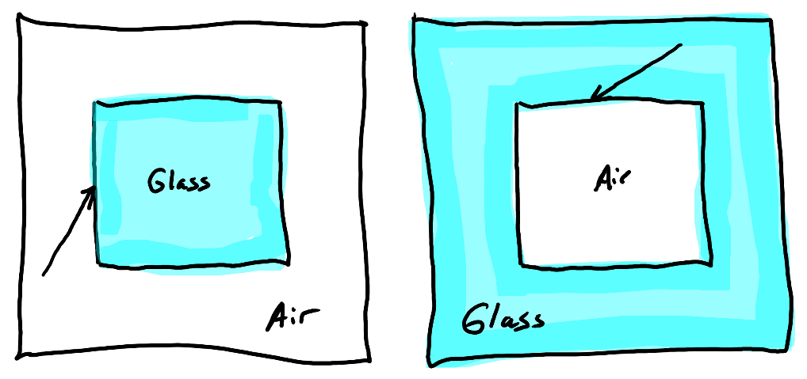
Physics 100
Class #42 Lesson Starter Quiz

The diagram on the right shows two light rays. Draw arrows showing how light rays refract as they passes from glass to air or air to glass.

Name: __________________________

Physics 100
Class #42 Lesson Starter Quiz

The diagram on the right shows two light rays. Draw arrows showing how light rays refract as they passes from glass to air or air to glass.

Name: __________________________

Physics 100
Class #42 Lesson Starter Quiz

The diagram on the right shows two light rays. Draw arrows showing how light rays refract as they passes from glass to air or air to glass.

Name: __________________________

Physics 100
Class #42 Lesson Starter Quiz

The diagram on the right shows two light rays. Draw arrows showing how light rays refract as they passes from glass to air or air to glass.

Name: __________________________

