Physics 100 Name: ______________________________
Free-Fall, More Kinematics Formulas, and Kinematics Problems

Free-fall: The state of being acted upon by only the force of gravity. Objects can be in free-fall if they are moving upward or downward – as long as there is no air resistance or any other force (other than gravity).
Free-fall acceleration: -9.8m/s² or -g. But we will probably use -10m/s² most of the time.
The diagram below is intended to represent an object that is launched vertically upward in the absence of air resistance (i.e. in free-fall). The diagram appears to show the ball moving sideways, but it isn’t moving sideways. The apparent sideways motion is unavoidable if we’re going to separate upward-moving objects from the downward-moving objects (as we need to do for clarity).

1. Fill in one of the blanks in the diagram with a made-up value. Based on that value, fill in the rest. Estimate by using g=10m/s²

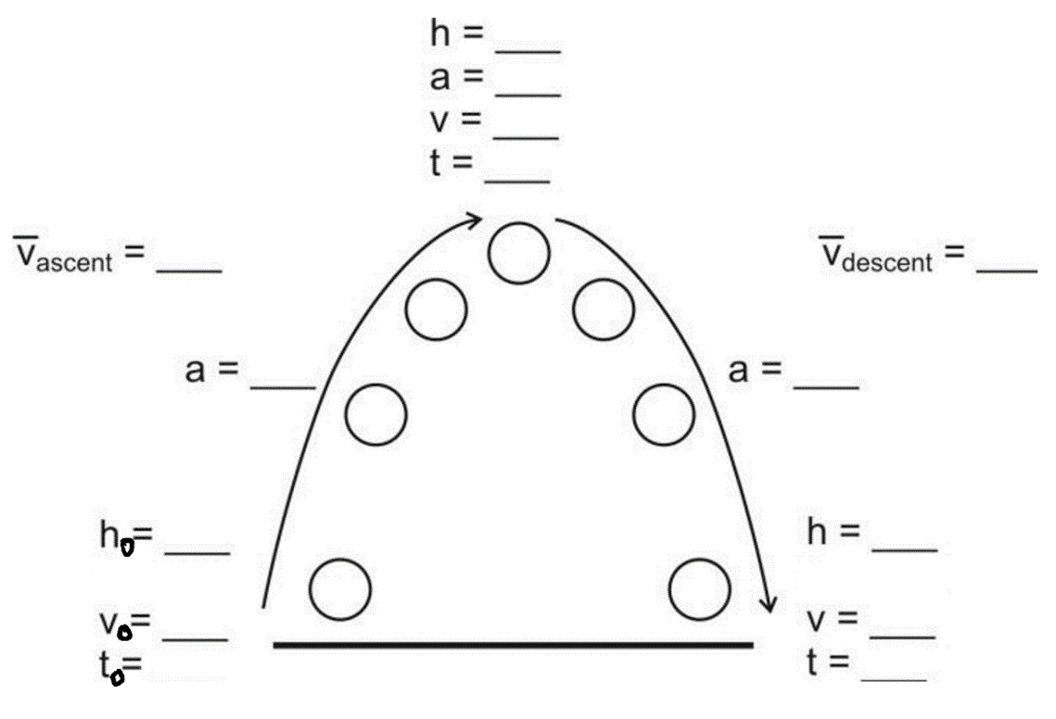

2. Write the formula for acceleration (starting from rest), based on time and displacement:

Example Problem: Starting from rest, a student travels a distance of 6m in a time of 2s, accelerating the entire time. What is the student’s acceleration over this 2s time period?

3. Write the formula for displacement, based on acceleration (starting from rest) and time:

Example Problem: If a ball is dropped in the absence of air resistance, how far does it fall during the first 3 seconds of its fall?

Review and practice Problems:

4. Write the basic formulas for average velocity and acceleration.

5. Starting from rest, a rubber band car travels 5m in 2.82 seconds.

a. What is its average velocity?

b. What is its acceleration?

6. The rubber band car travels over the last floor tile in a time of 0.076 seconds. If the distance across the floor tile is 0.305m, what is the rubber band car’s average velocity during that time?

7. A runner stands motionless. Then she accelerates at a rate of 3m/s² for 3 seconds. How far has she traveled?

8. A car speeds up from 3m/s to 8m/s over a time of 2 seconds. What is its acceleration?

9. A ferrari SF90 can accelerate from 0-60mph in 2.0 seconds. If 60mph is 26.8 m/s…

a. What is the Ferrari’s acceleration?

b. How far does the car travel in those 2 seconds?

.

