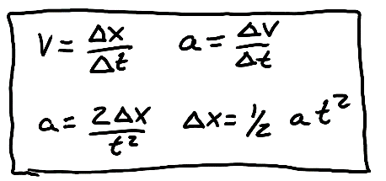
Physics 100 Name: __________________________
Kinematics Test Review
Part 1

1. What does each of these symbols stand for?

a. $∆x$ b. $∆v$

c. $x$ d. $∆t$

e. t f. v

g. a

2. Label each of the following with either a “V” or an “S,” depending on whether it is a vector (V) or a scalar (S) quantity.

Distance Velocity Acceleration Speed Displacement

3. What makes a vector different from a scalar quantity?

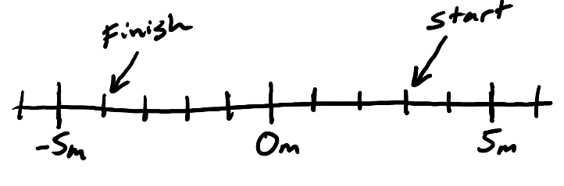
4. The number line on the right shows the starting point and the ending point of a student. The student leaves the starting point when her watch reads 8:07:35. When she reaches the finish line, her watch reads 8:07:49.

a. What is the student’s $∆t$ for this event?

b. What is her displacement?

c. What distance did she travel?

d. What was her average speed?

e. What was her average velocity?

5. A runner runs 400m around a track in a time of 50s, ending at the same point that they started.

a. What distance has the runner traveled?

b. What is the runner’s displacement?

c. What is the runner’s average speed?

b. What is the runner’s average velocity?

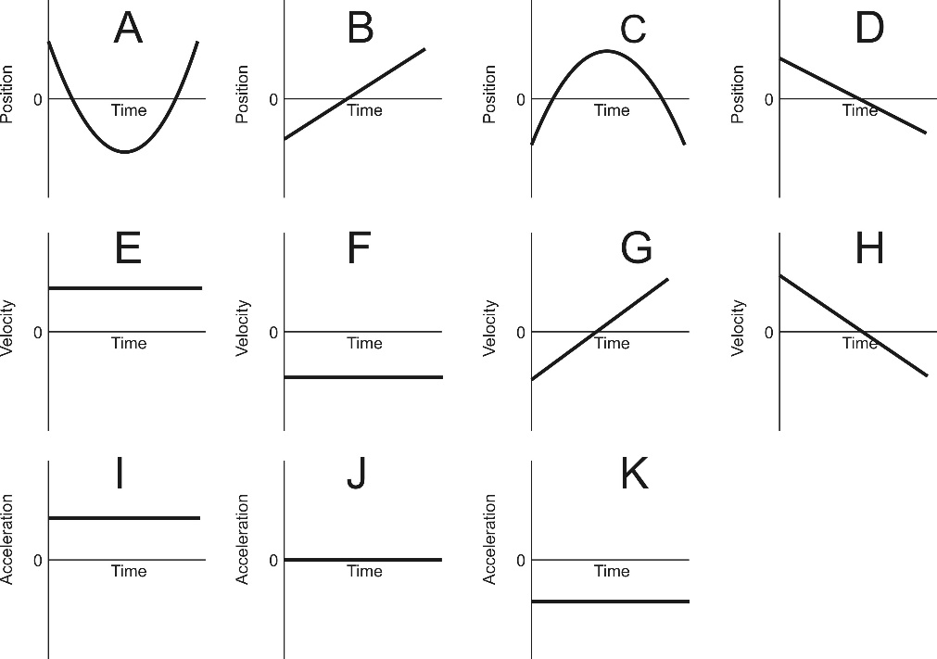
6. Match each of the position graphs with one velocity graph and one acceleration graph that represent the same motion.

Position Graph | Velocity Graph | Acceleration Graph
A
B
C
D

7. A car traveling with a velocity of 21m/s slows down to 15m/s. If it takes 3 seconds for the car to slow down, what is the car’s acceleration during this time period?

8. A ball is dropped from a high place. The ball free-falls for 5 seconds.

a. What is the acceleration of a free-falling object?

b. How fast is the ball traveling after falling for 5 seconds?

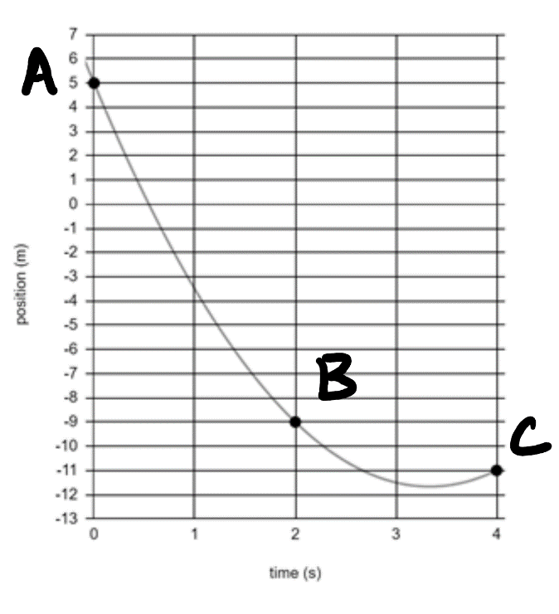

9. The graph on the right shows the positions of a moving object at three different moments in time.

a. What was the average velocity of the object between points A and B?

b. What was the average velocity of the object between points B and C?

c. What was the object’s acceleration?

