Physics 100 Name: __________________________
Kinematics Test Review, Part 2

Formulas that always work: Formulas that only work when starting from rest
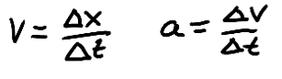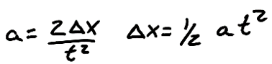

10. Write the basic units for each of the following:

- Position b. Speed

- Acceleration c. Displacement

- Velocity e. Time

11. Suppose an object is launched directly upward in the absence of air resistance (i.e. it is in free-fall). Between the time it is launched and the time it lands, a time of 6 seconds elapses. The object begins and ends at a height of zero meters.

Fill in all of the missing data below, given that the entire trip takes 6 seconds. [Hint: Start by writing “6s” next to the final time (t).]

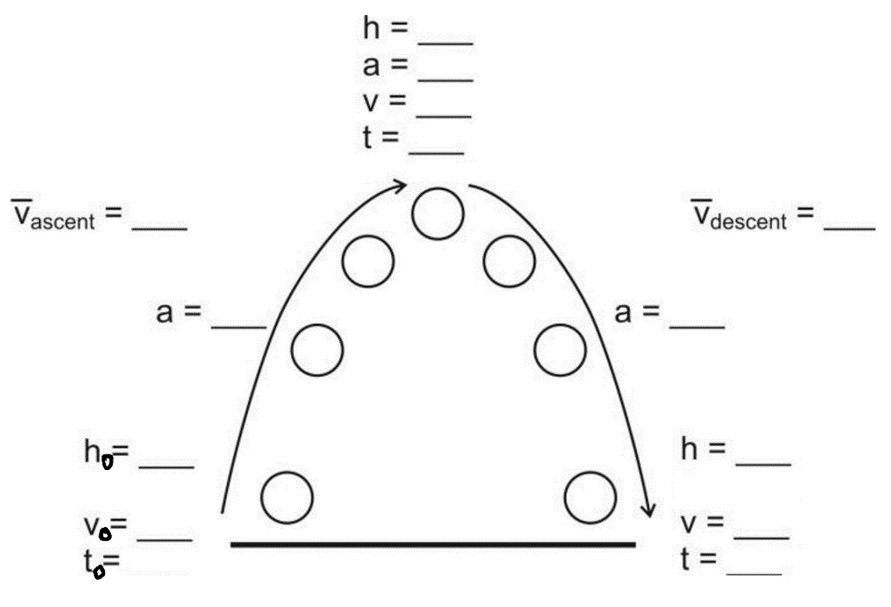

Some basic conversions:
1m/s = 2.24mph 1 foot = 0.305m 1km = 0.62miles 1m = 100cm
1 inch = 2.54cm 1km = 1,000m 1gallon = 128 fluid ounces 1 gallon = 4 quarts
1 mile = 5280 feet

12. If a spool tractor travels 5m, how many feet is this?

13. A car is travelling at a speed of 60mph. What is its speed in m/s?
14. Identify each of the following as either positive velocity or negative velocity.
Speed to the left Speed to the right
Speed upward Speed downward

Match the descriptions in the left column to the descriptions in the right column

15. ____ Negative velocity and positive acceleration
16. ____ Negative velocity and negative acceleration
17. ____ Positive velocity and positive acceleration
18. ____ Positive velocity and negative acceleration
19. ____ Zero velocity and zero acceleration
20. ____ Zero velocity and negative acceleration
21. ____ Zero velocity and positive acceleration

a. No speed, but beginning to move rightward.
b. No speed, but beginning to move to the left.
c. No movement.
d. Moving leftward, speeding up.
e. Moving rightward, speeding up.
f. Moving leftward, slowing down.
g. Moving rightward, slowing dow

22. Use the information from the position vs. time graph, below, to complete the velocity vs. time graph.
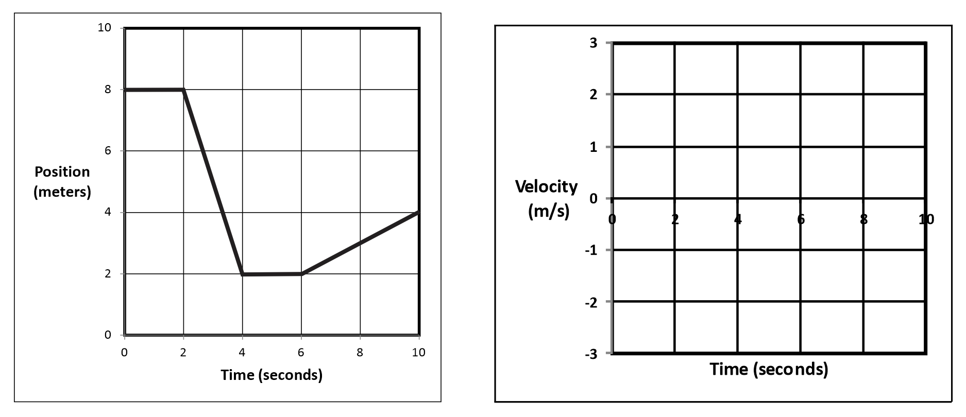

23. A helicopter is sitting still on the ground. Suddenly the helicopter takes off and begins to accelerate upward. If the helicopter travels a distance of 4m in 1.5s, what is its acceleration?

24. A bus can accelerate at a rate of 3m/s². The bus leaves a stoplight (where it was sitting motionless) and accelerates at this rate for 3 seconds. At the end of 3 seconds…

a. What is the speed of the bus?

b. How far has the bus traveled?

c. What is the bus’ average speed over these three seconds?

