Physics 100 Name: ____________________________________
Energy Notes

What is energy?

Units for energy:

Kinetic Energy:

Kinetic Energy Formula:

How much kinetic energy does 40kg person have if she is moving at a speed of 3m/s?

Potential Energy:

Some types of potential energy:

Gravitational Potential Energy Formula:

How much potential energy does 50kg person gain if he climbs to the top of a 4m ladder?

Thermal Energy:
Law of Conservation of Energy:

PhET Energy Skate Park Questions:

1. Go to the “Intro” tab. Turn on the energy graphs. Leave friction set to none. Place the skater on the half pipe and release her. Describe what happens to her potential energy, kinetic energy, and total energy as she passes through the half pipe.

2. Provide an explanation for number 1.

3. Reset and add some friction. Describe what happens to the skater’s potential energy, kinetic energy, thermal energy, and total energy as she passes through the half pipe.

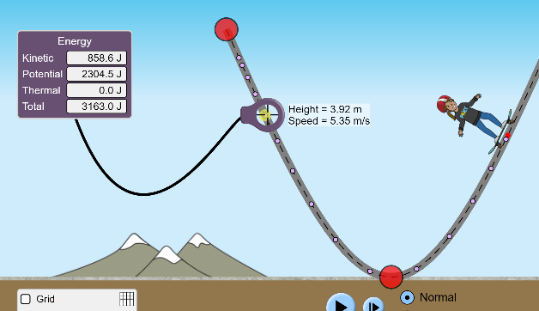
4. Open the “measure” tab. Release the skater from some height, and pause while the purple dots are visible. Use the measure tool to find the skater’s height and speed at one of those dots. Then use that height and speed (along with the skater’s mass – which you can find on the screen), to calculate the skater’s kinetic and potential energies at that point. Enter your data below, and show your work.

Height = _____________ Speed = ____________

Mass = _____________

Kinetic Energy = _________________ Potential Energy = ________________

