Physics 100 (Stapleton) Name: ________________________________
Energy Notes Part 2 – and some practice

1. What does “% efficiency tell us”? What is the formula for % efficiency?

2. Suppose you push a box along the floor with a force of 20N, and you push for a distance of 2m. If, at the end of your push, the box has 10J of KE, what is the efficiency of this process?

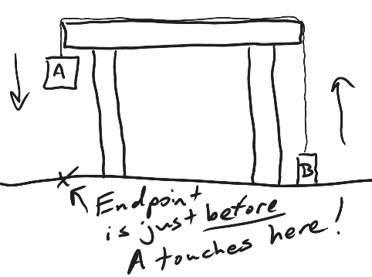
3. Object A has a mass of 400g, and object B has a mass of 300g. When they are released from the positions shown on the right, object A falls 0.4m to the floor, while object B rises the same distance upward away from the floor. This process takes 2 seconds.

- Convert the objects’ masses to kg.

- Calculate the object’s final speeds
[Ave speed = d/t. Final speed = 2(ave speed).

- Find the total input energy and total output energy by filling in the table below…

When? | What | KE (J) | PE (J) | Total E (J)
Starting Point | Object A
 | Object B
 |  |  | Total Input Energy
End Point (just before stopping) | Object A
 | Object B
 |  |  | Total Output Energy

- Calculate the % efficiency for this action.
Energy Practice Quiz #1

1. What is the physics definition of “energy?”

2. What is the physics definition of “work?”

3. Given an example of work. Provide example numbers and calculate the amount of work that is done. Use correct units.

4. Calculate how much power was used to do the work in your example above, assuming that the work took a time of 4 seconds. Use correct units.

5. Explain how kinetic energy and potential energy are different.

6. A 4kg cart is moving at a speed of 5m/s on a flat surface at a height of 0m. Without experiencing any outside forces, the car rolls up a ramp to a height of 2m above the flat surface. This means the car is “coasting” with no friction.

- Calculate the car’s KE on the flat surface.

- Calculate the car’s PE on the flat surface.

- Calculate the car’s PE at the height of 2m.

- What is the car’s PE at the height of 2m?

- Explain the reasoning behind your answer to part d.

