Physics 100 Name: ____________________
Unit 2: Electricity
Notes, part 1: Textbook Chapter 18.1 Electrical Charge, Conservation of Charge, Transfer of Charge

1. What are the two types of charges?

2. Like charges __________________ and unlike charges _________________.

3. In atoms, ______________ carry negative charge and _______________ carry positive charge.

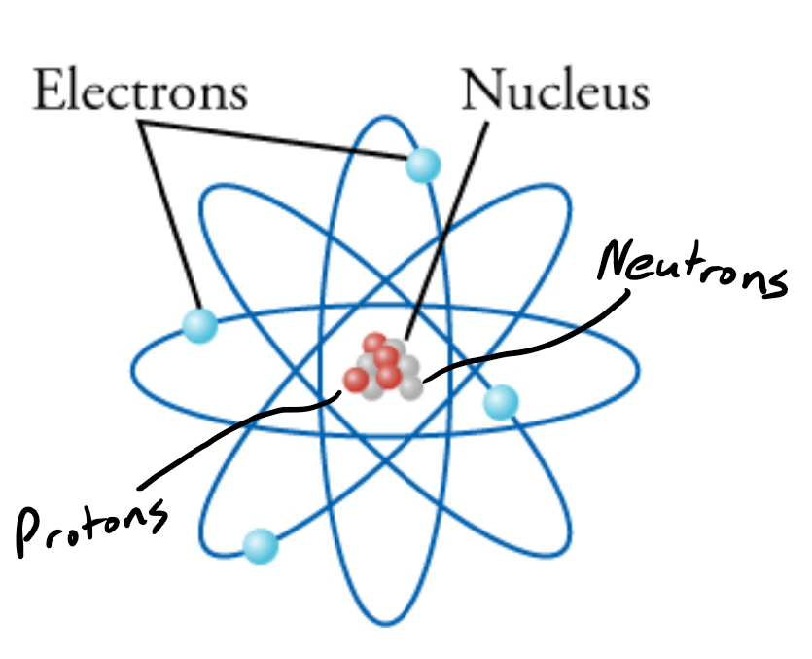

4. The strengths of a proton’s charge and an electron’s charge are

___________________ (though they are opposite)

5. “Net charge” is what you get when you add up all of the positive and negative charges inside something. What is the “net charge” of an object with….

a. 3 protons b. 4 electrons

c. 2 protons and 1 electron d. 5 electrons and 3 protons

d. 7 protons and 7 electrons

6. When materials are rubbed together, charges can be separated, particularly if one material has a greater ________________________________________ than another.

7. Rabbit fur has a _______________ affinity for electrons, while PVC has a _____________ affinity for electrons.

8. Suppose we have a rabbit fur that has zero net charge, and we also have a PVC pipe that has zero net charge. What can we say about the number of protons and electrons in each object?

9. If we rub a PVC pipe with rabbit fur, what effects might we observe? Why?

10. During this experiment, what has happened to the total number of positive and negative charges (if we add up all the positive and negative charges on the two objects)? Has the total increased, decreased, or stayed the same. Explain.

11. Law of Conservation of Charge:

12. In the winter, people often talk about static electricity. What does the “static” part of “static electricity” mean? Why is it called “static electricity?”

Simulation #1: Balloons and Static Electricity

Access: Go to http://phet.colorado.edu, click on “Play with Sims”, then choose “Electricity, Magnets, and Circuits” simulation. Click on “Balloons and Static Electricity” and click on “Run Now”.

1) What is the balloon’s net charge in the beginning? How do you know?

2) What is the sweater’s net charge in the beginning? How do you know?

3) Use the mouse to rub the balloon on the sweater. What is the new net charge on each object?

4) Use the mouse to move the balloon away from the sweater and release it. What happens? Why?

5) Move the balloon against the wall. Why do you think the balloon sticks to the wall?

6) What was the net charge of the wall in the beginning? Did the wall’s net charge ever change?

Simulation #2: John Travoltage

Access: Go to http://phet.colorado.edu, click on “Play with Sims”, then choose “Electricity, Magnets, and Circuits” simulation. Click on “John Travoltage” and click on “Run Now”.

1) Use the mouse to rub John’s foot on the carpet. What do you observe?

2) Why do the charges spread out through John?

3) Use the mouse to bring his hand close to the door knob. What do you observe?

4) What is the net charge of the door knob, before he touches it? Is his charge positive or negative?

5) Why do you think the charges flow out of John?

6) Find a way to charge John with maximum negative charge. Why don’t the charges leak back to the ground through his feet?

7) Does this simulation leave you with any unanswered questions? If so, what are they?

