EPS 200 (Stapleton) Name: __________________________
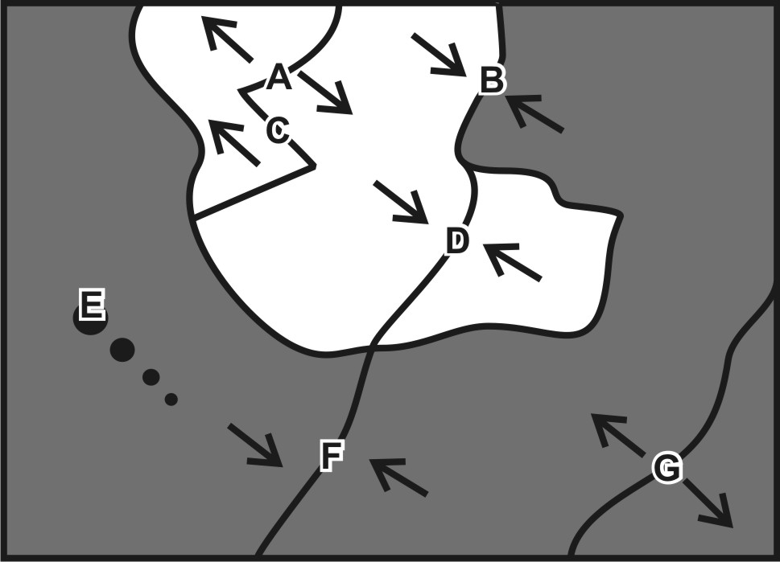
Plate Tectonics Test Practice #2

For each lettered feature on the plate map, darken all of the descriptions below that apply. On the map, dark plates are ocean crust and light plates are continental crust. [Suggestion: start with letter A. Sketch a cross-section diagram of letter A. Then read all of the descriptions from number 1 to number 15 and darken the descriptions that apply. Continue the process one map feature at a time.]

1. A B C D E F G Some mafic magma may reach the surface.
2. A B C D E F G Some felsic magma may reach the surface.
3. A B C D E F G Steep, composite cone volcanoes
4. A B C D E F G Rounded, shield volcanoes
5. A B C D E F G Relatively violent eruptions can occur.
6. A B C D E F G Relatively gentle eruptions can occur.
7. A B C D E F G There is thin seafloor sediment.
8. A B C D E F G There is an ocean trench nearby.
9. A B C D E F G Deep-focus earthquakes
10. A B C D E F G Shallow-focus earthquakes
11. A B C D E F G There are two long, parallel ridges.
12. A B C D E F G There are tall mountains, but no volcanoes
13. A B C D E F G New ocean crust is being created here.
14. A B C D E F G Situated over a relatively cool part of the mantle
15. A B C D E F G A line of volcanoes of diminishing size

EPS 200 (Stapleton) Name: __________________________
Plate Tectonics Test Practice #2

For each lettered feature on the plate map, darken all of the descriptions below that apply. On the map, dark plates are ocean crust and light plates are continental crust. [Suggestion: start with letter A. Sketch a cross-section diagram of letter A. Then read all of the descriptions from number 1 to number 15 and darken the descriptions that apply. Continue the process one map feature at a time.]

1. A B C D E F G Some mafic magma may reach the surface.
2. A B C D E F G Some felsic magma may reach the surface.
3. A B C D E F G Steep, composite cone volcanoes
4. A B C D E F G Rounded, shield volcanoes
5. A B C D E F G Relatively violent eruptions can occur.
6. A B C D E F G Relatively gentle eruptions can occur.
7. A B C D E F G There is thin seafloor sediment.
8. A B C D E F G There is an ocean trench nearby.
9. A B C D E F G Deep-focus earthquakes
10. A B C D E F G Shallow-focus earthquakes
11. A B C D E F G There are two long, parallel ridges.
12. A B C D E F G There are tall mountains, but no volcanoes
13. A B C D E F G New ocean crust is being created here.
14. A B C D E F G Situated over a relatively cool part of the mantle
15. A B C D E F G A line of volcanoes of diminishing size

