EPS 200 (Stapleton) Name: _______________________________________
Unit 1 Practice Test : Physical Properties and Buoyancy

The objects on the right are mostly empty space. The circle is the edge of each object. The dots inside represent all of each object’s mass. The empty space inside the objects has no air or mass of any kind.

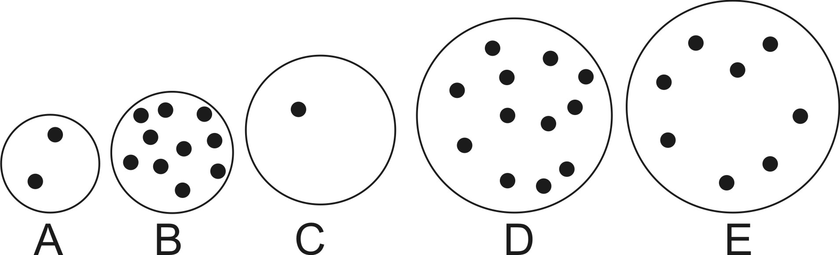
1. Which object has the most weight? ____
2. Which object has the least weight? ____

3. Which object has the most volume? ____
4. Which object has the least volume? ____

5. Which object is most dense? ____
6. Which object is least dense? ____

7. Which object has the most mass? ____

8. Which object has the least mass? ____

Someone blows up an ordinary rubber balloon and then ties it so that no air can escape or enter. Then the balloon is held near a flame, and this causes it to expand. While the balloon is expanding, what is happening to its...

9. mass 10. volume 11. density 12. weight

Astronauts on the moon prepare a rock for transfer to the Earth. Before making the trip, they weigh the rock on the moon, and it weighs 1 pound. On the way to Earth, the rock cracks and half of it is lost. Interestingly, when the rock is weighed on Earth, it still weighs 1 pound. Compared to its original condition on the Moon, what has happened to the rock’s…

13. mass 14. volume 15. weight

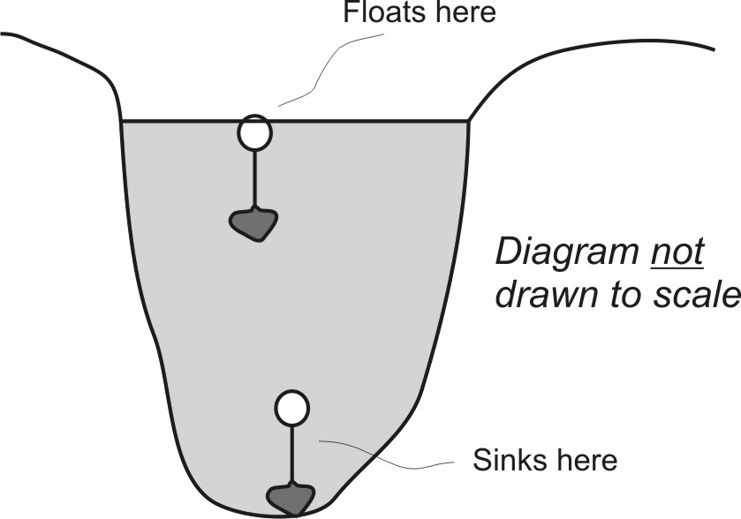
Suppose you fill a balloon with air and tie it off. Then you tie a rock to the balloon. You toss the whole thing in a lake, and it floats. Then you jump in the lake, grab the rock, and pull the rock/string/balloon to the bottom. When you let go of it, it just sits on the bottom. You take it back to the surface, and once again it floats. You take it to the bottom and it sinks. You repeat this process until you are convinced that what you are seeing is real. The contraption floats near the surface but sinks near the bottom. The balloon does not leak, and the rock and the string remain intact.

When you take the balloon/rock/string to the bottom, what is happening to its overall…

16. Mass? 17. Volume? 18. Density?

19. Explain why this change is occurring.

20. The average value of air pressure at sea level is ____________. ( Include correct units)

21. The density of water is ____________ g/ml

22. When you move rapidly to a lower elevation, do your ear drums stretch inward or outward? Explain.

23. Archimedes’ principle says that the force of buoyancy acting on an object is equal to…

24. The diagram on the right shows a giant boulder and a fishing bobber.

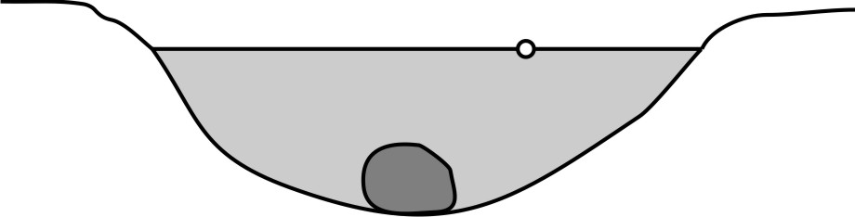
- Which object is being acted on by the strongest buoyant force?

- Explain how you know.

- Explain why the bobber floats and the boulder sinks, in terms of buoyancy and weight.

Why the bobber floats:

Why the boulder sinks:

25. Give one reason why the extreme force generated by the air pressure around us does not squish us flat.

26. Use words and a diagram to explain how suction cups work.

27. On the diagram below, add arrows to represent the forces of buoyancy and weight acting on each object. Label each with a B or a W.

28. Rank the objects in the diagram below according to the buoyant forces acting on them.

29. Use the column on the right to tell what you know about the buoyancy acting on each of the objects below. You may use > or < symbols.
Object | Weight | Buoyant force
A | 10 pounds
B | 6 pounds
C | 3 pounds
D | 1 pound

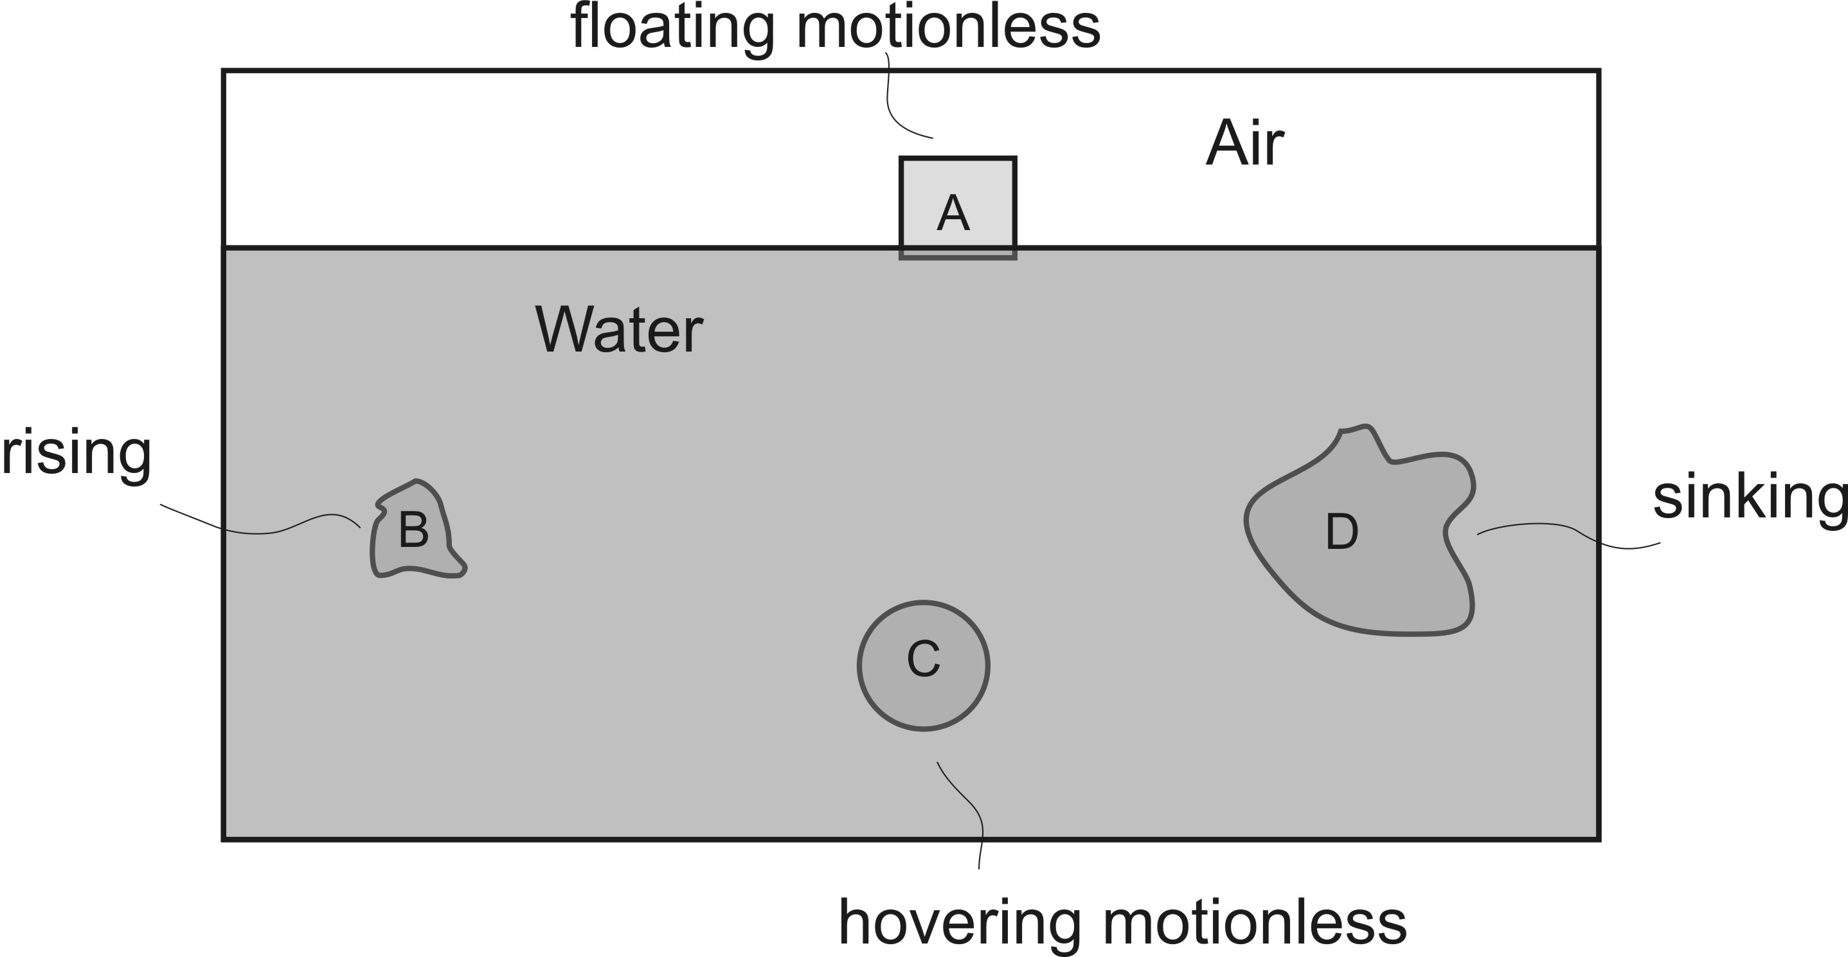

30. The figures below show the same beaker with the same volume of water. Find the objects’ masses, volumes, and densities.

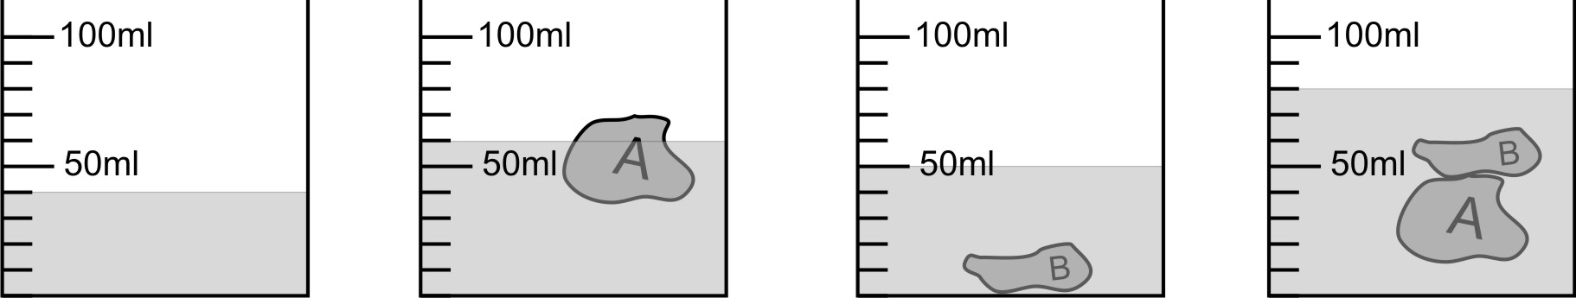

Do not forget proper units!

 | Mass | Volume | Density
Object A
Object B
Objects A and B Together

