EPS 200 (Stapleton) Name: __________________________
Plate Tectonics Practice #3

PLEASE DARKEN THE CORRECT ANSWER CHOICES.

Match each description to the appropriate rock type. Choices: A= Mafic B = Felsic

1. A B Relatively light in color/shade
2. A B Relatively low viscosity (runny) when molten
3. A B The primary constituent of continental crust
4. A B The most explosive volcanoes have this type of rock.
5. A B When piled up, tends to form rounded volcanoes that are not steep
6. A B An example of this rock type is called basalt.
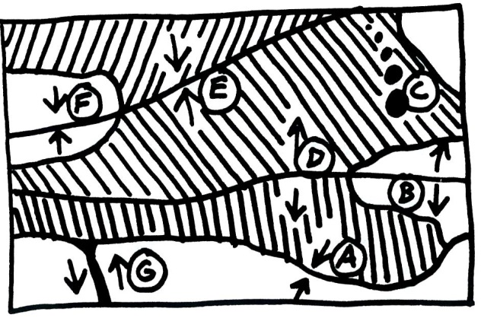
Match each feature name to the corresponding feature on the plate map on the right.

7. A B C D E F G Ocean/Ocean Convergent
8. A B C D E F G Ocean/Continent Convergent
9. A B C D E F G Continent/Continent Convergent
10. A B C D E F G Ocean/Ocean Divergent
11. A B C D E F G Continent/Continent Divergent
12. A B C D E F G Transform Boundary
13. A B C D E F G Hotspot

Each of the real-world locations below forms in an area that is similar to one of the lettered locations on the map. Match each real-world location to its corresponding map location.

14. A B C D E F G Himalayas (Mt. Everest).
15. A B C D E F G San Andreas Fault, California
16. A B C D E F G Mid-Atlantic Ridge
17. A B C D E F G Andes Mountains (South America)
18. A B C D E F G East Africa
19. A B C D E F G Japan
20. A B C D E F G Hawaii

For each lettered feature on the map above, darken all of the descriptions below that apply. [Suggestion: start with letter A. Darken that letter for all of the descriptions that apply to location A on the map. Continue the process one map feature at a time.]

21. A B C D E F G Some felsic magma may reach the surface.
22. A B C D E F G Some mafic magma may reach the surface.
23. A B C D E F G Steep, composite cone volcanoes
24. A B C D E F G Rounded, shield volcanoes
25. A B C D E F G Relatively gentle eruptions can occur.
26. A B C D E F G Relatively violent eruptions can occur.
27. A B C D E F G Tall mountains that are not volcanoes
28. A B C D E F G Deep-focus earthquakes
29. A B C D E F G Shallow-focus earthquakes
30. A B C D E F G New ocean crust is being created here.
31. A B C D E F G Situated over a relatively cool part of the mantle
EPS 200 (Stapleton)
Plate Tectonics Test Review

There will be two tests. They can be retaken individually
- Test 1: Multiple choice relating to
  - mafic/felsic properties
  - plate boundary feature names
  - real-world examples of tectonic features
  - characteristics of each type of plate boundary feature
- Test 2: Short answer and drawing
  - Answer 7-10 questions chosen from the 42 practice questions. Practice questions include
    - “Plate Tectonics Questions” -- Handout
    - “Plate Tectonics Questions, Part 2” -- Handout
    - The additional questions below (38-42).
  - Draw and label the features of two plate boundaries (chosen from the seven we drew in class). See #36 and #37 on “Plate Tectonics Questions, Part 2”

Additional Plate Tectonics Questions (answers provided)

38. What theory suggests that…
- …the Earth’s surface is made of plates of crust that ride over a flowing portion of the mantle; and…
- …those plates ride on convection currents that result from temperature variation within the hot, flowing, mantle; and…
- …this movement is responsible for landforms and events such as volcanoes, ocean trenches, ridges, rift valleys, and earthquakes.

Plate Tectonics

39. List three sources of the Earth’s internal heat.
- Radioactivity in some rocks
- Compression
- Energy left over from past collisions
- Friction from iron sinking to the Earth’s core during Earth’s formation

40. List the four main layers of the Earth, from outside to inside.

Crust (or lithosphere), Mantle, Outer Core, Inner Core

41. What is the name of the part of the mantle where scientists think convection currents flow, providing the forces that move the Earth’s plates?

Asthenosphere

42. What do scientists think are the primary constituents of the Earth’s inner and outer cores? Why is one liquid while the other is solid?

The inner core is mostly solid iron, and the outer core is mostly liquid iron. The inner core is hotter, but there is too much pressure for the iron to exist in its liquid form.

