EPS 200 (Stapleton) Name: _______________________________________
Midterm Review

1. What is the density of water… a) in g/cm³? b) in g/ml? c) in kg/L?

2. What is the average value of air pressure at sea level?

Define each of the following:

3. Mass:

4. Volume:

5. Weight:

6. Density:

7. Consider a person who had less mass on the 5th of May than she had on the 4th of May, even though she had the same weight on both days. Explain how this could be possible (though improbable)?

8. The Law of Universal Gravitation says that the force of gravity can be calculated using the formula$F=\frac{Gm_{2}m_{1}}{d^{2}}$. Taking hints from this formula, describe three fundamentally different ways to increase the weight of an object on a hypothetical planet. Your methods of increasing the object’s weight do not have to be realistically feasible, but each method must rely on changing a different variable in the equation.

9. The distance from the Earth to the moon is about 3.84x10⁸m. The Moon’s mass is 7.35x10²²kg. $F_{gravity}=\frac{Gm_{2}m_{1}}{d^{2}}$G = $\frac{6.67x{10}^{-11} {Nm}^{2}}{{kg}^{2}}$

a. If 1kg = 2.2 pounds, what is the mass of a 120 pound student?

b*. What is the force the gravitational attraction between that student and the moon?

The objects below are mostly empty space. The circle is the edge of each object. The dots inside represent all of each object’s mass. The empty space inside the objects has no air or mass of any kind.

10. Which object has the most weight? 11. Which object has the least weight?
12. Which object has the most volume? 13. Which object has the least volume?
14. Which object is most dense? 15. Which object is least dense?
16. Which object has the most mass? 17. Which object has the least mass?
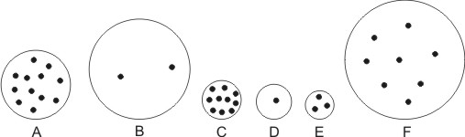

18. An object has been floating in water. Nothing enters or exits the object, but the object suddenly begins to sink. What has happened to these physical properties of the object to account for this change?
a. mass b. volume c. density d. weight

19. Somehow, a squirrel gets smaller, but its weight does not change. What has happened to the squirrel’s...
a. mass b. volume c. density

20. Someone blows up a latex balloon and then ties it so that no air can escape. Then the balloon is held near a flame, causing it to expand. While the balloon is expanding, what is happening to its...
a. mass b. volume c. density d. weight

21. Suppose you wet the inside of a 2-liter bottle. Then you place smoke in the bottle and cap the bottle. Finally, you squeeze the bottle. When you squeeze the bottle, what happens to the air in the bottle, with regard to its…
a. volume b. mass c. density d. temperature

22. What causes atmospheric air pressure?

23. Explain why your ear drums hurt when you go to a higher elevation

24. Why do suction cups “stick?”

25. What causes the force of buoyancy?

26. Buoyancy is pushing you upward at this very moment, but you are not floating. Explain how you could calculate this force of buoyancy.

27. State Archimedes’ principle.

28. If an object is floating in water…

a. …we know that the object’s mass is…

b. …and we also know that the object’s density is…

29. The diagram on the right shows a giant boulder and a fishing bobber.

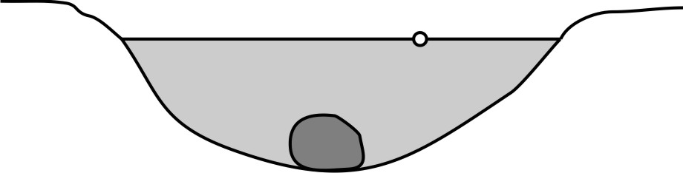
- Which object is being acted on by the strongest buoyant force?

- Explain how you know.

- Explain why the bobber floats and why the boulder sinks, in terms of buoyancy and weight.

30. The figures below show the same beaker with the same volume of water. Find the objects’ masses, volumes, and densities.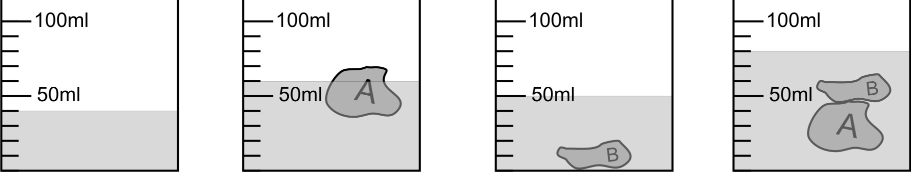

Do not forget proper units!

 | Mass | Volume | Density
Object A
Object B
Objects A and B Together

31. Suppose you have a 3-D computer design for an object that you would like to print on a 3-D printer. After you print the object, you would like to paint it. Currently, the object is 2 inches tall, and it has a volume of 0.6 in³. Its surface area is 5.1in². Unfortunately, you need the object to be 6 inches tall. If you scale the object from 2 inches tall to 6 inches tall while keeping all of the proportions the same…

- By what factor will you be multiplying the height?

- By what factor will you be multiplying the surface area?

- By what factor will you be multiplying the volume?

- What will be the surface area of your newly-scaled object?

e. What will be the volume of your newly-scaled object?

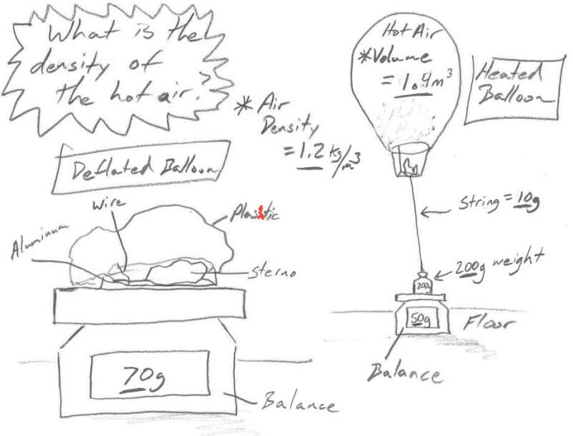
32. The diagram on the right shows a hot air balloon filled with hot air. A 10g string and a 200g weight are attached to the balloon. The weight is resting on a balance that reads 80g. The mass of the empty, deflated balloon (minus the string and weight) is 70g. The room air has a density of 1.2kg/m³.

- What mass of air is the balloon displacing?

- How much total mass is the balloon’s buoyancy capable of lifting?

- Excluding only the hot air inside the balloon, what total mass is being lifted by the balloon?

- What is the mass of the hot air inside the balloon?

- What is the density of the hot air inside the balloon?

33. Why does heating a hot air balloon cause it to become less dense?

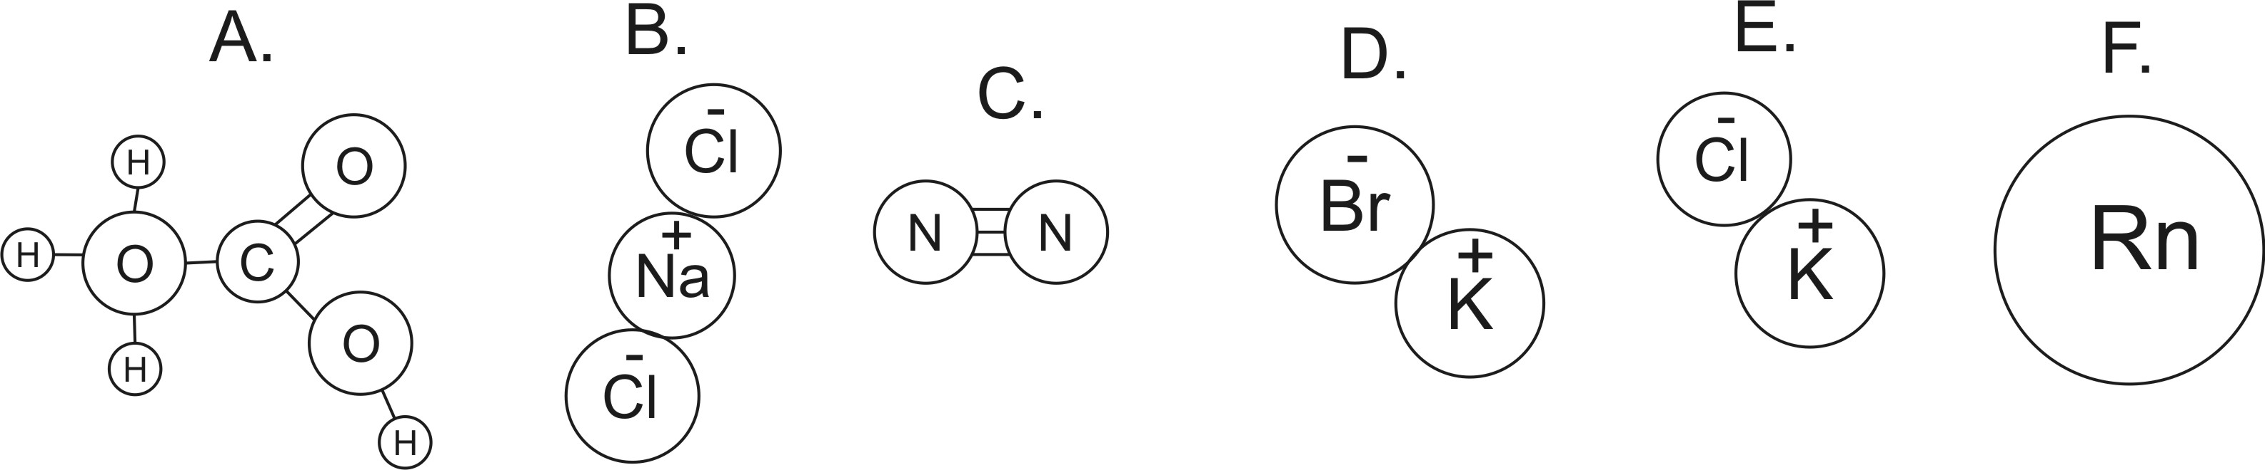

34. How many atoms are shown in the diagrams above?
35. How many elements are shown in the diagrams above?
36. How many ions are shown in the diagrams above?
37. Which lettered items are molecules?
38. Which lettered items are compounds?
39. Which items are neither molecules nor compounds? What are those items?
40. Which (if any) of the substances are in the top three most common particles found in “air?”
41. What is the approximate molecular weight of item C?
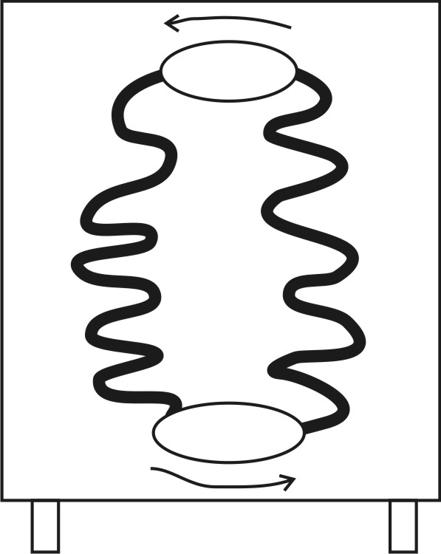

42. Complete the drawing of the dehumidifier. The direction of refrigerant circulation is shown. Show the direction of air flow. Label the compressor and expansion valve. Label the warm pipes, the cool pipes, and show where a drip pan should be placed.

Define the following terms in such a way that no two terms may be confused with one another:

43. Conduction

44. Convection

45. Radiation

46. Kinetic energy

47. Temperature

48. Thermal Energy

49. Heat

50. Latent Heat of Fusion

51. Latent Heat of vaporization

52. Absolute Zero

53. This is the state of matter in which molecules (or individual atoms) are flying free, but they occasionally bump into one another.
54. This is the state of matter in which molecules (or individual atoms) are touching one another, but they are sliding and bumping around and changing positions.
55. This is the state of matter in which molecules (or individual atoms) are locked in place, touching one another and vibrating.
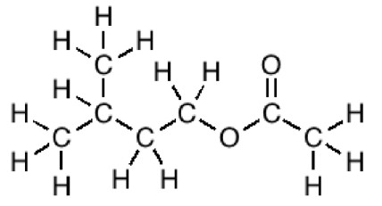
56. Write the molecular formula for “banana oil” (see diagram on right)

57. Why is latent heat called “latent?”

58. Explain the roles that salt and latent heat of fusion played in the ice cream making process that we used in class.

59. What are three most common substances in the air, in order of prevalence?

60. Explain, in detail, why rising air produces precipitation. Tell what happens to pressure, volume, and temperature, and explain any changes of state (phase) that occur.

61. Explain why sinking air produces clear skies.

62. What type of air pressure is generally associated with cloudy, rainy weather?

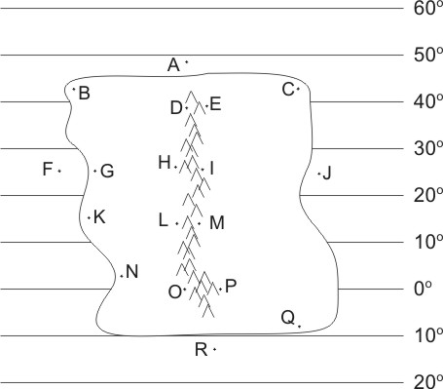
The descriptions below apply to locations on the climate map to the right. Identify all of the dotted map locations that meet each of the descriptions below.

63. In a high pressure belt
64. In a low pressure belt
65. Has a westerly (from the west) prevailing wind
66. In a major rainforest (not caused by a rain shadow or coastal breezes)
67. In a major desert (not caused by rain shadow)
68. Relatively warm ocean water
69. Wet due to breezes from the ocean
70. Wet due to rain shadow effect
71. Dry due to rain shadow effect
72. Drier during summer and wetter during winter
73. Drier during winter and wetter during summer

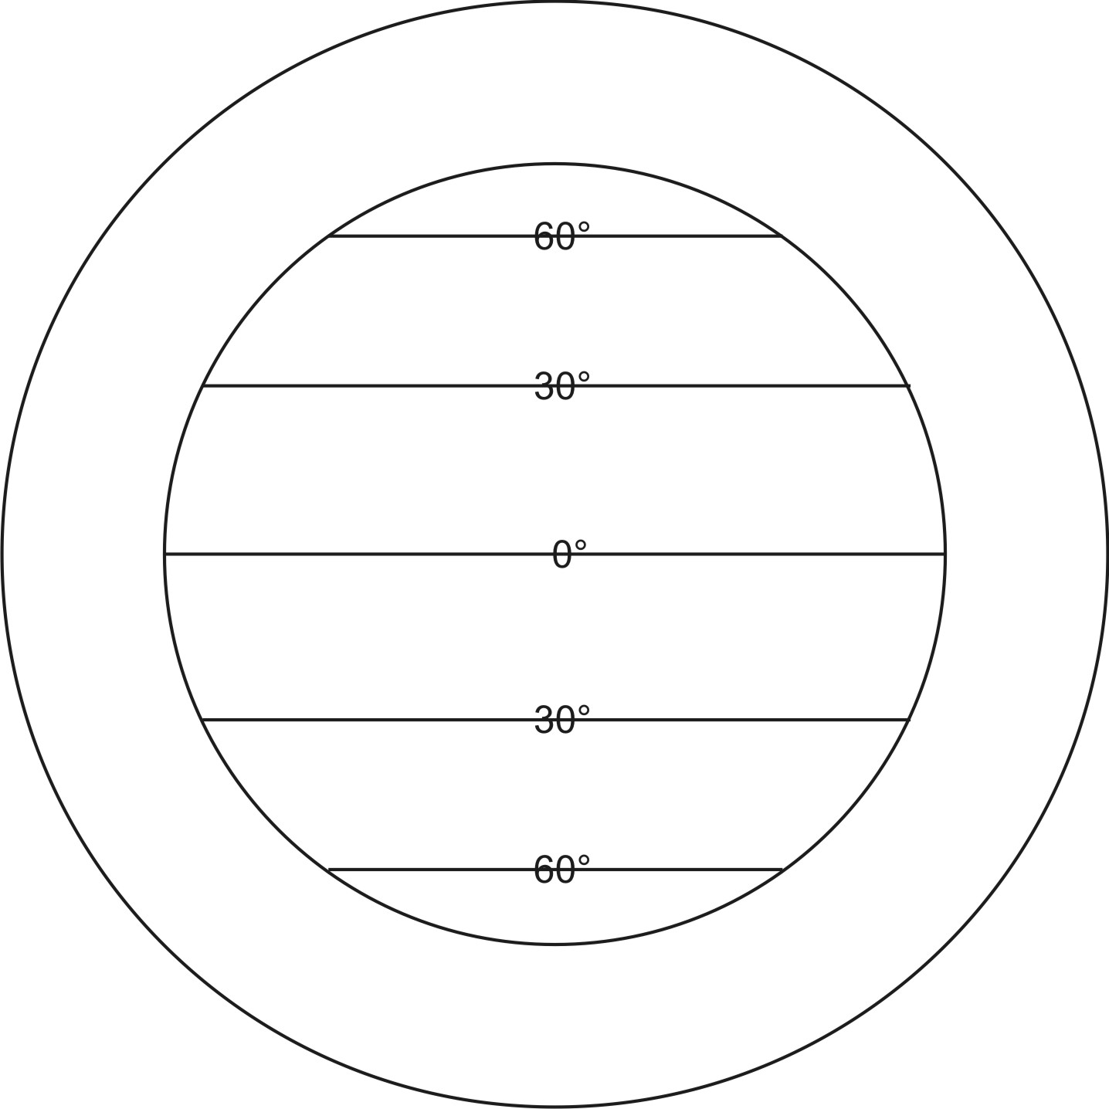
74. On the diagram to the right, sketch the pattern of air circulation in the Earth’s atmosphere. [This question is not asking you to draw the prevailing winds.]
75. Why does the atmosphere circulate?

76. If you feel a wind blowing toward the south, what does that tell you about the air pressures in your vicinity?

77. Explain how the Earth’s major year-round deserts are formed.

78. In Vermont, our prevailing winds come from the Southwest. Explain why.

79. Why do continents generally have warmer water on their east coasts and cooler water on their west coasts?

80. Explain why summer wet winter dry climates become wetter during the summer.

81. Why are deserts bigger on the west coasts of continents?

82. What causes ocean currents?

83. Explain how/why the rain shadow effect, causes some areas become drier and other areas to become wetter.

