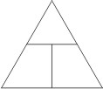
EPS 200 Name: ________________________________
Balloon Problems

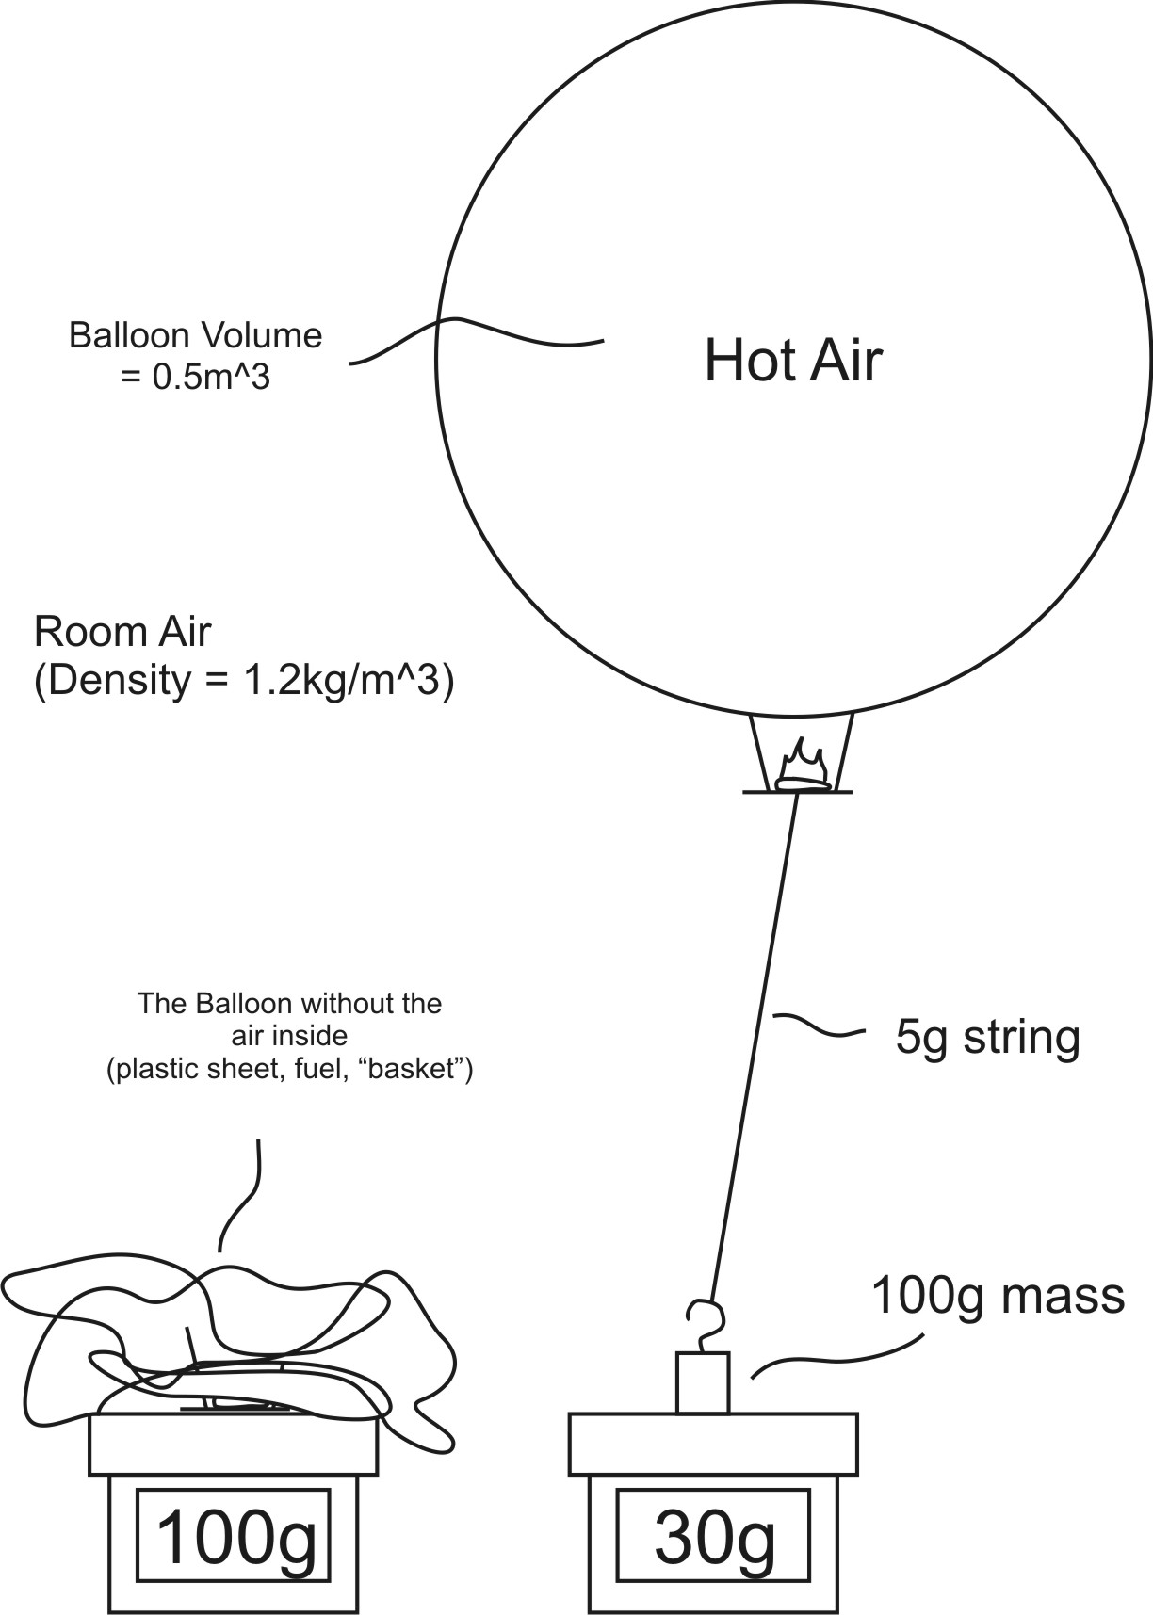
$Density= \frac{mass}{volume}$

*Note*: The “balloon” consists of the plastic sheet, the air inside the balloon, the “basket,” and the fuel.

1. What is the mass of the air that is being displaced by the balloon?

2. There is weight pulling the floating balloon downward. This weight comes from several masses added together. What is the sum of all of those masses?

3. What is the total mass that is working to pull the balloon downward – minus the mass of the hot air in the balloon?

4. What is the mass of the hot air in the balloon?

5. What is the density of the hot air in the balloon?

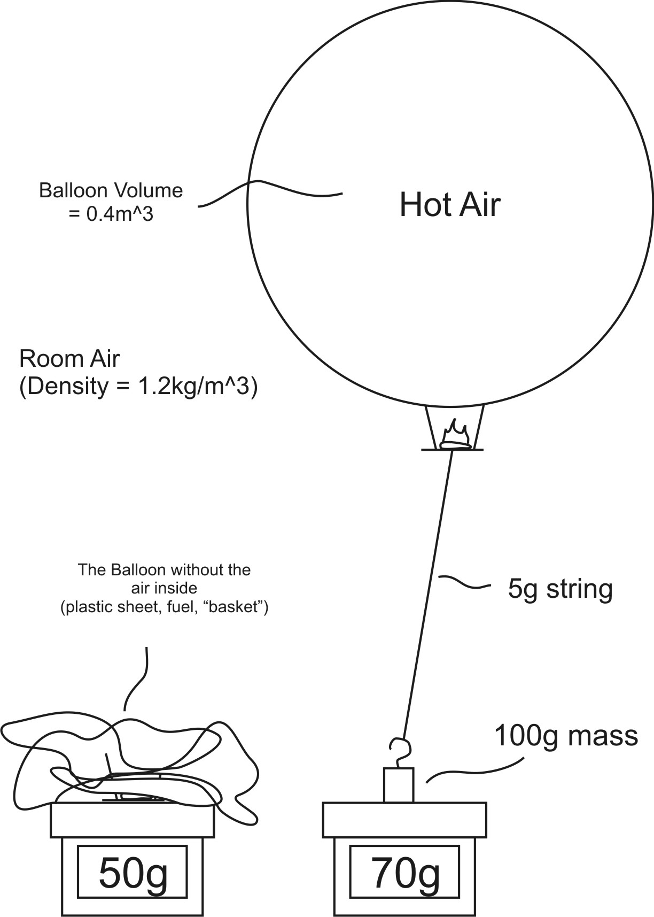
Problem Set 2
1. What is the mass of the air that is being displaced by the balloon?

2. There is weight pulling the floating balloon downward. This weight comes from several masses added together. What is the sum of all of those masses?

3. What is the total mass that is working to pull the balloon downward – minus the mass of the hot air in the balloon?

4. What is the mass of the hot air in the balloon?

5. What is the density of the hot air in the balloon?

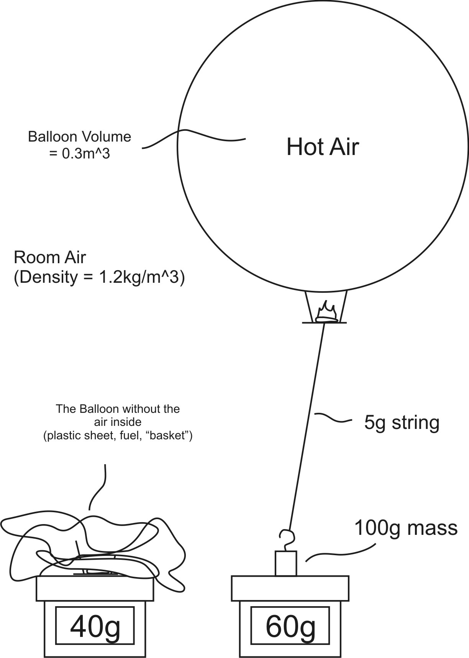

Problem Set 3
1. What is the mass of the air that is being displaced by the balloon?

2. There is weight pulling the floating balloon downward. This weight comes from several masses added together. What is the sum of all of those masses?

3. What is the total mass that is working to pull the balloon downward – minus the mass of the hot air in the balloon?

4. What is the mass of the hot air in the balloon?

5. What is the density of the hot air in the balloon?

