EPS 200 (Stapleton) Name: _________________________
Physical Chemistry Applications – Refrigerators, Air Conditioners, and Heat Pumps

**The diagrams on this sheet were originally color diagrams (red=warm; blue=cold). You might find it helpful to view this document on a computer so that you can see the colors.

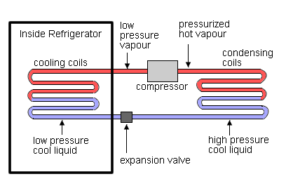
Part I: A Refrigerator
The diagram on the right shows the inner workings of a simple refrigerator. Although the diagram does not tell you this, the refrigerant moves clockwise through the system.

1. Inside the refrigerator, the low pressure liquid slowly turns to a low pressure vapor. Why does this happen, and why is it important?

2. Outside the refrigerator, the high pressure vapor turns into high pressure liquid. Why does this happen, and why is it important?

3. What purpose(s) does the expansion valve serve?

4. What purpose(s) does the compressor serve?

Part II: An Air Conditioner
5. Compare the refrigerator diagram above and the air conditioner diagram below. What differences do you see?

6. Air conditioners not only cool the air, they also dry it out. In the process of removing water from the air, car air conditioners tend to create puddles. Show where the puddle will form in the diagram below.

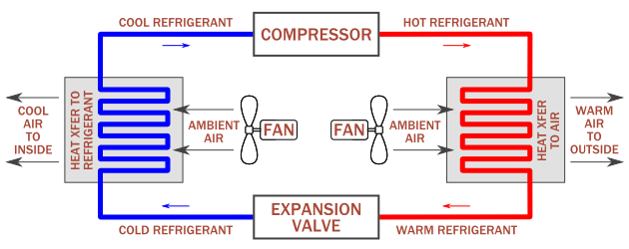

Part III: A Heat Pump
Consider the heat pump in the diagram below…

7. Convert the Celsius temperatures in the diagram to Fahrenheit. $℉=\left(℃×\frac{9}{5}\right)+32$

8. Why does the temperature of the outdoor pipe heat up from -3 to +2 degrees Celsius?

9. Why does the temperature of the outdoor pipe cool down from +2 to -3 degrees Celsius?

10. Why does the temperature of the indoor pipe heat up from 60 to 65 degrees Celsius?

11. Why does the temperature of the indoor pipe cool down from 65 to 60 degrees Celsius?

12. The diagram is meant to show the operation of a heat pump in the winter. How could the operational mode of the heat pump be changed for summer use?

13. How is this heat pump different from the refrigerator and the air conditioner on the previous page?

14. Estimate the temperatures of the a) evaporator b) condenser c) ground d) house

Diagram from http://www.baystarenergy.co.uk/wp-content/uploads/2013/05/how-a-heat-pump-works.jpg
